**REPORT ON RURAL AGRICULTURAL WORK EXPERIENCE (RAWE) PROGRAMME**

**IN**

**RAMLA VILLAGE (GODDA DISTRICT, JHARKHAND) AND GODDA KVK (GODDA DISTRICT, JHARKHAND)**

**A**

**Report Submitted to the Birsa Agricultural University, Ranchi**

**in Partial Fulfillment of the**

**Requirements for the Award of the Degree of**

**Bachelor of Science (Agriculture)**

**By**

**Anamika Pandey**

**(Adm. No.: AGTG021967)**

**Course Coordinator : Dr. Abhijeet Satpathy**

**Assistant professor cum junior scientist, Agricultural Extension Education**



**TILKA MANJHI AGRICULTURE COLLEGE, GODDA**

**BIRSA AGRICULTURAL UNIVERSITY, KANKE RANCHI - 834006**

**March, 2023**

**CERTIFICATE**

**This is to certify that**

**MISS ANAMIKA PANDEY with the registration number AGTG021967 of B.Sc (Hons) Agriculture, Tilka Manjhi Agriculture College, Godda ( B.A.U. Ranchi ) has successfully completed the RAWE Programme in Ramla (Naukhil ) Village, Godda District, Jharkhand and KVK (Godda), Godda District, Jharkhand**

**RAWE Chairman RAWE Co-Ordinator**

**Date: Date:**

**Department of Agronomy Department of Soil Science**

**Department of Horticulture Department of Ag. Extension**

**Department of Ag. Economics Department of Ag. Engineering**

**Department of Plant Pathology Department of Entomology**

**ACKNOWLEDGEMENT**

I’m Anamika Pandey, student of 4th year BSc. (Hons Area. Feel highly delighted after the accomplishment of my assigned RAWE based on PRA tools & technique. My journey towards the accomplishment wouldn’t have been possible without the support & guidance of my teachers & groupmates.

I express my heartiest gratitude to our honourable Associate Dean Sir Dr. Amrit Kumar Jha, who gave us this great opportunity to take part in the RAWE Programme and endeavoured to make this course successful.

I am also very grateful to our professor Dr.Abhijeet Satpathy (Coordinator of RAWE Programme) for continuously guiding , motivating, encouraging us to explore various aspects of this course and organising this course in such a manner that we can take maximum academic benefit out of it.

To this, I add my sincere gratitude and heartily thanks to all the professors of different disciplines of our college for their precious time and guidance and for sharing their own experiences during this RAWE .

It was a great privilege to work under the loving and caring guidance of our instructors at allotted village in RAWE. I give my special thanks to all the villagers who accompanied us during RAWE programme.

I would also like to thank my batch mates and my seniors for their pretty involvement and suggestions and for their continuous cooperation.I will always be thankful to those who have helped me directly or indirectly in successfully completing this course.

**Anamika Pandey**

**Roll no. :- 67**

**INDEX**

|  |  |  |
| --- | --- | --- |
| **SI. No.** | **PARTICULARS** | **PAGE NO.** |
|  | Introduction | 9 – 13 |
| **I.** | Village Attachment |  |
|  | Rapport Building | 15 – 16 |
|  | Village Profile Study | 16 – 25 |
|  | Agronomic Interventions | 26 – 44 |
|  | Horticultural Interventions | 45 – 53 |
|  | Soil Interventions | 54 – 56 |
|  | Plant Protection Interventions |  |
|  | A. Entomology | 57 – 62 |
| B. Pathology | 63 – 68 |
|  | Agricultural Engineering | 69 – 70 |
|  | Animal husbandry Interventions | 71 – 74 |
|  | Agril. Economics Interventions | 75 – 82 |
|  | Agricultural Extension Interventions | 83 – 101 |
|  | ITKs | 102 |
|  | Action Plan Development of the Village | 103 |
| **II.** | KVK Attachment | 104 – 112 |
|  | Media Coverage & Glimpses | 113 |

**List of Tables**

|  |  |  |
| --- | --- | --- |
| **Table No.** | **Name of table** | **Page no.** |
|  | **Village Profile** |  |
| 2.1 | Village Population | 16 |
| 2.2 | Housing type | 16 |
| 2.3 | Education | 17 |
| 2.4 | Occupation | 17 |
| 2.5 | Land use pattern of village | 18 |
| 2.6 | Sources of irrigation of village | 19 |
| 2.7 | Farmers’ profile | 19 |
| 2.8 | Average annual income | 20 |
| 2.9 | Credit facility | 20 |
| 2.10 | Communication network | 20 – 21 |
| 2.11 | Institutional network | 21 |
| 2.12 | Marketing facilities | 21 |
| 2.13 | Extension participation | 22 |
| 2.14 | Allied enterprises in village | 22 |
| 2.15 | Technological access | 23 – 24 |
| 2.16 | Crop profile | 24 – 25 |
|  | **Agronomical intervention** |  |
| 3.1 | Details of cropping scheme of previous year | 38 |
| 3.2 | Details of calendar of operations of major field crops | 38 – 39 |
| 3.3.1 | Cost of cultivation of wheat | 40 – 41 |
| 3.3.2 | Cost of cultivation of mustard | 42 – 43 |
| 3.5 | Details of cropping scheme of current year | 43 |
|  | **Horticultural intervention** |  |
| 4.1 | Information on system of irrigation | 49 |
| 4.2 | Information on field preparation | 50 |
| 4.3 | Information on problems identified on field preparation | 50 |
| 4.4 | Problems identified on nutrient management | 51 |
| 4.5 | Field Crop profile | 51 – 52 |
| 4.6 | Problems of field crops | 52 |
| 4.7 | Horticultural crop profile | 52 |
| 4.8 | Problems identified on horticultural crops | 52 |
|  | **Department of Entomology** |  |
| 6.A.1 | Crop-wise information of pests | 61 |
| 6.A.2 | Control measures adopted | 61 |
| 6.A.3 | Suggestion for proper storage of food grains | 62 |
|  | **Department of Plant Pathology** |  |
| 6.B.1 | Crop disease profile | 67 |
|  | **Agricultural engineering** |  |
| 7.1 - 7.3 | Farm tools and equipments | 69 – 70 |
|  | **Animal husbandry intervention** |  |
| 8.1 - 8.5 | Basic data on livestock | 72 – 74 |
|  | **Agricultural Economics Intervention** |  |
| 9.1 - 9.19 | Rural economics | 75 – 82 |
|  | **Agricultural extension services** |  |
| 10.1 | Common details of the farmer | 83 |
| 10.2 | Age distribution | 83 |
| 10.3 | Land holding classification | 84 |
| 10.4 | Education qualification | 84 |
| 10.5 | Gender | 84 |
| 10.6 | Caste | 85 |
| 10.7 | High school survey | 86 – 87 |
| 10.8 | High School teachers’ list | 88 – 89 |
| 10.9 | Aanganbaadi survey | 91 |

**List of figures**

|  |  |  |
| --- | --- | --- |
| **Fig. No.** | **Name of figure** | **Page no.** |
|  | Agro-climatic zone of Jharkhand | 12 |
|  | Map of Godda District | 13 |
|  | Social Map of Ramla Naukhil | 97 |
|  | Resource Map of Ramla Naukhil | 98 |
|  | Timeline Map | 99 |
|  | Trend Analysis | 100 |
|  | Venn Diagram | 101 |

**INTRODUCTION**

"If agriculture goes wrong, nothing else will have a chance to go right".

~ M.S. Swaminathan

Agriculture is the art and science of cultivating the soil, growing crops and raising livestock for consumption and benefit of mankind.

Agriculture in India is a major economic sector and it is the backbone of the Indian economy.It creates plenty of employment opportunities as well. About 65% of the Indian population depends directly on agriculture.

**What is RAWE?**

**The Rural Agricultural Work Experience Programme (RAWE)** provides a unique opportunity to the students of agriculture to work with the farmers at their farms and homes and get exposed to the real field problems and extension methods with sound basic knowledge.

The Rural Agricultural Work Experience programme (RAWE) is being conducted in the 7th semester (20 credit hours) . In this programme, all students are allotted different villages,are assigned to carry out different data collection activities under the proper guidance from our respected Professors.

**History**

In India, the Randhawa Committee (1992) recommended the rural agricultural work experience (RAWE) program for imparting quality, practical and production oriented education for agriculture degree programs. Therefore, the agenda for the 21st century in agricultural education should be drawn on the basis of challenges it has to meet in the near future. RAWE program provides significant hands-on experience in acquiring knowledge and skill.

Here participatory rural appraisal (PRA) technique is conducted to gain experience. So, we were required to carry out the exercise in the assigned village with the help of the villagers and submit our report. During visiting villages and doing PRA exercise, we were exposed to village situations and we got a basic understanding of various on-farm activities. We develop communication skills with farmers during interaction regularly under this programme. Various exercises under this project developed this knowledge of the student

and revised all the courses that we studied for the last 3 years. We are now comfortable while communicating with the villagers.

This RAWE programme has been very effectively programmed and is of most importance for agricultural graduates as they have to work “with the people, by the people and for the people” at the grass root level in the near future, to take our country in the line of a developed Nation.

**COMPONENTS COVERED:-**

* Rural Agricultural Work Experience
* In-Plant Training / Agro Industrial attachment

**Component I: Rural Agricultural Work Experience**

The Rural Agricultural Work Experience (RAWE) helps the students primarily to understand the rural situations, status of agricultural technologies adopted by farmers, prioritize the farmers’ problems and to develop skills and attitude of working with farm families for overall development in rural areas. The students may be placed in the villages adjacent to the University establishments like College, Krishi Vigyan Kendra, Regional Research Station, Regional Research Sub-Station etc. under its jurisdiction.

**Component-II: In-Plant Training / Agro Industrial Attachment (AIA)**

Technology and globalization are ushering an era of unprecedented change. The need and pressure for change and innovation is immense. To enrich the practical knowledge of the students, in-plant training shall be mandatory for a period of up to 3 weeks. In this training, students will have to study a problem from an industrial perspective and submit the report. Such in-plant training will provide an industrial exposure to the students as well as to develop their career in the high tech industrial requirements. The students may be placed in Agro-and Cottage industries including Seed / Sapling production, Pesticides-insecticides, Post-harvest-processing-value addition, Agri-finance institutions, etc. and Commodities Boards for 3 weeks.

**OBJECTIVES OF RAWE:-**

* To provide an opportunity to the B.Sc.(Ag.)Hons. students for reorienting their subject matters knowledge through work experiences in local situations.
* To know the socio-economic status of the rural people in the particular area.
* To enumerate the local livelihood status of the people by the students for getting information regarding people's farm experiences.
* To emphasize the communication linkage between the organization, agricultural university and local people.
* To develop confidence and competence of the students and local people for solving the problems related to farm enterprises with the help of local resources.

**LIMITATIONS of the study:-**

* Inadequate time limit.
* Small size of target respondents.
* Homogeneity of target people or farm entrepreneurs.
* Very little fund allotment of the course.
* Information of crops only from a single season.

**PARTICIPATORY RURAL APPRAISAL (PRA)**

PRA is both an attitude and methodology. It is one of the tools of surveying that helps outsiders to understand the village symbols, systems, dynamics and politics by using various techniques as well as by methods of direct observation and 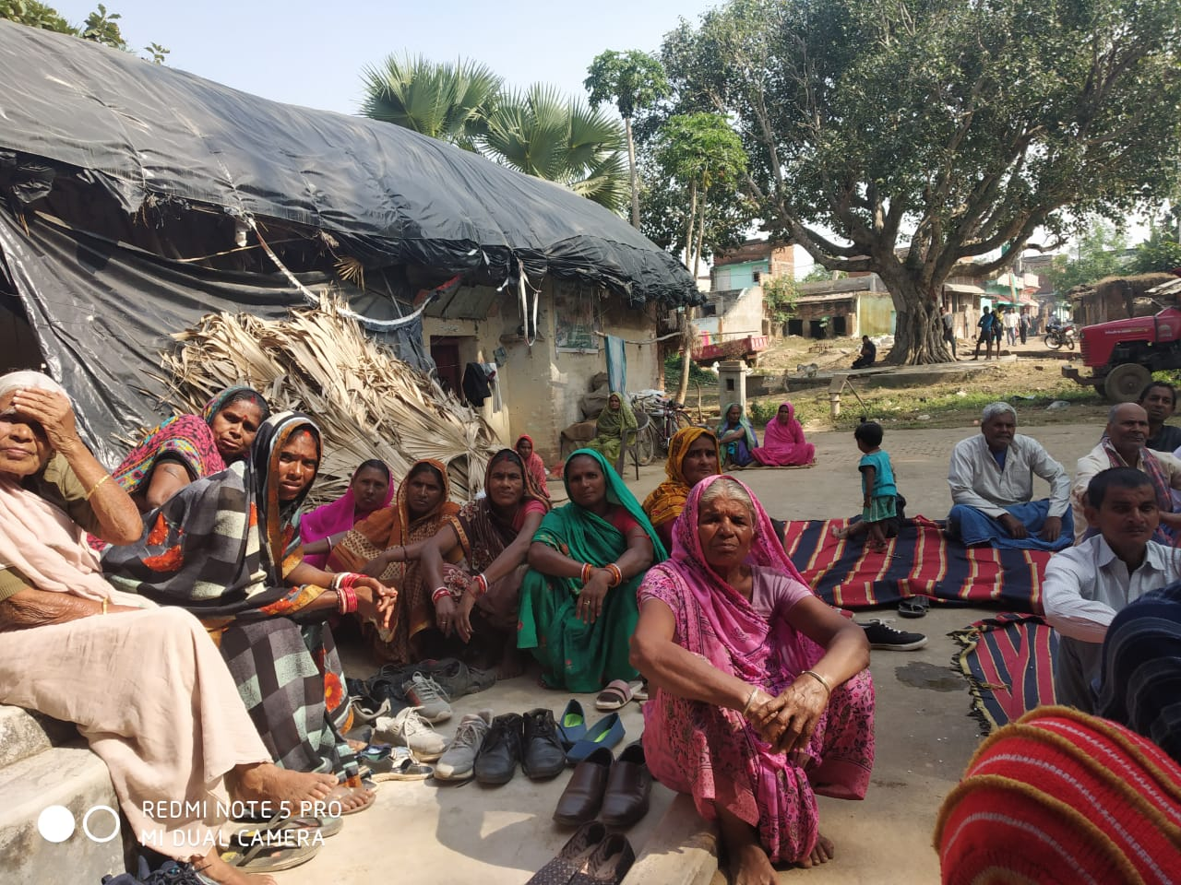

discussion. It can be defined as, “A growing

family of approaches and methods that enable

local people to share, enhance and analyze

their knowledge of life and condition to plan

and act.”

Father of PRA : Robert Chambers

**OBJECTIVE OF PRA**

* To generate information and collection of

data for immediate or future use.

* For greater and better involvement of villages by learning about their perception, experiences and capabilities.
* For learning about the impacts of earlier or ongoing policies and programmes and to frame new ones.
* For training of different categories of persons involved in the development process, whether from Govt., NGOs, Banks, Researchers, Extension Agents, Scientists etc.
* For validation and cross-checking of data collected from other sources.

**PURPOSE OF PRA**

* To use farmer’s criteria, choices and understand the local environment with clear priorities.
* To learn farmer’s indigenous technologies.
* To achieve triangulation using different methods & involving various people to check and recheck the findings.
* To develop self critical analysis and direct contact with local needs and communities.

**JHARKHAND:-** 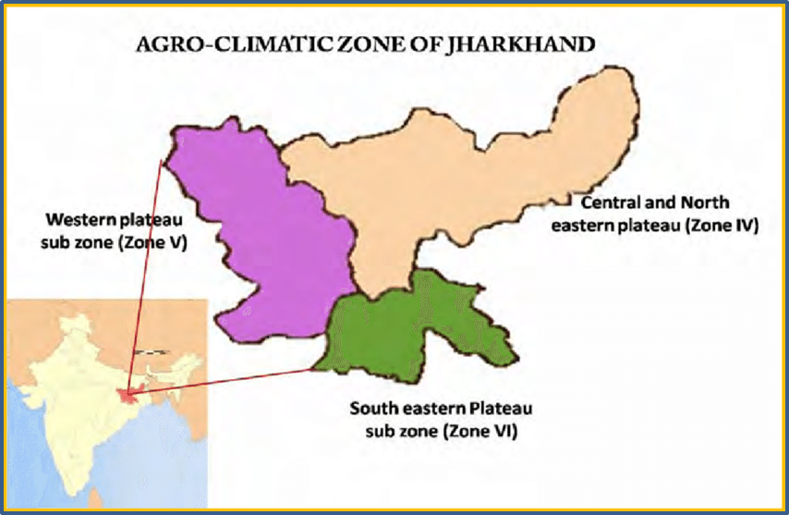

***About:-***

Jharkhand is 'the land of forests' -

endowed with rich flora and fauna.

To have a complete panoramic view

of nature and beauty, one can visit

the zoological gardens and national

parks. The state is situated in the

eastern part of India. In the year

2000, it was split from southern

Bihar and was formed into another

State. Jharkhand is encircled by the

Indian states of West Bengal(east),

Uttar Pradesh (west), Chhattisgarh **Fig. 1**

(west), Bihar (north) and Odisha (south). The state is spread out across 30,778 miles. Ranchi is the state's prime capital, whereas the largest city for industrial purposes is Jamshedpur. The sub-capital of the state is Dumka

**FACTS ABOUT JHARKHAND:-**

|  |  |
| --- | --- |
| **Date of formation** | 15, Nov ,2000 |
| **Area** | 79,714sq km |
| **Density** | 414/km² |
| **Population (2011)** | 3,29,88,134 |
| **Males population** | 1,69,57,819 |
| **Female population** | 1,60,57,819 |
| **No. Of District** | 24 |
| **Capital** | Ranchi |
| **Forests and National Parks** | Betla National Park (231.67 sq km), Hazaribagh Sanctuary (186.25 sq. km), Palamu WS (794.33sq. Km) |
| **State Animal** | Elephant |
| **State bird** | Asian koel |
| **State Tree** | Sal |
| **State Flower** | Palash |
| **Literacy Rate** | 67.60 |
| **Females per 1000 Males** | 947 |

**ABOUT THE DISTRICT GODDA**

Godda was a part of undivided Santhal Pargana district until the 1981 census. Later, the old Godda sub-division of Santhal Pargana was separated and formed as a new district. The district of Godda was created on 17 May 1983 out of old Santhal Pargana district which was upgraded to the level of division. Godda(M), the only one town of the district, is the headquarters of Godda district, Godda subdivision and Godda block.

The area of the district is 2110 km², with a population of around 1313551. The Godda district is connected with a rail link. The nearest railway station is Godda. The main economic activity of the people is agriculture, and major crops are paddy, wheat and maize. For administrative purposes the district has been divided into 2 sub-division – Godda & Mahagama and 9 nos. of Blocks.

**Fig. 2**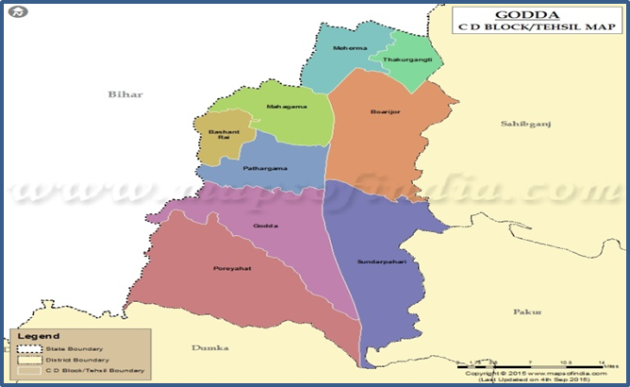

DISTRICT AT A GLANCE:

Area : 2,110 sq km

Language : Hindi

Population : 1,313,551

Males : 6,77,927

Females : 6,35,624

Village : 1634

1. **VILLAGE PROFILE**:

Naukhil is a small Village in Godda Block in Godda District of Jharkhand State, India. It is located 2 KM towards East from District head quarters Godda. 298 KM from State capital Ranchi

**Village Attachment**

**1)RAPPORT BUILDING :**-

Rapport building is the process of creating rapport and building trusting relationships between two or more people. Rapport building is the first step of PRA.

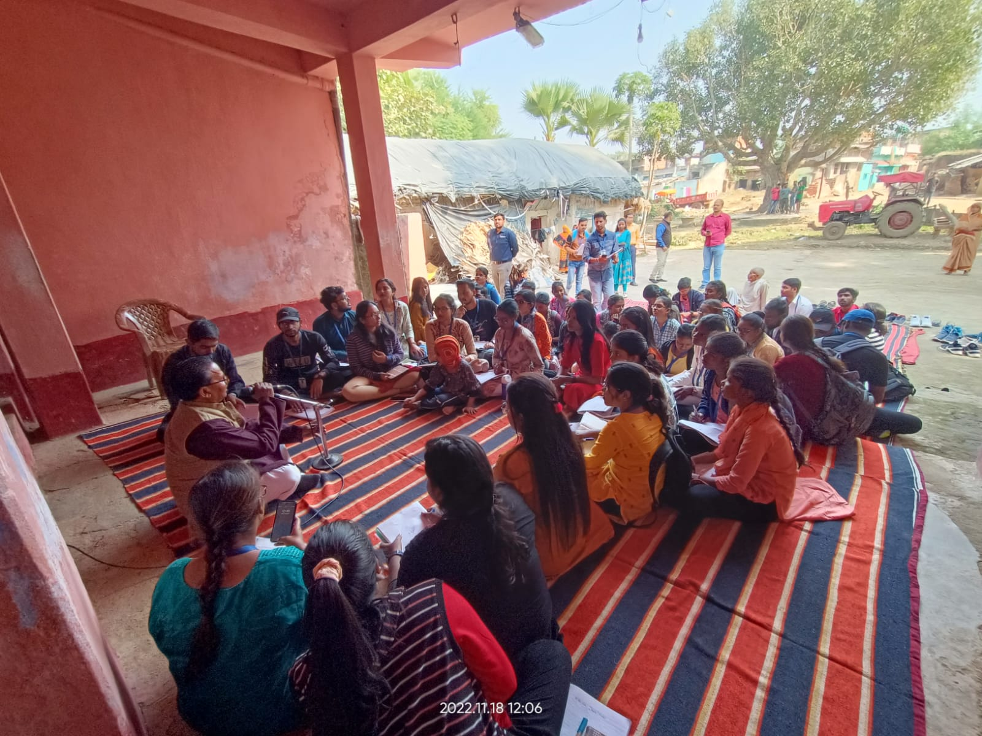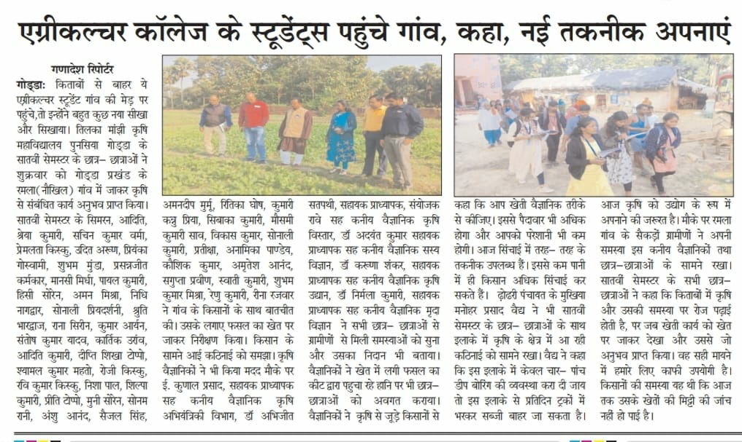

We reached Ramla village on 18th of Nov 2022 for the 1st time . We were welcomed warmly by Manohar Prashad Vadhya the sarpanch of the village and the other villagers. We all gathered in the "Satsang Bhawan" were the people of the village has arranged mattresses and Audio Amplifier Systems for our convenience. This made our way much easier to reach each and every villager. They served us tea, biscuit , water and all of this was really very overwhelming. We all started interacting with them and this went too far. We (Us and the villagers) broke our barriers and all preconceived notion, our conversation became informal. Gradually the villagers started sharing their problems, we heard it all and discussed the possible ways to solve them. Then we were allotted with our respective host farmers and we left Satang Bhawan with them. We visited their field, also collected necessary data. At 4 pm we gathered again near the Satsang Bhawan again and left for our college.

**Name of the farmers:-**

Sintu Kumar

Bhawani Devi

Hardev Mandal

Shrikant Mandal

Dhananjay Vaidh

Basant Mandal

Shri Sitaram Vaidh

Chandan Kumar Vaid

Chakardhar Manjhi

Rapport building is an important task for the team for collecting reliable information. It is usually done to develop communications and to establish working relationships with the local people. Generally, rapport building is initiated immediately as the team enters a village. This may help the team to get closer to the village people.

* Start talking to the rural people saying “local Hello” whenever you meet them, for example, on the trail, agricultural fields, tea shops, homes etc.
* Treat and respect rural people as per their local custom.
* Ask the knowledgeable people about a subject or area in a village .
* Clearly explain reasons for coming to the area.
* Show genuine interest in the local issues .
* Choose a time and venue that are convenient for the local people.

1. **VILLAGE PROFILE STUDY :-**

**Table no. 2.1) Village Population:-**

|  |  |  |
| --- | --- | --- |
| **Category** | **Numbers** | **Percentage** |
| Male | 538 | 29.88% |
| Female | 535 | 29.72% |
| Children | 727 | 40.38% |
| **Total Population** | 1800 | 100% |

**Table no. 2.2) HOUSING TYPE:**

|  |  |  |
| --- | --- | --- |
| Type | Numbers | Percentage |
| a) Kachha | 50/500 | 10% |
| b) Pucca | 450/500 | 90% |

**Table 2.3) EDUCATION:**

|  |  |  |
| --- | --- | --- |
| Category | Numbers | Percentage |
| Illiterate | 180 | 10% |
| Primary education | 1620 | 90% |
| Middle school | 1480 | 82.22% |
| High school | 1245 | 69.16% |
| Intermediate | 891 | 49.5% |
| Graduation and above | 540 | 30% |

**Table no. 2.4) OCCUPATION:**

|  |  |  |
| --- | --- | --- |
| Occupation | Numbers | Percentage |
| Professional | 05 | 0.68 % |
| Teacher and Managers | 12 | 1.64 % |
| Farmer | 514 | 70.6 % |
| Skilled laborer | 118 | 16.2 % |
| Unskilled laborer | 79 | 10.8 % |

**Table no. 2.5) LAND USE PATTERN OF VILLAGE :**

|  |  |  |  |
| --- | --- | --- | --- |
| **Sl.**  **No.** | **Item** | **Area in hectares** | **% of total**  **geographical area** |
| 1 | Total Geographical area of village | 220 ha | 100% |
| 2 | Area under forest | 2 ha | 0.9% |
| 3 | Barren and uncultivable land | 5 ha | 2.27% |
| 4 | Cultivable land | 82 ha | 37.27% |
| 5 | Total fallow land | 7 ha | 3.18% |
| 6 | Net sown area | 82 ha | 37.27% |
| 7 | Net irrigated area | 26 ha | 11.81% |
| 8 | Area sown more than once | 26 ha | 11.81% |
| 9 | Gross cropped area | 82 ha | 37.27% |

**Table 2.6) SOURCES OF IRRIGATION FOR VILLAGE:**

|  |  |  |
| --- | --- | --- |
| Sources | Area irrigated (Ha.) | Percentage |
| Channel | 3 ha | 11.5 % |
| Tank | 0 ha | 0 % |
| Open well | 15.6 ha | 60 % |
| Bore well | 0.4 ha | 1.54 % |
| Others | 7 ha | 26.9 % |

**Table 2.7) FARMERS PROFILE:**

|  |  |  |
| --- | --- | --- |
| Category | Numbers | Percentage |
| Marginal farmers | 416 | 52.79 % |
| Small farmers | 60 | 7.61 % |
| Medium farmers | 38 | 4.82 % |
| Agricultural labourers | 79 | 10 % |
| Rural artisans | 118 | 15 % |
| Others | 77 | 10 % |
| Total | 788 | 100 % |

**Table 2.8) AVERAGE ANNUAL INCOME:**

|  |  |  |
| --- | --- | --- |
| Rupees/year | No. of households | Percentage |
| Up to 10000 | 150 | 30% |
| 10000-50000 | 250 | 50% |
| 50000-100000 | 75 | 15% |
| >100000 | 25 | 5% |

**Table 2.9) CREDIT FACILITY:**

|  |  |  |  |  |
| --- | --- | --- | --- | --- |
| **Sources** | No. of people preferred | | Percentage | |
| Landlords | 5 | | 12.5% | |
| Friends | 5 | | 12.5% | |
| SHGs | 20 | | 50% | |
| Bank | | 10 | | 25% |
| Cooperative societies | | nil | | - |

**Table 2.10) COMMUNICATION NETWORK**

|  |  |  |
| --- | --- | --- |
| **Sources** | No. of people preferred | Percentage |
| Newspaper | 200 | 40 % |
| Radio | 30 | 6 % |
| Television | 240 | 48% |
| Extension agent | nil | - |
| Local leaders | 60 | 3.33 % |
| Input dealer/NGOs | 10 | 1.67 % |
| ICT(Mobile/Internet) | 1200 | 66.67 % |

**Table 2.11) INSTITUTIONAL NETWORK ( Access to Institution)**

|  |  |  |
| --- | --- | --- |
| **Sources** | No. of people preferred | Percentage |
| Agril. Dept. | 5 |  |
| KVK | 3 |  |
| Block Office | 2 |  |
| Educational Inst. | --- | --- |
| Panchayat | 10 |  |
| NGOs | 5 |  |

**Table 2.12) AVAILING MARKETING FACILITIES:**

|  |  |  |
| --- | --- | --- |
| **Sources** | **No. of people preferred** | **Percentage(%)** |
| Local Markets | 700 | 63.64% |
| Mandi | 300 | 27.27% |
| Regional | 100 | 9.09% |
| National | 0 | 0 |
| International | 0 | 0 |

## **Table 2.13) EXTENSION PARTICIPATION :**

|  |  |  |  |
| --- | --- | --- | --- |
| Sl. No. | Extension activities | No. of people preferred | Percentage |
| 1. | Training | 05 | 14.28% |
| 2. | Demonstrations | 10 | 28.57% |
| 3. | Exhibition | nil | - |
| 4. | Exposure Visits | nil | - |
| 5. | Awareness Campaign | 20 | 57.14% |
| 6. | Farmers’ fair | nil |  |

**Table 2.14) ALLIED ENTERPRISES IN THE VILLAGE**

|  |  |  |
| --- | --- | --- |
| **Enterprises** | **No. of Families** | **Percentage to total** |
| Dairy | 30 | 27.27% |
| Goatery | 20 | 18.18% |
| Poultry | 20 | 18.18% |
| Piggery | 2 | 1.81 |
| Others | 38(buffalo) | 34.54% |
| Total | 110 | 100% |

**Table 2.15) TECHNOLOGICAL ACCESS:**

|  |  |  |
| --- | --- | --- |
| **Techniques** | **No. of farmers adopted** | **Percentage(%)** |
| Soil testing | -- | --- |
| Line sowing / transplanting | 225 | 22.5% |
| Nutrient management | 250 | 25% |
| System of Rice Intensification | NIL | NIL |
| Weed management | 112 | 11.2% |
| Use of machineries | 84 | 8.4% |
| Integrated Farming Approach | 86 | 8.6% |
| Integrated Pest and disease management | 28 | 2.8% |
| Cash Crops | --- | -- |
| Climate smart agriculture | NIL | NIL |
| ICTs use | NIL | NIL |
| HYVs | 85 | 8.5% |
| Hybrids | 100 | 10% |
| GM crops | NIL | --- |
| Organic farming | 20 | 2% |
| Micronutrients (Zn, B) application | NIL | --- |
| Conservation agriculture | NIL | --- |
| Seed treatment | 10 | 1% |
| Drip Irrigation | NIL | --- |

## **Table 2.16) CROP PROFILE:**

|  |  |  |  |  |  |
| --- | --- | --- | --- | --- | --- |
| **Sl.** | **Name of Crops** | **Land types (up/mid/low)** | **Area under cultivation** | **Average Yield** | **Profit** |
| **Cereals** | | | | | |
| 1 | Paddy | Low | 57ha | 102.6 ton |  |
| 2 | Wheat | Low | 50ha | 75.4 ton |  |
|  |  |  |  |  |  |
| **Pulses** | | | | | |
|  | Pigeonpea | Upland | 25 ha | 388.5 q |  |
|  | Chickpea | Medium | 30 ha | 216 q |  |
|  |  |  |  |  |  |
| **Oilseeds** | | | | | |
|  | Mustard | Low | 53 ha | 54 ton |  |
|  |  |  |  |  |  |
|  |  |  |  |  |  |
|  |  |  |  |  |  |
| **Vegetables** | | | | | |
|  | Potato | Low | 57 | 1020 ton |  |
|  | Tomato | Low | 40.32 | 241ton |  |
| **Fruits** | | | | | |
|  | Mango | Low,medium | 10.8 | 86.4 |  |

1. **AGRONOMICAL INTERVENTION:-**

**Learning objectives**

* To study the existing cropping system, constraints and possible recommendations.
* To analyze the production practices of existing major field crops and technological gaps.
* To assess the weed infestation and their management.

**3.1.1) MUSTARD:-**

**1)Land preparation:-**

**Farmer's practice:** ploughing using cultivator followed by 2 cross harrowing using Rotavator

**Recommended practice:** Fine seed beds are required for good germination of crops. Ploughing of soil should be done for two to three times followed by two harrowing. Planking should be done after every ploughing. Firm, moist and uniform seed bed as it will help in uniform germination of seed.

**2)Variety used:-**

**Farmer’s practice:** indigenous variety, local hybrid variety.

**Recommended practice:** Pusa Mustard 30, Pusa bold, kranti, Pusa jai kisan.

**Technology Gap:** All the farmers are not aware about the new varieties which is suitable for this village.

**Suggestion:** since the land is irritated by the farmer before sowing so irrigated suitable variety is Pusa Mustard 30, kranti and or late sown irrigated variety Pusa bold is used.

**3) Seed Rate**

**Farmer’s seed rate:**  23 kg/ha

**Recommended seed rate:** 10-12 kg/ha (Broadcasting)

**Technology Gap**: farmers lack information about seed rate.

**Suggestion**: They may use line sowing methods to reduce seed cost.

**4)** **Time of Sowing**

**Farmer’s practice**: 1st fortnight of Oct to 1st week of Nov.

**Recommended practice**: 1st fortnight of October.

**Suggestion:** Farmers may be advised for timely sowing practice to get high yield and less disease pest infestation.

**5) Method of Sowing**

**Farmer’s practice:** Broadcasting

**Recommended practice:** Line sowing with spacing 30×15 cm.

**Technology Gap:** Inadequate knowledge about proper method of sowing**.**

**Suggestion:** Farmer’s may be advised to use an improved method of sowing for lowering seed rate and getting optimum yield. Proper spacing decreases competition and increases yeild

**6) Manure and Fertilizer Application**

**Farmer’s practice**: Urea thrice the area of field in kattha, DAP twice the field area in kattha and no MOP.

**Technology Gap**: Improper use of fertilizer and no use of manure

**Recommendation of Fertilizer For Mustard Field to the host farmer :**-

Mustard was sown in 2.8 kattha i.e. 0.043 ha by my host farmer

80:60:40 Fertilizer dose is required for 1ha

3.4 : 2.6 : 1.72 Fertilizer dosage is req for 0.043 ha.

Calculation for DAP :-

46 kg of p2o5 get from 100 kg of DAP

100/46= 2.17

2.17×2.6 = 5.6 KG OF DAP

FROM DAP we get nitrogen as well

From 100 kg of DAP we get 18 kg of N2

So, 5.6 kg of DAP gives N = 18/100* 5.6

= 1 kg (approx)

Calculation for Urea :-

Net nitrogen required= 3.4kg

Nitrogen from DAP. = 1kg

Remaining nitrogen required from urea = 3.4kg- 1 kg =2.4 kg

From 100 of urea we get 46 lg of nitrogen

100/46 = 2.17 × 2.4 = 5.2 kg urea

Calculation for potash :-

From 100 kg of potash we get 60 kg of K2O

100/60

0.6× 1.7 = 2.8 kg MOP

= 3 kg approx.

**FYM** @ 15-20 t/ha

**Technology Gap**: Improper use of fertilizer and manure

**Suggestion**: Farmers are requested to follow proper doses of FYM and fertilizer.

**7) Irrigation Scheduling**

**Farmer’s practice**: Pre irrigation - 9 October

2nd irrigation - 5 November

3rd irrigation - 25 November (at the time of flowering)

**Recommended practice**: Two irrigations at pre bloom and pod filling stages

**Technology Gap:** Lack of proper information about irrigation scheduling.

**Suggestion**: Farmers may follow recommended irrigation scheduling which is more beneficial for the crop

**8) Plant Protection Scheduling**

**Farmer’s practice:** Rogor 2 ml/l of water only once.

**Recommended practice**: Apply copper oxychloride (Blitox) @ 4g/lit of water and difenoconazole (Score) @ 1 ml/litre of water at 7 days interval for 2-3 times

**Technology Gap:** Lack of awareness about plant protection measures.

**Suggestion:** Farmers may use resistant varieties, follow proper protection measures, burn the affected plant part after harvest.

**9) Yield**

**Farmer’s practice:** 12 -12.5 q/ha

**Recommended practice:** 20-25 q/ha

**Technology Gap**: Present yield is below the expected yield due to lack of awareness and insufficient knowledge about the package of practices .

**Suggestion:** They may follow proper scientific technique of cultivation, use of high yielding variety suitable for this particular village situation.

**3.1.2) Wheat :-**

1. **Land Preparation**

**Farmer’s Practice:** One ploughing using cultivator and two harrowing by using rotavator.

**Recommended Practice:** wheat grows well and gives uniform germination in a pulverized but compact seed bed. In case of irrigated wheat, pre-sowing irrigation should be given after harvesting of the kharif crop and field should be prepared by carrying out one deep ploughing to uproot the weed and stubbles followed by two harrowings and planking is desirable.

**Suggestion**: proper leveling of fields.If fields are not properly leveled it leads to poor performance of the crop, because part of the area suffers due to water stress and the other parts due to excess of water which further leads to yield loss.

1. **Seed and sowing**

**Farmer’s Practice:** Farmer’s seed ( indigenous variety)

**Recommended Practice:** HD2967, HD3171, K1317.

**Technology Gap:** All the farmers are not aware about the new varieties and quality seed.

**Suggestion:** farmers should use the variety that is well suited for irrigated conditions.

Good quality seeds have following advantages:

* Gives desired plant population
* Capacity to withstand the adverse conditions
* Seedlings produced will be more vigorous, fast growing and can resist pest and disease incidence to certain extent
* Ensures uniform growth and maturity
* Development of the root system will be more efficient that aids absorption of nutrients efficiently and result in higher yield.
* It will respond well to added fertilizer and other inputs.
* Good quality seeds of improved varieties ensures higher yield at least 10 – 12 %.

1. **Seed Rate:**

Total Area of Farmer’s field : 0.0642 had (4.2kattha)

**Farmer’s Practice:** @3 Kg per kattha (for broadcasting)

For 4.2 Kattha 13-13 kg fertilizer is being used by the farmer.

**Optimum Seed Rate**: 125 kg/ha ( broadcasting)

For 0.064 ha 8.6 kg seeds are required

**Technology Gap**: Lack of knowledge about optimum seed rate.

**Suggestion:** Optimum seed rate is most important for maximum yield of crop. If more seed rate is used,

* Plant population will be more and there will be competition among plants for water, nutrients and sunlight resulting in low quality and low yield.
* Intercultural operations will be more difficult.

1. **Optimum time of Sowing**:

**Recommended practice**: 1st fortnight of November is the best time of sowing wheat.

1. **Method of Sowing**

**Farmer’s Practice** : Broadcasting

**Recommended Practice** : Line Sowing

**Line Sowing:-**  means sowing of seed in a fixed geometry pattern along horizontal or vertical line.

**Technology Gap**: Inadequate knowledge about proper method of sowing**.**

**Suggestion**: Farmers are advised to use improved method of sowing i.e, line sowing because of the following reasons:

* Line sowing provides sufficient space for growth of each plant.
* Seed used and seed cost is less than Broadcasting.
* Along the rows, interculturing can be done. Proper utilization of water and nutrients.
* Proper plant growth and good yield.

1. **Manure and Fertilizer Application**

**Fertilizer dose recommendation for wheat field:-**

√The recommended those of fertilizer is 100:40:40 for 1 hectare

(For irrigated conditions)

√ DAP contains 18% N and 46% P2O5.

√ urea contains 46% N.

√ MOP contains 60% of k2O

Calculation:-

√Total land area of the farmer is 7 Katha i.e. 0.109 hectares.

√ wheat is sown in 4.2 kattha i.e. 0.0642 ha.

√ Fertilizer dosage for 0.0642ha is 6.4 : 2.6 : 2.6

DAP calculation:-

40 kg of P2 O5 is provided by 100 kg of DAP

So, 3.6 kg of P2O5 will be provided by = 100/46* 2.6 kg DAP

=2.17* 2.6

= 5.6kg

Now, as we know that 100 kg of DAP provides 18 kg nitrogen.

100 kg of Urea provides 18 kg nitrogen.

So, 5.6 kg of Urea will provide 18/100* 5.6 kg of Nitrogen.

= 1 kg N

Urea calculation :-

Net Nitrogen required. = 5.6 Kg

N from DAP = 1 kg

Total N req. now. = 5.6kg - 1 kg

= 4.6 kg

46 kg of nitrogen is provided by 100 kg of urea

So 4.6 kg of Nitrogen will be given by = 100/46 * 4.6 kg urea

= 9.99 kg urea = 10 kg

Calculation for MOP

60 kg K2O is provided by 100 kg of MOP

2.6 kg will be provided by = 100/60 * 2.6

= 4.33Kg

**Technology** **Gap**: Improper use of fertilizer and manure

**Suggestion:**

* Farmers are advised to follow the recommended dose of FYM and Fertilizers.
* Half dose of N and full dose of P and K applied as basal and remaining half dose of Nitrogen applied as top dressing at 1st irrigation.

1. **Irrigation Stages:-**

**Farmers Practice:**

* 1st irrigation- Before Sowing
* 2nd irrigation- 21 DAS
* 3rd irrigation- 42-45 DAS

**Recommended Practice**: Wheat requires 4-6 irrigation for optimum yield and total water requirement is 450-650 mm. Irrigation should be given at the following critical growth stages.

|  |  |  |  |
| --- | --- | --- | --- |
| S. no. | Critical growth stage | DAS | Reduction in yield if not irrigated (%) |
| 1) | CRI (Crown Root initiation) | 21 DAS | 35 |
| 2) | Tillering | 40-45 DAS | 20 |
| 3) | Flowering (booting) | 80-85 DAS | 25 |
| 5) | Milking | 100-105 DAS | 17 |

* If one irrigation is possible then it should be given at 21 DAS (CRI).
* If two irrigations are possible, they should be given, first at 21 DAS (CRI) and second at 65-70 DAS (Flowering stage).
* If three irrigations are possible, they should be given at CRI, Jointing and Flowering stages.

**Technology Gap**: Lack of proper information about irrigation scheduling

**Suggestion:** Farmers are suggested to follow recommended irrigation scheduling which is more

beneficial for the crop.

1. **Harvesting -**

**Farmer’s Practice:** Farmer harvested wheat in the month of March.

**Recommended Practice:** The crop is harvested when grains become hard, straw become golden yellow, dry and brittle. The plants are harvested manually with the help of sickle early in

the morning. Harvested plants are tied into bundles and then carried to the threshing floor.

**Response of farmers :-:**

They were amazed by knowing that a huge amount of money that they spend on fertilizer, seeds every year can be reduced without any negative effect on fields and crops. They were willing to adopt the new Suggestion.

**3.2) Recommendation Of Line Sowing Over Broadcasting In Farmers Field :-**

**Introduction:-**

In Ramla village farmers generally adopted broadcasting methods for sowing crops. So we recommended them to adopt line sowing because of its many advantages.

First of all , we told them what line sowing is and their benefits.

Seeds are sown in the main field in lines.The seeds are dropped into furrow lines in a continuous flow and are then covered with soil. This is done either mechanically or manually. The proper amount of seeds are sown at proper depths and proper spaces. It helps in good germination of seeds, easy pest management, nutrient management, application of plant protection chemicals, intercultural practices like weeding, hoeing, etc.

* The line sowing method has been found economical over that of broadcasting owing to less per hectare seed requirement and cost of weed management.
* The increase in productivity could be attributed to increased Nutrient use Efficiency (NuE) under Line sowing method owing to proper placement of seeds and fertilizers and reduced competition amongst weeds and crops.

**Farmer's practice**

**Broadcasting:-** Broadcast sowing method is a traditional method of sowing seeds. In this method, farmers sow the seeds by randomly scattering them on the land while walking around the field.

**Recommended practice:-**

**Line Sowing:-**  means sowing of seed in a fixed geometry pattern along horizontal or vertical line.

**Advantages of Line sowing over Broadcasting**

* Line sowing provides sufficient space for growth of each plant.
* Seed used and seed cost is 30% less than broadcasting.
* No problem with thinning.
* Proper utilization of water and nutrients.
* Proper plant growth and good yield.
* The weed management can be done properly under line sowing as compared to broadcasting method.
* Easy to operate intercultural operation

**Disadvantages of Broadcasting:-**

* The requirement of seed per area is more.
* The cost of weeding and thinning in broadcast crop is more
* The intercultural operations such as earthing up, manuring, irrigation, etc., cannot be carried out with ease.
* Broadcast crops do not grow uniformly, and the desired yield is not possible.

**Technology lag:-** farmers are unaware about the benefits of line sowing.

**Farmers Response:-**

The response was different from different farmers. Some farmers were ready to adapt these methods while some denied this by comparing the labour and time requirement of both methods. However, we persuaded them by giving different examples.

**3.3) WEED MANAGEMENT:-**

**3.3.1)Introduction:-**

WEED : Weeds are unwanted and undesirable plants that interact with utilization of land and water resources and thus adversely affect crop production and human welfare.

Weed control and weed management are the two terms used in weed science.

**Importance of weed management** :-

* Weeds have serious impacts on agricultural production.
* Weeds compete with crops for water, soil, nutrients, light, and space, and thus reduce the crop yields.
* Weeds also act as alternate hosts that harbor insects, pests and diseases and other microorganisms. Alternate hosts of some of the pests and diseases.
* Some weeds release into the soil poisonous substances that may be harmful to the crop plants, human beings and livestock. Health problems caused by weeds to humans,Health .
* Weeds not only reduce yield but also interfere with agricultural operations.

**3.3.2) A CRITICAL PERIOD OF WEED COMPETITION**

Critical period of weed competition is defined as the shortest time of crop growth when weeding results in higher economic Returns. The crop yield level obtained by weeding during this period is almost similar to that obtained by full season weed free conditions.

**Factors Influencing Critical Period Of Weed Competition:-**

**Nature of crop:-** Faster growing crops have shorter critical periods of weed competition while slow growing crops have longer critical periods of weed competition.

**Varieties:-** tall growing traditional varieties suppress the weeds effectively while the dwarf varieties the critical period of weed competition is longer.

**Growing conditions:-** It also affects the critical period of competition. Ex - upland rice suffers for this competition throughout the life time while in transplanted rice this competition period is Short.

**Period of weed growth:-** weeds that germinate along with the crops are more competitive. They require very less time for germination as compared to the main crops.

**Weed crop density:-** The relationship between yield and weed competition is inversely proportional.

**Plant species**:- Weeds differ in their ability to compete with the crops at similar density levels this is because of the differences in the growth habit and to some extent due to allelopathic effects.

**3.3.3)Weed management in farmers field :-**

In Ramla village, the growth of weeds is one of the most neglected issues. Farmers lack the awareness and means to tackle this problem. We told them that weeds deplete crops' environment of nutrition, water and light. Crop yields are reduced considerably. In addition, weeds interfere and cause inconvenience in agriculture operations. Not only quantity, but also the quality of the produce is reduced by weeds infestation.

**Farmer's practice:-** hand weeding ( occasionally)

**Recommended practice:**- Methods suggested by us for weed management:-

1. **Cultural method**: It includes field preparation, planting methods, planting density, varieties, fertilizer application, irrigation and drainage etc to check the growth of weeds.
2. **Physical method:** Physical methods such as hand weeding, hand hoeing, digging, mulching, cutting, burning and flaming, inter-cultivation are important.
3. **Biological weed control**: Bio-agents like insects, pathogens, and other animals are used to control weeds. Insects and pathogens infest weeds and either reduce their growth or kill them. Bio-agent should affect only one host and it should not affect any other useful plants. Feasible examples of biological weed control –
   1. Insects - In Australia, *Lantana camara* was controlled by two beetles *Octotoma scabripennis* and *Uroplata giraldi*.
   2. Fish - Common crap and chinese crap control aquatic weeds.
   3. Fungi - Water hyacinth can be controlled by *Rhizoctonia* blight.
4. **Chemical weed control**: For the efficient and effective control of weeds, herbicides are important.
   1. **Fallow application** –
      1. Application of herbicide in advance of sowing, more than 10 days before sowing, is called as Fallow application.
      2. It control weeds like *Cynodon* *dactylon.*
   2. **Pre-plant application** –
      1. Application of herbicides 2 to 10 days before sowing.
   3. **Pre-emergence herbicides application** –
      1. Application of herbicides after the sowing of crops but before its emergence.
      2. It is done 1 to 4 days after sowing.
      3. Highly soluble herbicides are not advisable as they may leach and affect the plant if heavy rain occurs after the plantation.
   4. **Post emergence herbicide application–**
      1. Applied after the emergence of the crop.
      2. It is generally resorted to when the crop has grown sufficiently to tolerate herbicides.
      3. Generally applied when crop has grown sufficiently to tolerate herbicide. This is done after 30-40 DAYS after sowing.

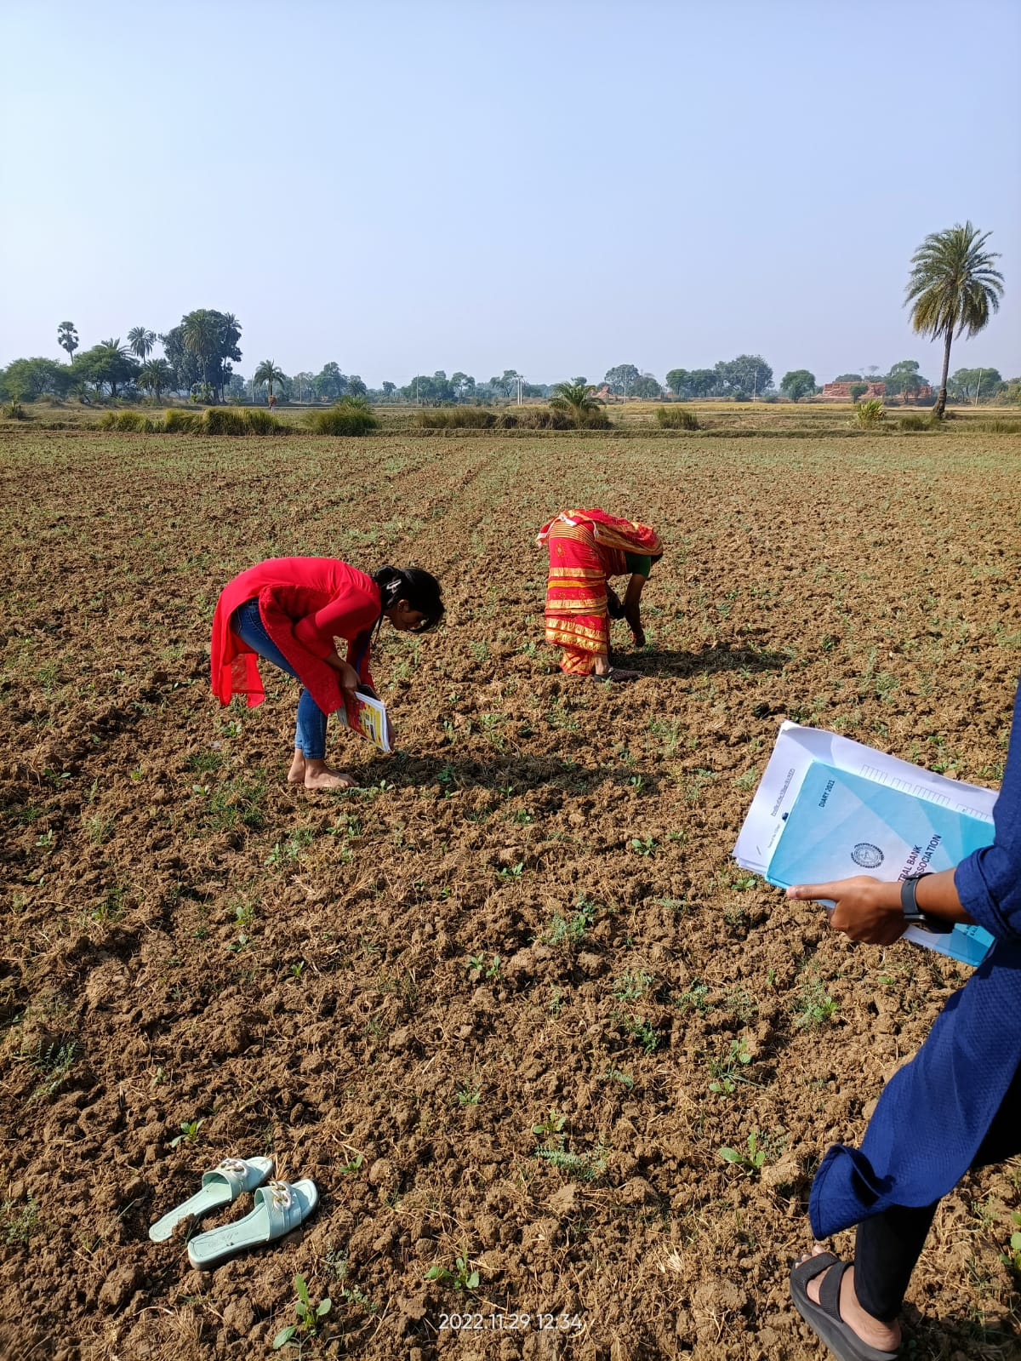

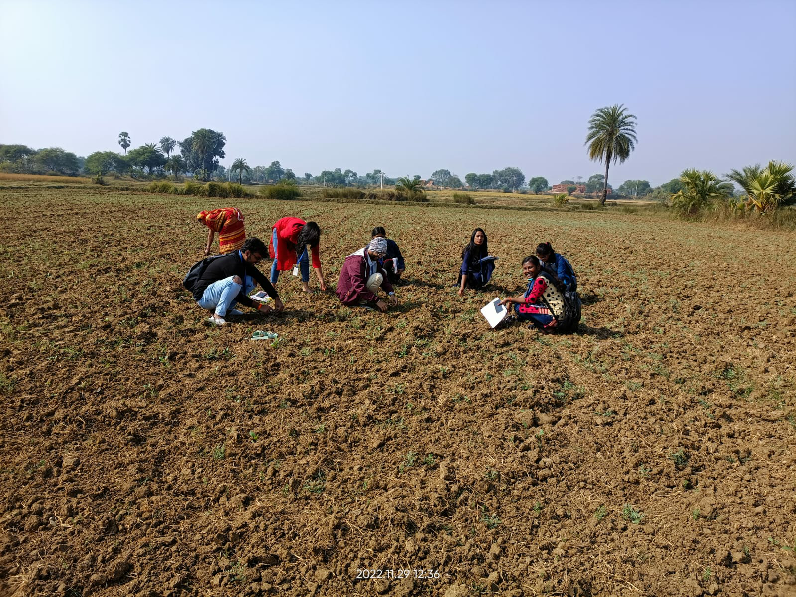

**Technology Gap:**

* Inadequate knowledge about the intensity of yield loss caused weed infestation.
* Lack of knowledge about the pre and post emergence application of herbicides.

**Suggestion:-**

* Awareness of crop damage by weeds: One estimate suggests that weed causes 37% yield loss.
* Alternate utilization and commercialization of weed sp: Compost preparation by weed biomass,. Biogas production from weed sp.
* Use a proper dose of herbicide. Consult with experts regarding selection and recommendation of herbicides.

**Farmer's response:**- They were highly interested in the chemical methods of weed control.

### **3.4) Agronomical Interventions (Individual activities)**

### Plot wise history of Host Farmers including Cropping Scheme

* + 1. Name of the Student : Anamika Pandey
    2. Registration No: AGTG021967

3. Two major field crops cultivated in the village : 1)..Wheat.. 2)...Paddy.......

1. Name of the Host Farmer: Shintu Kumar
2. Name the field crops cultivated by the host farmer: wheat, mustard.
3. Total area under field crops with host farmer (ha.) …0.107 ha…. (Irrigated/Rainfed)

6.1. Area under crop 1: .............0.0642(wheat)............. ha, Area irrigated….0.0642….ha

6.2. Area under crop 2: ..............0.043(Mustard).............ha, Area irrigated….0.043…ha.

6.3. Source of Irrigation ...............Well................

1. Soil properties-

8.1. Soil Type: .........Sandy loam and sandy clay.............

8.2. Soil Texture: ......................

8.3. Soil pH: .............6-7...............

8.4. Soil Organic Carbon (%): ............< 0.5 %...............

8.5. Available nutrients (Kg/ha): N.........140-160........., P2O5.........8-9........., K2O.........70-80............

1. Previous Cropping History: 1.1 Kharif: .........wheat, mustard...........

1.2 Rabi: .........wheat, mustard..............

1.3 Zaid: ..........fallow.............

10. Cropping Intensity (%): ..............100 %............... & Rotational Intensity (%): ..........100 %...........

### Cropping Scheme (Previous Year )

**Table 3.1: Details of cropping scheme of previous year and inputs and output**

|  |  |  |  |  |  |  |  |  |  |
| --- | --- | --- | --- | --- | --- | --- | --- | --- | --- |
| **Plot no.** | **Area (ha)** | **Crops & varieties** | **Field preparation** | **Manure & fertilizer** | **Irrigation & plant protection** | **Yield obtained (q/ha)** | **Value of produce (Rs/ha)** | **Cost of cultivation (Rs/ha)** | **Net profit (Rs/ha)** |
| 1 | 0.0642 | Wheat | 2-ploughing  1- harrowing | Urea- 12.6  Kg  DAP- 8.4  Kg | 3 irrigation  Insecticide- Rogor | 23.36 q/ha | ₹4,96,630/ ha | ₹1,32,512 /ha | ₹3,65,118/ha |
| 2 | 0.043 | Mustard indigenous (black mustard) | 3 – ploughing | Urea - 9.4  Kg  DAP - 3.6  Kg | 3 – irrigation | 18.57 q/ha | ₹1,11,420/ha | ₹1,75, 539/ha | Loss of ₹ 64,119 |

### Calendar of operations (Major Field crops):

**Table 3.2: Details of calendar of operations of major field crops**

|  |  |  |
| --- | --- | --- |
| **Name of crop** | **Date and Month** | **Name of the operation to be performed** |
| **Wheat** | 5 – 13 November  5 November- ploughing  8 & 13 November – harrowing | **Field Preparation –** 3 tillage in 2 to 3 days |
|  | 15 November | **Sowing** |
|  | 6 December – Urea application  14 November – DAP | **Manure and fertilizer** |
|  | 14 November – Pre-irrigation  6 December – 2nd irrigation  28 December – 3rd irrigation (at the time of flowering) | **Irrigation** |
|  | 2nd week of march | **Harvesting** |
| **Mustard** | 2 – 9 October  2 October- ploughing  6&9 October- harrowing | **Field Preparation –** 3 times in interval of 2-3 days |
|  | 10 October | **Sowing** |
|  | 25 October and 5 November – Urea application  9 October – DAP | **Manure and fertilizers** |
|  | 9 October – Pre-irrigation  5 November – 2nd irrigation  25 November – 3rd irrigation (Flowering time) | **Irrigation** |
|  | March | **Harvesting** |

### Cost of cultivation per unit area:

**Table 3.3.1: Cost of cultivation of (Name of the crop ........Wheat.......) @ Area 0.0642 (ha)**

|  |  |  |  |  |  |  |  |  |  |  |  |  |  |  |
| --- | --- | --- | --- | --- | --- | --- | --- | --- | --- | --- | --- | --- | --- | --- |
|  | **Name of operation** | **Inputs used** | | | **F.**  **Labours** | | **H.**  **Labours** | | **Total** | | **Labour costs (Rs/ha)** | | | **Grand Total** |
| **Name** | **Qty** | **Value** | **M** | **F** | **M** | **F** | **M** | **F** | **M** | **F** | **Machine** |
| 5-15 November | Field Preparation | Tractor | 1 | Rs. 600 | 0 | 0 | Nil | Nil | 0 | 0 | Nil | Nil | Rs. 600 | Rs. 600 |
| 15 November | Sowing | - | - | - | 2 | 0 | - | - | 2 | 0 | Rs. 600 | 0 | 0 | Rs. 600 |
| 14 November – 28 December | Irrigation | Motor | 1 | Rs. 1440(12 hours) | 2 | 0 | - | - | 2 | 0 | Rs.  1800 | 0 | Rs. 1440 | Rs. 3240 |
| 6 December | Fertilizer application | Urea | 12.6 kg | Rs. 113.4 | 2 | - | Nil | Nil | 2 | - | Rs.  600 | 0 | - | Rs. 713.5 |
| 14 November | Fertilizer application | DAP | 8.4 kg | Rs. 285.6 | 2 | 0 | 0 | 0 | 2 | 0 | Rs.  600 | 0 | - | Rs. 885.6 |
|  |  |  |  |  |  |  |  |  |  |  |  |  |  |  |
| 2nd week of march | Harvesting | Sickle | 4 | - | 2 | 2 | 0 | 0 | 2 | 2 | Rs.  1200 | Rs.  1000 | 0 | Rs. 2200 |
|  | Misc. Cost |  |  |  |  |  |  |  |  |  |  |  |  |  |
|  | Total cost |  |  |  |  |  |  |  |  |  |  |  |  | Rs. 8239 |

Daily wage of Male labour: 300 (Rs/ Man day)

Daily wage of Female labour: 250 (Rs/ Man day)

### **Table 3.3.2:** **Cost of cultivation of (Name of the crop ........Mustard........) @ Area 0.043 (ha)**

|  |  |  |  |  |  |  |  |  |  |  |  |  |  |  |
| --- | --- | --- | --- | --- | --- | --- | --- | --- | --- | --- | --- | --- | --- | --- |
| **Date** | **Name of operation** | **Inputs used** | | | **F.**  **Labours** | | **H.**  **Labours** | | **Total** | | **Labour costs (Rs/ha)** | | | **Grand Total** |
| **Name** | **Qty** | **Value** | **M** | **F** | **M** | **F** | **M** | **F** | **M** | **F** | **Machine** |
| 2 October | Field Preparation | Tractor | 1 | Rs. 400 | 0 | 0 | 0 | 0 | 1 | 0 | 0 | 0 | Rs. 400 | Rs. 400 |
| 10 October | Sowing | - | - | - | 1 | 0 | 0 | 0 | 1 | 0 | Rs.  300 | 0 | 0 | Rs. 300 |
| 9 – 25 October | Irrigation | Motor | 1 | Rs. 720(6hrs) | 2 | 0 | 0 | 0 | 2 | 0 | Rs.  1800 | 0 | Rs. 720 | Rs. 2520 |
| 5 and 15 November | Fertilizer application | Urea | 8.4 kg | Rs. 75.6 | 1 | 0 | 0 | 0 | 1 | 0 | Rs.  600 | 0 | Rs. 75.6 | Rs. 675.6 |
| 9 October | Fertilizer application | DAP | 5.6 kg | Rs. 190.4 | 1 | 0 | 0 | 0 | 1 | 0 | Rs.  300 | 0 | Rs. 190.4 | Rs. 490.4 |
|  |  |  |  |  |  |  |  |  |  |  |  |  |  |  |
| March | Harvesting | Sickle | 4 | Rs. 0 | 2 | 2 | 0 | 0 | 2 | 2 | Rs.  1200 | Rs.  1000 | Rs. 0 | Rs. 2200 |
|  | Total Cost |  |  |  |  |  |  |  |  |  |  |  |  | Rs. 6586 |

Daily wage of Male labour 300 (Rs/ Man day)

Daily wage of Female labour: 250 (Rs/ Man day)

### Estimated Cost of cultivation:

**Table 3.4.1 Cost of cultivation of (Name of the crop - Wheat ) @ Area 0.0642 (ha)**

|  |  |  |  |  |  |
| --- | --- | --- | --- | --- | --- |
| **Sl.no** | **Items** | **Unit** | **Inputs per unit area** | **Input in 0.0642 (ha)** | **Total cost(Rs.) per (ha)** |
| 1 | Hired male  labourers | Man days - 0 | 0 | 0 | 0 |
| 2 | Hired female  labourers | Man days – 0 | 0 | 0 | 0 |
| 3 | Bullocks | Hrs – 0 | 0 | 0 | 0 |
| 4 | Machinery charges |  |  |  |  |
| 4.1 | Machine 1(Tractor) | Hrs – 36 mins | Rs. 1/metre-square | Rs. 600 | Rs. 9346 |
| 4.2 | Machine 2 | Hrs – NA | - | - | - |
| 5 | Seed | Kg – 7 kgs | Rs. 0.0105x22=0.23 | Rs. 7x22=154 | *Rs. 109x22=2399 |
| 6 | Manure | Tonnes – 0.1 tonnes | - | - | - |
| 7 | Fertilizers |  |  |  |  |
| 7.1 | Fertilizer 1 (Urea) | Kg – 12.6 kgs | 0.17 Rs/metre-square | Rs. 655x.17=111 | Rs1728 |
| 7.2 | Fertilizer 2 (DAP) | Kg – 8.4 kgs | 0.44 Rs/metre-square | Rs. 655x.44=288 | Rs.4436 |
| 7.3 | Fertilizer 3 | Kg |  |  |  |
| 8 | Irrigations | Hrs – 12 hours | 2.2 Rs/metre-square | Rs. 1440 | Rs. 22430 |
| 9 | Crop protection | - | - | - | - |
| 9.1 | Insecticides | 2 ml/l | 0.12Rs/metre-square | Rs 79 | Rs. 1230 |
| 9.2 | Fungicides | ml/g | - | - | - |
| 9.3 | Herbicides | ml/g | - | - | - |
| 10 | Land revenue/cess  & taxes | 5Rs/kattha/yr | - | Rs. 10.5 | Rs. 163.6 |
| 11 | Depreciations on  implements & farm buildings | Rs 13000-10590  =2410 | - | - | Rs. 2410 |
| 12 | Expenses on acquisition on  inputs and misc | Rs | 7.7 Rs/metre-square | Rs. 5003+79+10.5=  Rs. 5082.5 | Rs. 42749 + 1230 + 163 = Rs 44,142 |
| 13 | Interest on  working capital | Per cent | - | - | - |
| 14 | Rental value of  land | Rs | - | - | - |
| 15 | Family male  labourers | 5 Man days | 5.95 Rs/metre-square | Rs. 3900 | *Rs. 60,747 |
| 16 | Family female  labourers | 3 Man days | 1.5 Rs/metre-square | Rs. 1000 | *Rs. 15,576 |
| 17 | Total | Rs | 15.24 Rs/metre-square | Rs. 9,982.5 | Rs. 1,20,465 |
| 18 | Supervision charges 10% of  total cost | Rs | 1.52Rs/metre-square | Rs. 998.25 | Rs. 12,046.5 |

1. Total cost of cultivation: (Row no. 17 + Row no. 18) =Rs. 1,32,512
2. Yield Grain......23.36...q/ha Straw=32.7q/ha

21. Price Grain @ Rs …….20000……. per quintal, Straw @900 per quintal

22. Gross return = Rs 496630

23. Net Profit Rs = (Row no. 22 - Row No. 19) = Rs. 3,65,118

### **Table 3.4.2 Estimated cost of cultivation of (Name of the crop - Mustard)**

|  |  |  |  |  |  |
| --- | --- | --- | --- | --- | --- |
| **Sl.no** | **Items** | **Unit** | **Inputs per unit area** | **Inputs in 0.043 hectare** | **Total cost per (Rs/ha)** |
| 1 | Hired male  labourers | Man days | - | - | - |
| 2 | Hired female  labourers | Man days | - | - | - |
| 3 | Bullocks | Hrs | - | - | - |
| 4 | Machinery  charges |  |  |  |  |
| 4.1 | Machine 1 (tractor) | 24 mins | 0.91Rs/metre square | Rs 400 | Rs. 9302 |
| 4.2 | Machine 2 | Hrs |  |  |  |
| 5 | Seed | 1Kg | 0 | Rs60 | Rs1395 |
| 6 | Manure | Tonnes | 0 | 0 | 0 |
| 7 | Fertilizers |  |  |  |  |
| 7.1 | Fertilizer 1 (urea) | 8.4Kg | RS 0.2/sqm | Rs.75.6 | Rs.1758 |
| 7.2 | Fertilizer 2 (DAP) | 5.6Kg | Rs 0.054/sq m | Rs190.4 | Rs. 4428 |
| 7.3 | Fertilizer 3 | Kg | 0 | 0 | 0 |
| 8 | Irrigations (motor) | 6Hrs | Rs. 1.6/sqm | Rs720 | Rs. 16744 |
| 9 | Crop protection |  |  |  |  |
| 9.1 | Insecticides (rogor) | 2 ml/l | Rs. 0.12/sqm | Rs. 79 | Rs.1230 |
| 9.2 | Fungicides (saaf) | ml/g | Rs0.12/sqm | Rs. 52.5 | Rs, 1,221 |
| 9.3 | Herbicides | ml/g | 0 | 0 | 0 |
| 10 | Land  revenue/cess & taxes | 5Rs/kattha/yr | Rs 0.016 /sqm | Rs.7 | Rs162.8 |
| 11 | Depreciations on implements &  farm buildings | Rs. 13000-10590  =2410 |  | Rs. 2410 | Rs2410 |
| 12 | Expenses on acquisition on  inputs and miscellaneous | Rs | Rs9.08/sqm | Rs. 3994.5 | Rs. 38,650.8 |
| 13 | Interest on  working capital | Per cent |  |  |  |
| 14 | Rental value of  land | Rs |  |  |  |
| 15 | Family male  labourers | Man days | Rs. 9.5/sqm | Rs. 4200 | Rs. 97,674 |
| 16 | Family female  labourers | Man days | Rs. 2.27/sqm | Rs. 1000 | Rs. 23,256 |
| 17 | Total | Rs | Rs. 20.9/sqm | Rs. 9194.5 | Rs. 1,59,581 |
| 18 | Supervision  charges 10% of total cost | Rs | Rs. 2.09/sqm | Rs. 919.45 | Rs. 15958.1 |

|  |
| --- |
| **NOTE (Calculating cost of cultivation for Ramla Naukhil):**   1. Tractor - Rs. 1000/hr 2. Motor (Honda 1 HP diesel engine) - Rs. 13000(approx.) 3. Diesel - Rs. 120/litre 4. Urea - Rs. 9/kg 5. DAP - Rs. 34/kg 6. Rogor - Rs. 198/100 ml 7. Saaf - Rs. 105/100 g 8. Land taxes - Rs. 5-10/kattha/year 9. Depreciation on implements - 5 % per year |

1. Total cost of cultivation: (Row no. 17 + Row no. 18) = 175539
2. Yield per ha Grain..18.57...q/ha Straw q/ha

21 Price Grain @ Rs ,,6000 ,,per quintal, Straw @ per quintal

22 Gross return Rs/ha 1,11,420

23 Net Profit Rs/ha= (Row no. 22 - Row No. 19) = -64119 (loss)

### Cropping Scheme (Current Year )

**Table 3.5 Details of cropping scheme of current year**

|  |  |  |  |  |  |  |  |  |  |  |
| --- | --- | --- | --- | --- | --- | --- | --- | --- | --- | --- |
| **Plot no.** | **Area (ha)** | **Crops & varieties** | **Field preparation** | **Manure & fertilizer** | **Irrigation & plant protection** | **Estimate of Yield obtained (q)** | **Value of produce (Rs)** | **Estimated Cost of cultivation (Rs)** | | **Net profit (Rs)** |
| 1 | 0.0642 | Wheat  varity - Indigenous | 1 ploughing  2 harrowing | DAP and Urea | 3 irrigation  Fungicide-SAAF  Insecticide-ROGOR | 1.5 | 3000 | 10980.7 | | Loss of  7980 |
| 2 | 0.043 | Mustard  varity - indigenous | 1 ploughing  2 harrowing | DAP and Urea | 3 irrigation  Fungicide-SAAF  Insecticide-ROGOR | 0.8 | 4800 | | 10113.95 | Loss of  5303.95 |

**4) HORTICULTURAL INTERVENTION:-**

**4.1) Canopy Management:-**

**Introduction:-**

Canopy management is the manipulation of tree canopies to optimize the production of quality fruits. The canopy management, particularly its components like tree training and pruning, affects the quantity of sunlight intercepted by trees, as tree shape determines the presentation of leaf area to incoming radiation.

**Some of the basic principles in canopy management are:**

* maximum utilization of light
* avoidance of built-up microclimate congenial for diseases and pest infestation
* convenience in carrying out the cultural practices
* maximizing productivity with quality fruit production
* economy in obtaining the required canopy architecture

**Objective of Canopy Management:-**

* Formation of strong frame work having branches on all directions with near equidistance between branches.The crotch angle should be strong( 45 degree to 60 degree) and not narrow.
* Developing the canopy with centre opened so that it gets better exposure to sun light.
* Controlling the stature/size of the plant to harness the maximum productivity
* Regulate the number and location of main scaffold limbs and remove crossing and interfering branches and also remove water sprouts.
* Regulate growth , vigour , direction of roots.

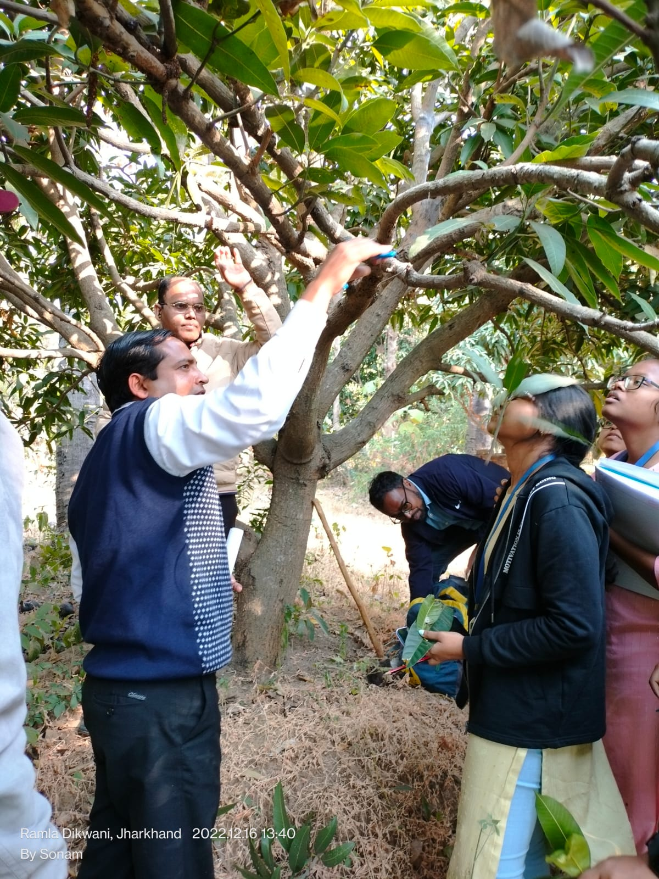

**4.1.1CANOPY MANAGEMENT IN MANGO**

1. **New Orchard:-**

* Heading back of plants when they attain the age of 1 year, done in October to December, at the height of 60 to 70 cm above the ground
* Heading back results in emergence of new shoot during march -april (spring season)
* Thinning of excessive shoot is done during May.lt should be done in such a manner as to retain for well distributed shoot in all directions these shoot developed as primary branches
* If the crotch angle of retained shoot a smaller than bending should be done at this stage to increase the crochea angle of newly developed shoots.
* 2nd cutting is done when they shoots accquire maturity which which is determined by the change in colour of the shoots from yellow to brown
* Second cutting of primary branches in is done in october-november this cutting also induces new growth during spring season again thinning of excessive should be done to ensure 2 to 3 shoots per primary branch.

1. **Bearing Mango Orchard:-**

* Identify a uprightly growing branches in each tree and thin them out for increasing the productivity
* Remove only 1-2 uprightly growing branches during October to December from the base of their origin, from the centre of the 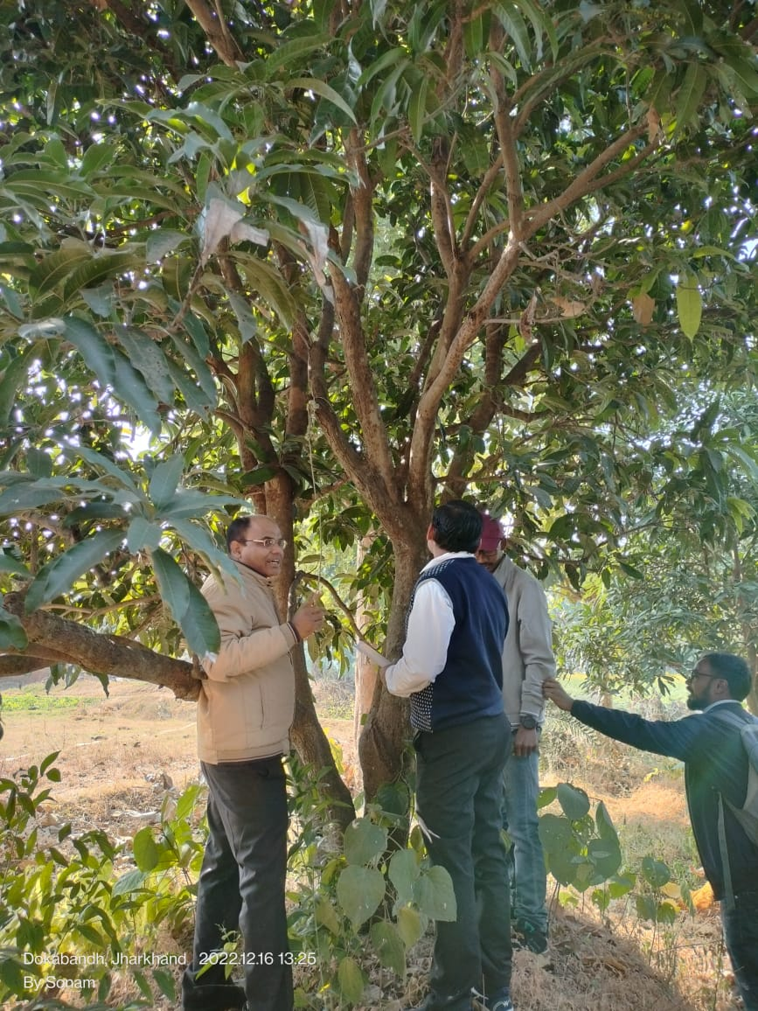

tree to reduce the tree height and

increase the sunlight availability inside

the canopy.

* Protect the branches with wide crotch

angle as they are more productive.

* In bearing mangoes not more than 25%

should be removed at the time of better

canopy management otherwise it results

in excessive vegetative growth.

* In high density planting system remove

10 to 15% of biomass annually during

October to December.

**(c) Rejuvenation Of Senile Orchard:-**

* Select unproductive branches and mark

them to cut.

* Mark those branches from height 2.0-2.5 m from the ground to be kept for future canopy development.
* Heading back should be done in nov - dec, to avoid bark splitting, in long branches, it can be done in two or more splits.
* Cut should be sharp and slant. It is important.
* In February, Application of 2.5 kg urea, 3 kg single superphosphate and 1.5 kg muriate of potash along with 120 kg FYM is recommended for each pruned tree.
* Basin irrigation is followed at an interval of 15 days from April to onset of monsoon.
* New shoot initiation on rejuvenated trees on April onwards.
* Thinning operation is followed in June, if required.
* If there are any symptoms of stem borer, grub, leaf cutting weevil, its management is required immediately.
* Unwanted emerging shoots are regularly removed to maintain the tree canopy and avoid overcrowding of the branches.
* Flowers (marigold, tuberose, gladiolus, etc.), vegetables (cucurbits, lobia etc. during kharif season and potato, pea, cauliflower, cabbage etc. during rabi season) and spices (ginger and turmeric) are ideal intercrops for mango orchards
* After two years of pruning new shoots come into bearing and the yield of fruit increases gradually.
* Thus, old and unproductive trees are converted in to productive ones.

**4.2) ALTERNATE BEARING AND MANAGEMENT**

Mango producing a good crop one year and no crop or fewer crops in the next year is known as biennial bearing or alternate bearing.

This is genetic and inherent in mango varieties.

**Causes for Alternate Bearing:**

1. Climatological factors: Rain, high humidity, low temperature making on to off year
2. Age and size of shoots: Shoots of 8-10 months maturity will be product
3. Carbon/Nitrogen ratio: High carbon/moderate N encourages flower bud formation (30-40)
4. Hormonal balance: Higher levels of auxin and inhibitor-like substances and lower levels of gibberellins like substances were found to be vital for a flowering shoot.
5. Management:
   1. Proper upkeep and maintenance of orchards
   2. Deblossoming in one year (NAA)
   3. Smudging and chemical regulation like application of paclobutrazol (10gm/tree), spraying 1-2% KNO3, 6-8% calcium nitrate, etc.
6. Pruning: Pruning the fruited shoots and opening tree top properly
7. Growing regular bearing cultivars: Bangalore, Rumani, Neelum and almost all hybrids.

By managing the above cultural operations alternate bearing can be managed in mango.

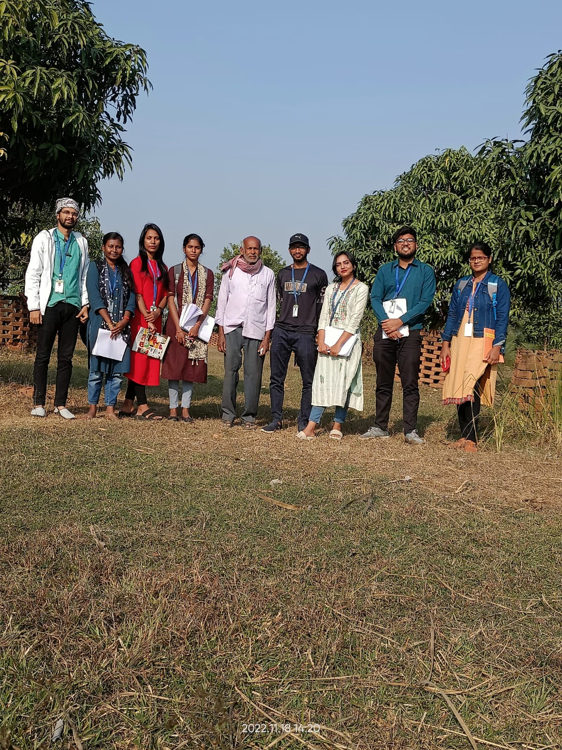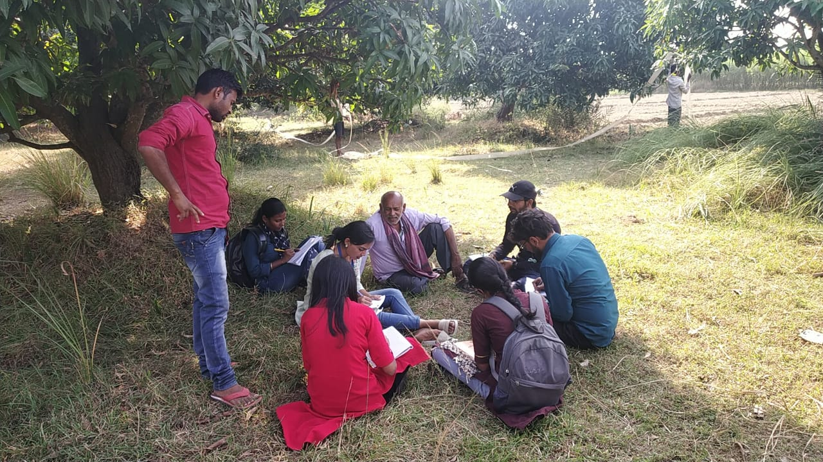

**4.3) HORTICULTURAL INTERVENTION (GROUP INTERVENTION)**

1.Name of the Student : Anamika Pandey

2. Name of Host farmer : Manohar Baidhya

3. Name of Village & district: Ramla Naukhil, Godda

4. Major horticultural crops of the village: Fruit- Mango; Vegetables- Potato

5. Land type : Upper land

6. Total area : 0.73 ha

7. Total area under Hort. Crops (in ha.) : 0.23 ha (Mango Orchard), 0.08 ha (Potato)

8. Soil type : Sandy loam

9. Crops information: Mango variety- Malda, Potato variety- Kufri Jyoti

10. **Irrigation:**

* Sources- Deep well
* Irrigated area (in ha.) – 0.73 ha
* Non- irrigated area (in ha.) – Nil

**Table: 4.1) Information on system of irrigation**

|  |  |  |  |  |
| --- | --- | --- | --- | --- |
| **System of irrigation** | **Area (In ha.)** | **Crop** | **Time of irrigation** | **Number of irrigation** |
| Flood irrigation |  |  |  |  |
| Ridge and furrow | 0.08 ha | Potato | 7-10 days interval | 4-5 times |
| Ring basin | 0.23 ha | Mango | Initial year-  15-20 days interval in winter  10 days interval in summer season | 5-10 times |

11. **Seed treatment**

* Seed treatment adopted: No

12. **Field Preparation**

* Layout and time of planting (month): Mango- July- August; Potato- October

**Table 4.2:**  **Information on Field Preparation**

|  |  |  |  |
| --- | --- | --- | --- |
| **Systems of planting** | **Crop** | **Spacing** | **Population** |
| Square system | Mango | 10 x 10 cm | 40 |
| Rectangular system |  |  |  |
| Hexagonal system |  |  |  |
| Contour farming |  |  |  |

**Table 4.3 : Information on problem identified on field preparation**

|  |  |  |  |
| --- | --- | --- | --- |
| **SI. No.** | **Problem identified** | **Farmers practices in field** | **Recommended**  **Suggestion to farmer** |
|  | Presence of weeds in field | Remove weeds where required | Use of pre-emergence weedicides to overcome the problem of weeds. |
|  | Mango cultivar- Malda | Use same old variety of mango, alternate bearing variety | Use of regular bearing mango variety such as Neelam. |
|  | Spacing in mango plantation | Traditional practice- use of 10 x10 spacing | Modern spacing of 5 x 5 cm in mango plantation |
|  | Occurrence of soil borne pathogen | Use of chemical spray and uprooting of potato before maturity | Proper cultural practices should be done before field practices |
|  | Monocropping | Use of single variety of crop and single crop in a year | Use of crop rotation and change of cultivar |

13. **Protected Cultivation:**

* + Any protected structure is adopted : NO
  + Area under protected cultivation (in ha.) : NA
  + Protected cultivation : NA
  + Cost of protected structure (Rs.) : NA
  + Subsidy provided by Govt. (Rs.) : NA
  + Crop taken in pc (season wise) : NA
  + Having knowledge on Fertigation : **No**
  + Is it profitable??? : NA
  + If its yes mention the sum : NA

14. **Nutrient management**

* Soil testing is done? No, due to lack of proper knowledge regarding soil testing.
* Green manuring is practiced? If No, then specify the reason : No, due to lack of knowledge about the incorporation of green manuring and its benefit.
* If yes, the name the green manuring crops: NA

**Table 4.4): Information on problem identified on nutrient management**

|  |  |  |  |
| --- | --- | --- | --- |
| **SI.**  **No.** | **Problem identified** | **Farmers Dosage to**  **crop** | **Recommended**  **Suggestion to Farmer** |
|  | Presence of weeds lead to nutrient loss while application |  | Removal of weeds under the canopy of tree and then apply nutrient |

1. **Weed control**

* Weeds known to farmer (Local name) : motha
* Number of manual weeding done : 1-2 times
* Time of weeding : After 15-20 days after sowing
* Tools used in weeding (if any local tools) : Hand weeding
* Weedicides used? : No
* Doses of weedicides : NA
* Purchased from (Govt./Private) : NA

## Vegetables:

Name of the crop: Potato

Total area cultivated: 0.08 ha

Status of production technology: Self- consumption

Irrigated area: 0.08 ha

**Crop Profile:**

**Table no. 4.5**

|  |  |  |  |  |  |  |  |
| --- | --- | --- | --- | --- | --- | --- | --- |
| **Sl.** | **Name of Vegetables** | **Varieties** | **Area under cultivation** | **Fertilizer dose** | **Yield** | **Normal yield** | **Yield gap**  **(%)** |
|  | Potato | Kufri Jyoti | 0.08 ha | DAP- 2.5 kg  Urea- 5 kg | 600-800 kg | 20,000 kg | 62.5% |

**Problems**

**Table no. :- 4.6**

|  |  |  |  |  |  |
| --- | --- | --- | --- | --- | --- |
| Sl. | Crops | Problem identification | Solution available | Solution Recommended | Activities  Proposed/Ext teaching method |
|  | Potato | Greening of potato tuber | ------ | Proper earthing up | On-farm problem identification |
|  | Potato | Common scab | Early harvesting | Use of disease free seed tuber and crop rotation | On- farm problem identification and solution recommended |
|  | Potato | Use of monocropping | --------- | Crop rotation | Awareness |

## 

## **Fruits:**

Name of the crops: Mango

Total area cultivated: 0.23 ha

Status of Production technology: Self- consumption

Irrigated area: 0.23 ha

Cropping Pattern: NA

**Crop Profile:**

**Table no. 4.7**

|  |  |  |  |  |  |  |  |
| --- | --- | --- | --- | --- | --- | --- | --- |
| **SI.no.** | **Name of Fruit** | **Varieties** | **Area under cultivation** | **Fertilizer dose** | **Yield** | **Normal yield** | **Yield Gap(%)** |
|  | Mango | Malda | 0.23 ha |  |  |  |  |

**Problems**

**Table no 4.8**

|  |  |  |  |  |
| --- | --- | --- | --- | --- |
| **S.No.** | **Problem Identification** | **Solution Available** | **Solution Recommended** | **Activities Proposed/ Ext. Teaching Method** |
|  | Falling of flower and fruits | Use of water | Use of fertilizer along with water | On- field problem identification and solution suggested |
|  | Falling of trees due to strong wind | No practice |  |  |

1. **Market Situation**

* Whether he/ she sells their own produce in the market: No.
* Distance of nearby vegetable market: 3 km
* Number of market/weeks: 1
* Position of the market: Outskirt of village, Godda
* Price of commodities are decided by (local union/ RMC/ Govt./ as per the demand in market or any other reason, specify) : Rs. 40-50/ kg during season
* Having knowledge on MSP (Yes/ No): No

**5) SOIL** **INTERVENTIONS**

**5.1) SOIL TESTING**

1. **Soil Testing Procedure:-**

* It's an essential procedure to know the nutrient content of the soil.
* We can calculate primary nutrients- N,P,K secondary nutrients like Ca, Mg, some ultra micronutrients Mo, B, soil moisture content, pH ,electrical conductivity.
* By knowing the actual nutrient content of soil we get to know how much fertilizer should be added to soil to make it easily available to plant .
* Number of samples depends upon the size of the farm.
* Generally we have to collect 5-6 samples for an area of 1 acre.

1. **Material Requirements**

* Spade
* Khurpi
* Chart paper
* Polybag
* Marker
* Rubber
* Soil

1. **PROCEDURE**

* Divide the field into small units based on visual experience (We took 3 units from 1 kattha to make one composite sample)
* Remove the surface litter at the sampling spot
* Drive the hoe to a plough depth of 15 cm.
* Make a ‘V’ shaped cut to a depth of 15 cm in the sampling spot using hoe.
* Remove thick slices (approx. 1 inch ) of soil from top to bottom of the exposed face of the ‘V’ shaped cut and place on clean white chat please.
* Collect the soil sample after mixing it with the hoe in the pit itself.
* Collect at least 3-4 samples from 1 kattha land to make one composite sample.6
* Repeat this process in different units and collect all the soil.
* Remove pebble stone, weed and other things.
* Mixing the soil throughout and spread on paper evenly
* Then divide the soil into 4 paths and remove the soil on the opposite side.
* Then mix the remaining soil then repeat the process again but this time discard the soil of alternate side and repeat this process until we get desirable amount of soil( 500- 600 gms)

1. **Tagging:-**

Take polybag and write detail of farmer

* Sample no.
* Name of farmer
* Date of collection
* Mobile no
* Name of crop
* Previous crop

put all the soil in bag and tie up with rubber band

1. **Precautions**

* Collect the soil in zig- zag manner to maintain homogeneity
* Do not collect the soil sample from bund or area nearby by bunds.
* Take sample 30 cm away from bunds
* Do not collect soil samples under stagnant water.
* Do not collect soil samples from the area where fertilizer application is done within 30 days .
* Avoid sampling in dead furrows, wet spots, areas near main bund, trees, manure heaps and irrigation channels.

1. **Point To Remember:-**

For shallow rooted crops, collect samples up to 15 cm depth. For deep rooted crops, collect samples up to 30 cm depth. For tree crops, collect profile samples from 3 points at 30cm, 60cm, 90cm .

1. **Processing And Storage**

* Collected soil taken out from the polybag and spent on cardboard to dry the soil.
* Remove all the roots , stones, pebbles, foreign material.
* Grind for further use by using a wooden container.
* If it is used to know soil nutrients content sieve it with 2mm sieve or if we use the soil to know organic matter it should be sieved with 0.2 mm sieve
* If we use soil to know content of N either in form of NO3, ,NH4 or bacteria count we should avoid Air drying
* If we use soil to know soil moisture of the soil then there must be estimated in un-dried sample or to be preserved in a sealed polythene bag immediately after collection.

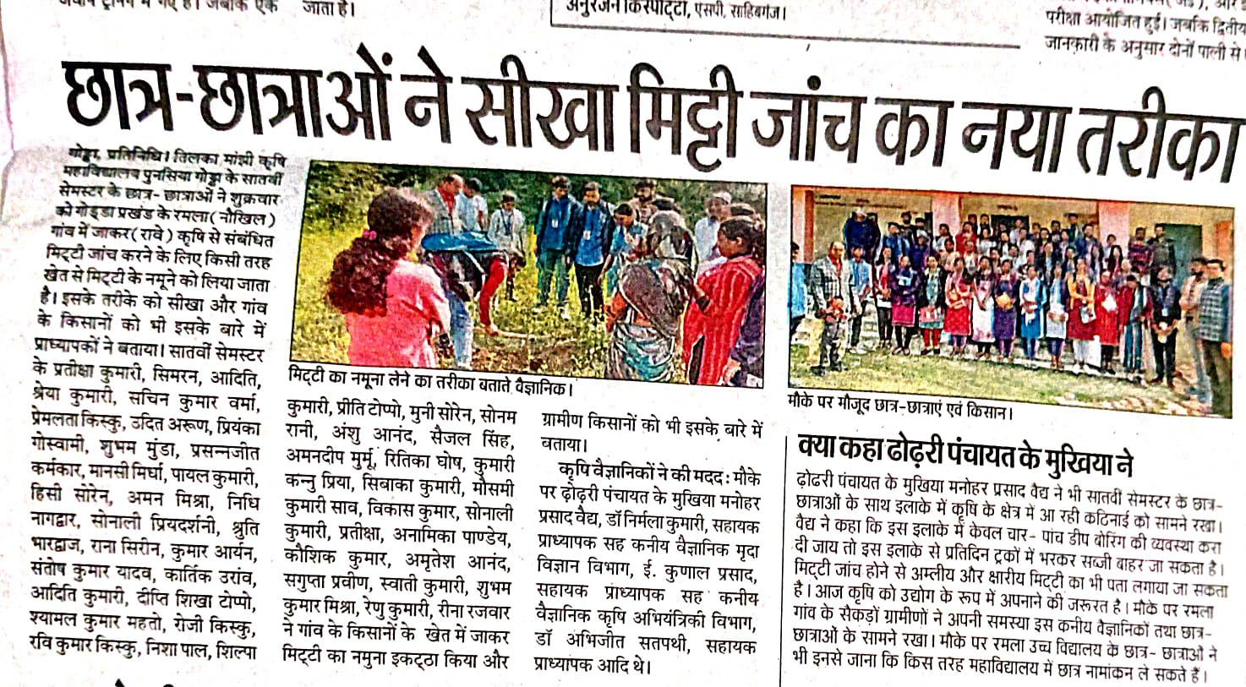

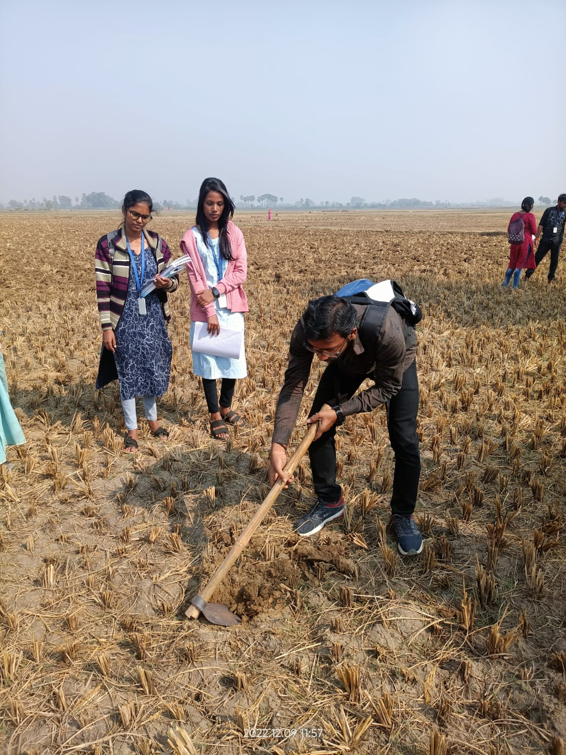 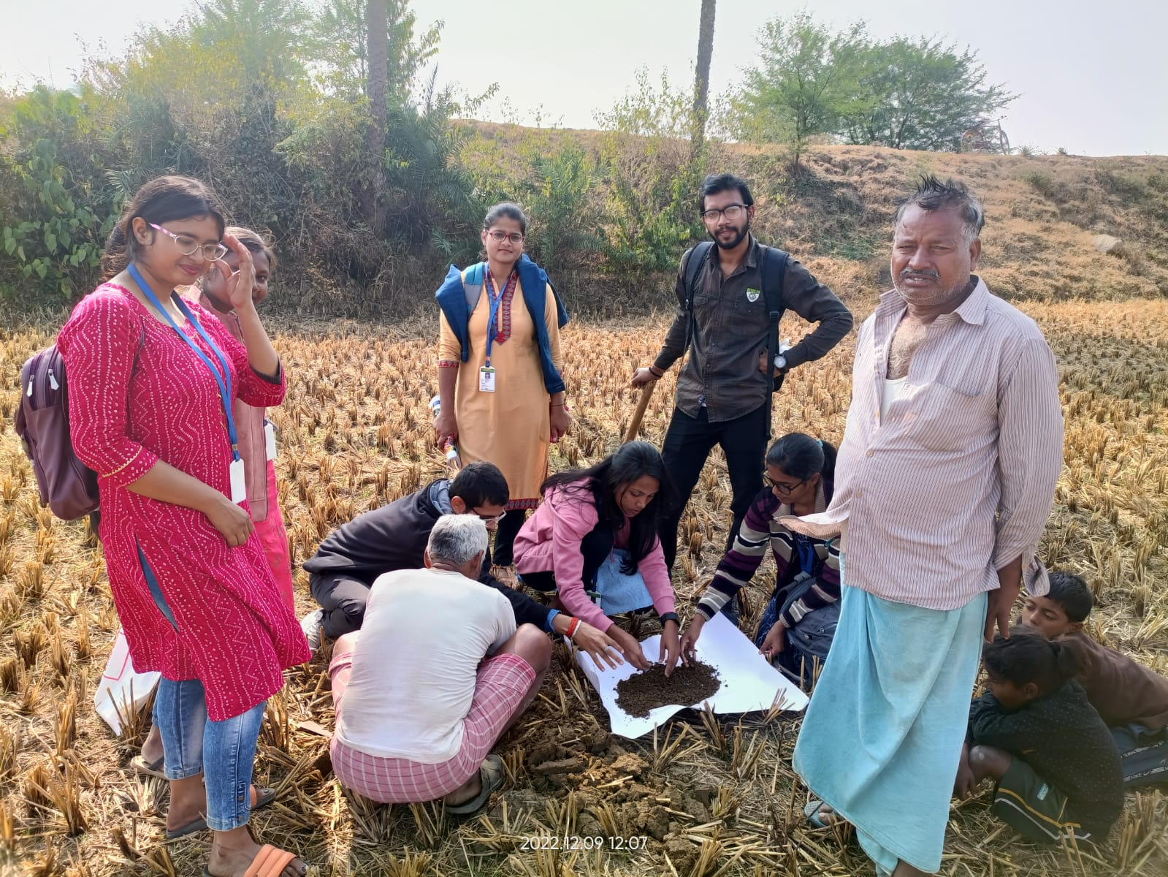

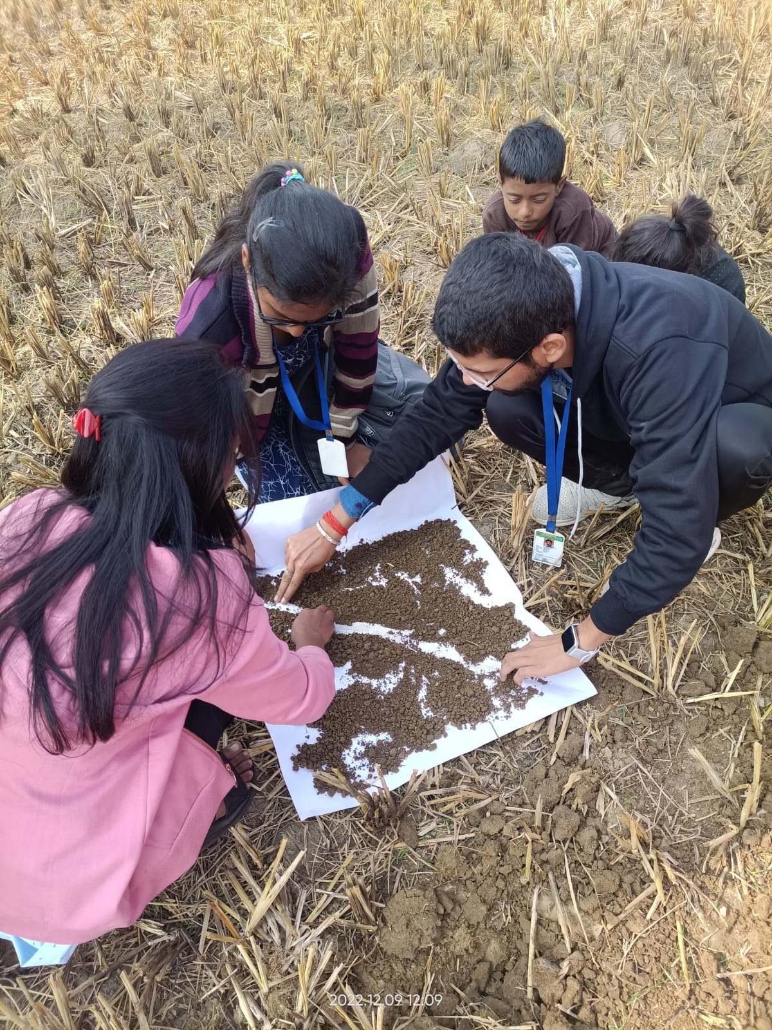

**6) PLANT PROTECTION INTERVENTION:-**

**6.A) Department of Entomology:-**

**6.A.1) Demonstration of Yellow Sticky trap:-**

1. **How does the sticky trap work?**

**Introduction:**-

Sticky traps are essential in the detection and partial elimination of many species of flying pests in greenhouses. Sticky traps make it possible to detect pests at an early stage and then use biological measures to combat them. This prevents unnecessary applications of chemicals. Moreover, counting the captured insects on the sticky traps on a regular basis makes clear when pests are present in the greenhouse, how fast their population is developing, and when their population is likely to reach its peak. In this way growers are much better prepared for potential threats.

1. **Materials required:**

* Plywood board or card board (1.5 ft X 1.0 ft size) or used empty oil tin (1 or 2 litre size)
* Yellow colour oil paint
* Glue or white grease
* Bamboo poles
* Wire or rope

1. **Procedure:**

* Take a new or used sheet of plywood board or hardboard or card board or empty oil tin (1 or 2 litre size).
* Paint it with Yellow colour oil paint.
* Allow it for drying. Apply grease or glue on the painted board.
* Erect these traps above crop canopy with the help of bamboo poles.

1. **Cleaning of traps:**

Clean the tin or plywood or hardwood traps by dipping into the hot water for couple of minutes to soften the sticky coating. Discard dead insects by using brush or duster. Dry the traps completely and recoat with similar glue for reinstallation. Cardbord traps should be discarded after use.

Benefits: Highly effective, non-toxic and easy to use.

**Farmers practice** :- Some farmers didn't do anything about the insects saying,they are not such a big problem while some farmers used Rogor without knowing the proper concentration to be used.

1. **Farmer's response on yellow sticky trap demonstration:-**

They were very happy to know that insects can be minimized without using any toxic chemicals.

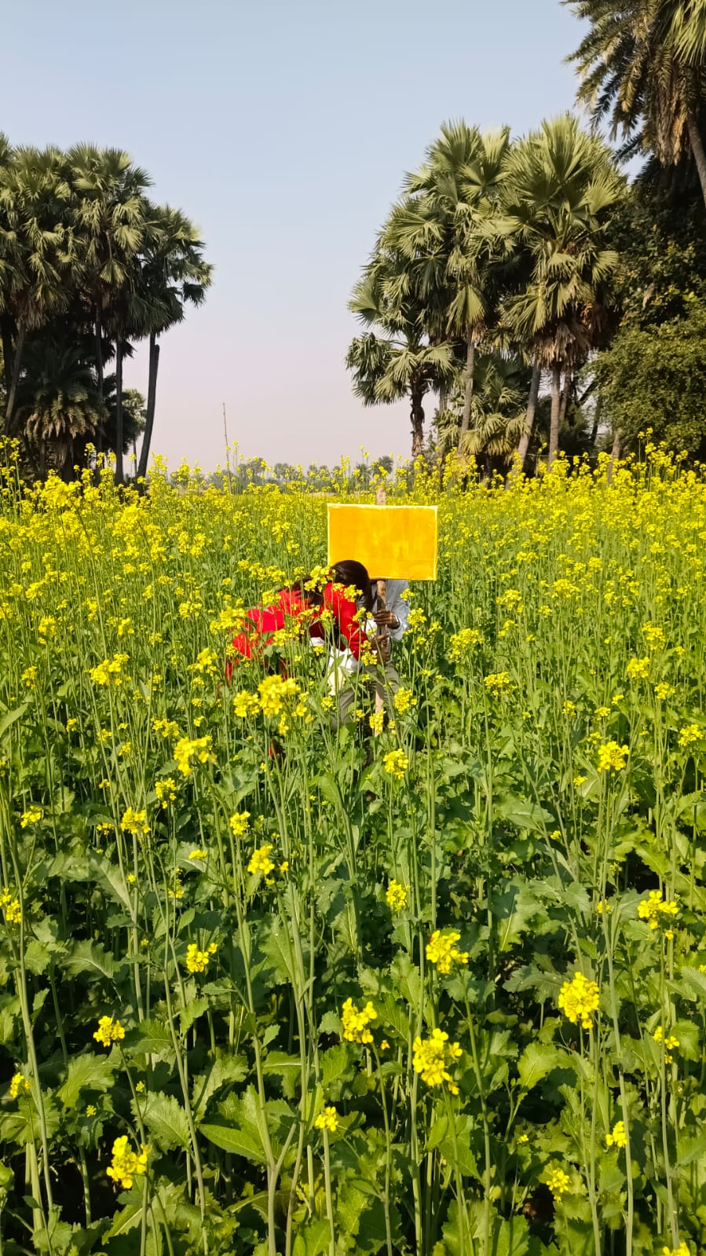 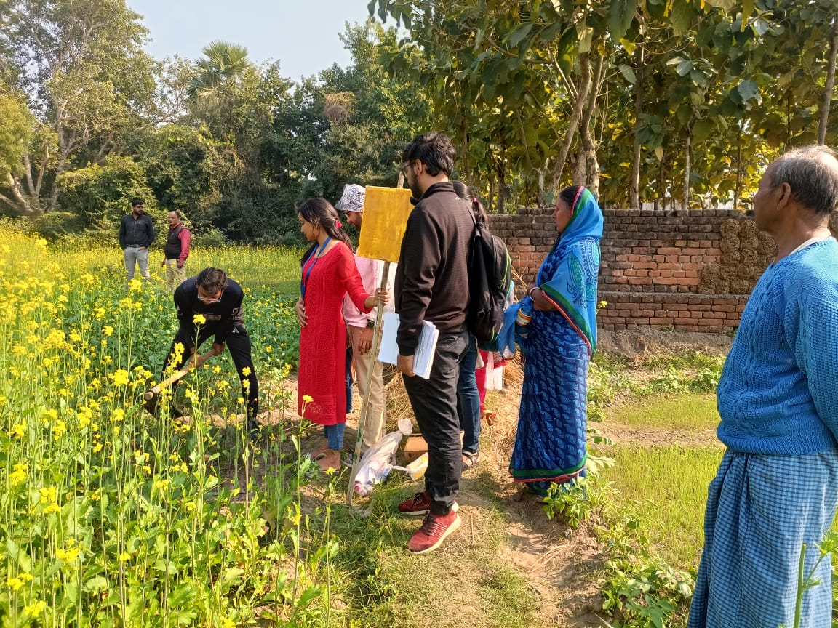

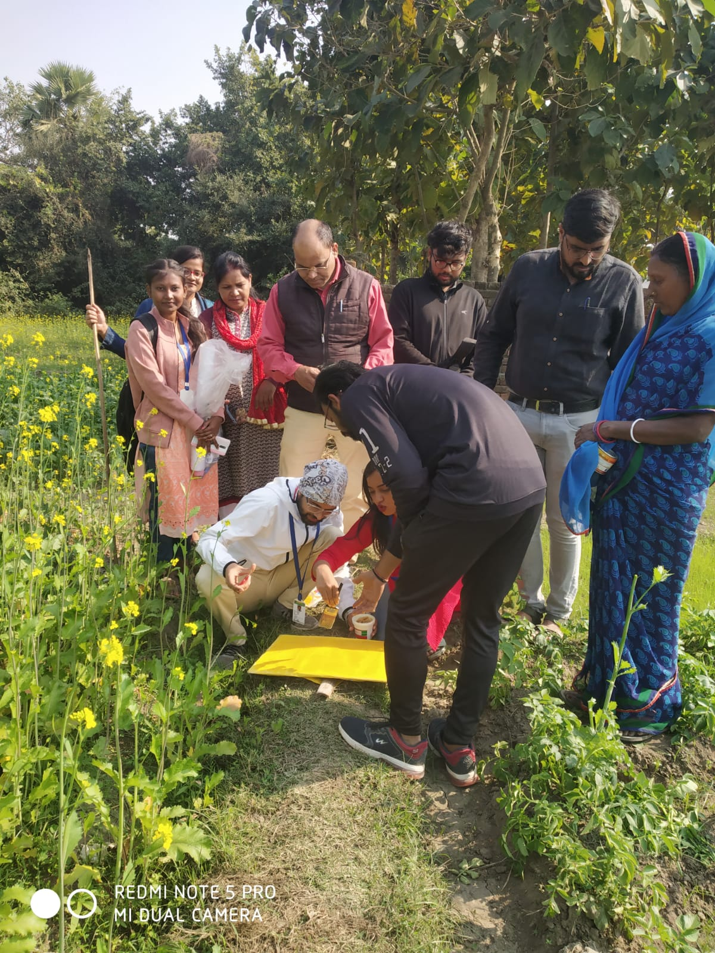 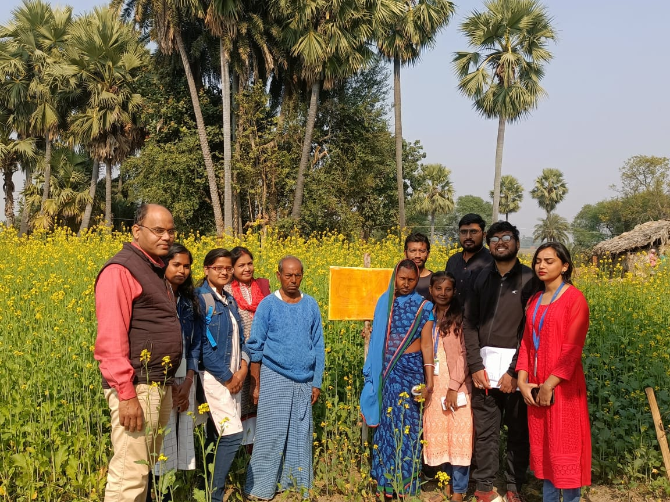

**6.A.2) Pheromone Trap:**

1. **Materials required:**

* Rubber septa (Pheromone lures), traps and pouches
* Polythene bags/ sheets
* Small piece of wire for suspending the lures
* Knife for opening the bottom
* Insect brush and scissor

1. **Methodology:**

* Cut the polythene sheets into required size (2ft. length X 4 inch wide) and make a polythene arm.
* Close the bottom end of the arm with a rubber band to prevent the escaping of trapped insects and to flush out them.
* Wrap and fit the other end of the polythene arm with the wider end of the funnel with the help of rubber band/wire.
* Keep the lid of the funnel one inch above the mouth of the funnel.
* Make a small hole to place septa/ lure.
* Fix the trap containing lure in the field with the help of bamboo sticks keeping the lure nearly one foot above the crop canopy.

1. **Field application:**

Lures containing sex pheromones are placed into insect trap and erected in the field at a recommended spacing. The lure will release the sex pheromone at a constant rate over a period of 2-4 weeks. Male moths are attracted and while attempting for mating, fall into a container having pesticide. Thus the female moths in the field are deprived of successful mates and fail to reproduce or lay viable eggs.

1. **Precautions while using pheromone trap:**

* Always label the trap with detailed information of the species to be trapped and the date of fixing the lure
* Change lure once in 15-20 days
* Dispose properly the lure wrappers/covers
* Wash hands before/after handling baits
* Remove all captured adults during each visit. Put live ones into a bucket with soap solution to drown.

**6.A.3) LIGHT TRAPS:-**

Pest attracted

Armyworm, bugs, cutworm, flies, gnats, bollworm, leafhoppers, planthoppers, stem borers

1. **Materials required:-**

Light trap, Plastic buckets 5-10 lts., Metal light shade (2 nos.), Fluorescent light with holder, Electrical wires Coated metal rods (4 nos.), Tin sheets, String/ flexible wire, Nut bolts & Screws, Rubber plug for drainage hole, Soap water or Kerosinized water.

1. **Methodology:-**

Take a bucket and make 4 holes at the top rim and one larger hole at the bottom rim. Adjust a small sized light shade on the bucket in the inverse direction. Fix four rods with screws/nuts with the bucket for holding up the large sized light shade. Fix the light source as shown in the figure. Hang the light trap on the large sized light shade. Drainage hole on the bucket should be kept closed by the rubber plug while filling it with soap water/kerosinized water. Collect/drain out trapped insects periodically.

1. **Procedure for installation**

* Install the light trap near or within the field where you want to trap the flying insects/
* Secure the poles firmly on the ground.
* Mount the lamp or the bulb on the frame, five meters from the ground-
* When using an electric bulb, make sure that the bulb and wiring are not in contact with water to avoid electric conduction.
* Place the shallow basin with soapy water or the jute sack underneath the light.
* Put the light trap from early evening 6:00 PM to 10:00 PM
* Collect the trapped insects daily and dispose of them properly.

1. **Precautions:-**

* don't place the trap too high above the floor (higher than 6 feet).
* don't mount units where natural light from outside can compete with the light from the insect light trap.

## 

## **6.A.4) Crop wise information:**

1. Name of Crop: Mustard

Table no.:- 6.A.1

|  |  |  |  |  |  |
| --- | --- | --- | --- | --- | --- |
| SI. | Common Name of  Pests | Local  Name | Scientific  Name | Stage of  damage | Intensity of pest  damage (%) |
| 1 | Mustard Aphid |  | *Lipaphis erysimi* | Nymphs & Adults |  |

## **Control measures adopted:**

Table no.:-6.A.2

|  |  |  |  |  |  |
| --- | --- | --- | --- | --- | --- |
| SI. | Name of  insects | Damage symptoms | Traditional practices  (ITK) | Modern practices (Cultural/Mechanical/Chemical) | Recommended practices |
| 1 | Mustard Aphid | Nymphs & adults feed  on flower buds, shoots,  pods.  Flowers don’t form pods. | Use of Kerosene oil. | Cultural control- early sowing; apply  recommended dose of  fertilizer.  Mechanical control- Use of Pheromonetraps , yellow sticky traps.  Chemical control- spray 1L Dimethoate per ha. | Use of Neem oil.  Early sowing escapes the attack.  Set up a yellow sticky trap.  Use of natural enemies like ladybird beetles ( *Coccinella septempunctata).* |

1. Commonly available insecticides in the village / local market (Trade and chemical name):

Trade name- Rogor

Chemical name- Dimethoate

1. Precautions observed while using insecticides :

Avoid direct contact with hands.

Always apply insecticide in the recommended dose.

1. Method of calibration of machines (sprayer / duster): Knapsack Sprayer

## **Suggestion for proper storage of food grains**

**Table no. :- 6.A.3**

|  |  |  |  |  |
| --- | --- | --- | --- | --- |
| SL. | Name of Food grain | Storage  structure | Moisture content | Fungicide/fumigant  treatment with dose |
| 1 | Rice | Bamboo matting, Wooden crates | 14% | Fumigation with aluminum phosphide @ 3 tablets/ tonne |
| 2 | Mustard | Plastic sac | 9% | Minifume (Ethylene dibromide tablet) @ 1 tablet/ q |

**Problems in storage of food grains and recommendations:**

**Problems-**

* New stocks are stored with old stocks.
* Improper ventilation.

**Recommendations –**

* Material should be clean & dried.
* Sun drying & cleaning.
* Provide dunnage of bamboo poles or bamboo matting or wooden crates to make bags damp proof.

**6.B) Department of Plant Pathology :-**

**6.B.1) SEED TREATMENT:**-

1. **Introduction**

Seed treatment refers to the application of fungicide, insecticide, or a combination of both, to seeds so as to disinfect and disinfect them from seed-borne or soil-borne pathogenic organisms and storage insects. It also refers to the subjecting of seeds to solar energy exposure, immersion in conditioned water, etc. The seed treatment is done to achieve the following benefits.

1. **Benefits of Seed Treatment:**

1) Prevents spread of plant diseases

2) Protects seed from seed rot and seedling blights

3) Improves germination

4) Provides protection from storage insects

5) Controls soil insects.

1. **Chemical method of seed treatment;-**

Using fungicides on seed is one of the most efficient and economical methods of chemical disease control.

Now, the systemic fungicides are impregnated into the seeds to eliminate the deep seated infection in the seeds. The seed dressing chemicals may be applied by (i) Dry treatment (ii) Wet treatment and (iii) Slurry.

**(c.i) Dry Seed Treatment:-**

In this method, the fungicide adheres in a fine form on the surface of the seeds. A calculated quantity of fungicide is applied and mixed with seed. The fungicides may be treated with the seeds of small lots using a simple rotary seed dresser (seed treating drum) or of large seed lots at seed processing plants using Grain treating machines. The dry dressing method is also used in pulses, cotton and oil seeds with the antagonistic fungus like *Trichoderma viridae by* mixing the formulation at the rate of 4 g/kg of the seed e.g. dry seed treatment in paddy. Mix a required amount of fungicide with required quantity of seeds in a seed treating drum, lined with gunny bags, so as to provide uniform coating of the fungicide over the seeds. Treat the seeds at least 24 hours prior to soaking for sprouting. Any one of the following chemical may be used for treatment at the rate of 2 g/kg Thiram or Captan

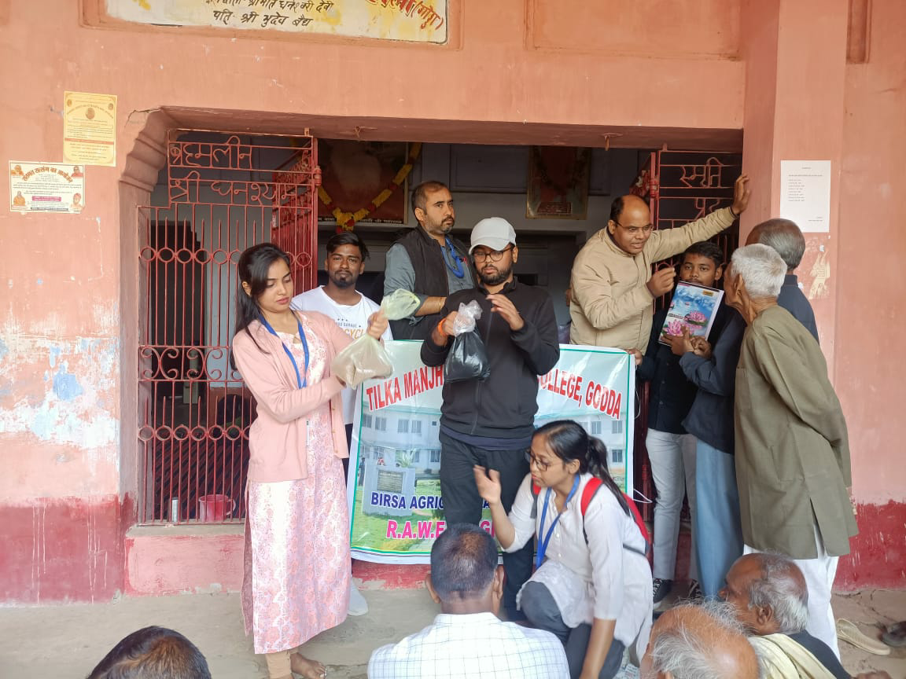

Tricyclazole

1. **The demonstration:-**

10 kg of linseed was taken in 10 different bags containing 1 kg of linseed each. One bag was picked and 2 g of thiram was added into the bag using gloves. The bag was shaken well so that it could get mixed thoroughly and a thin layer of fungicide was formed around the seeds. While shaking, the mouth of bags must be held tightly so that the chemicals do not escape. Then the bags were handed over to the farmers. We told them to leave it for 24 hours and then sow it immediately in the fields.

1. **Farmer's response :-**  they did not follow any such activities so, after hearing this they were quite willing to adapt to this method. Also, some farmers started writing down the name of the chemicals used in seed treatment along with the dosage.

**(c.ii) Wet seed treatment:**

* **Rhizome dip:**The rhizomes of cardamom, ginger and turmeric are treated with 0.1% emisan solution for 20 minutes to eliminate rot causing pathogen present in the soil.
* **Set dip/Sucker dip:**The sets of sugarcane are dipped in 0.1% emisan solution for 30 minutes. The suckers of pineapple may also be treated by this method to protect from soil borne diseases.

**c. iii) Slurry treatment (Seed pelleting):**

In this method, chemical is applied in the form of a thin paste (active material is dissolved in small quantity of water). The required quantity of the fungicide slurry is mixed with the specified quantity of the seed so that during the process of treatment slurry gets deposited on the surface of seeds in the form of a thin paste which later dries up Mix 2.5 g of carbendazim in 40 ml of water and add 0.5 g of gum to the fungicidal solution. Add 2 kg of seeds to this solution and mix thoroughly to ensure uniform coating of the fungicide over the seed. Dry the seeds under the shade.Treat the seeds 24 hrs prior to sowing

**Farmers Response:-**  Farmers were mostly interested in dry seed treatment and the response was lukewarm towards these methods.

**6.B.2) FUNGICIDE:-**

1. **Introduction:-**

The word “fungicide” originated from two latin words, viz., “fungus” and “caedo”.

The word “caedo” means to kill. Thus the fungicide is any agency/chemical which has the ability to kill the fungus.

1. **Based On Mode Of Action**  1) Protectant 2) Therapeutant 3) Eradicant

1) Protectant :-

* Protectant fungicides are prophylactic in their behaviour.
* Fungicide which is effective only if applied prior to fungal infection is called a protectant.
* eg., Zineb, Sulphur.

2) Therapeutant :-

* Fungicide which is capable of eradicating a fungus after it has caused infection and thereby curing the plant is called chemotherapeutant.
* eg. Carboxin, Oxycarboxin, antibiotics like Aureofungin. Usually chemo therapeutant are systemic in their action and affect the deep-seated infection.

3) Eradicant :-

* those which remove pathogenic fungi from an infection court (area of the host around a propagating unit of a fungus in which infection could possibly occur).
* E.g. Organic mercurials, lime sulphur, dodine etc. These chemicals eradicate the dormant or active pathogen from the host. They can remain effective on or in the host for some time.

1. **Based on general uses:-**

The fungicides can also be classified based on the nature of their use in managing the diseases.

1. Seed protectants : Eg. Captan, thiram, organomercuries, carbendazim, carboxin etc.

2. Soil fungicides (preplant) : Eg. Bordeaux mixture, copper oxychloride, Chloropicrin, Formaldehyde Vapam, etc.

3. Soil fungicides : Eg. Bordeaux mixture, copper oxy (for growing plants) chloride, Capton, PCNB, thiram etc.

4. Foliage and blossom : Eg. Capton, ferbam, zineb, protectants mancozeb, chlorothalonil etc.

5. Fruit protectants : Eg. Captan, maneb, carbendazim, mancozeb etc.

6. Eradicants : Eg, lime sulphur, etc.

7. Tree wound dressers : Eg. Bordeaux paste, etc.

8. Antibiotics : Eg. Actidione, Griseofulvin, Streptomycin, Streptocycline, etc.,

9. General purpose spray and dust formulations.

1. **Fungicides and its mode of application, its uses, precautions, and calculation of dose:-**

SAAF FUNGICIDE (CARBENDAZIM 12% + MANCOZEB 63% WP), CONTROLS ANTHRACNOSE, POWDERY MILDEW AND RUST DISEASE

Saaf is a fungicide with systemic & contact action. It is very effective in controlling fungus in plants as it contains Mancozeb which is contact fungicide and it also contains Carbendazim which is systemic fungicide.

**Application Method -** UPL Saaf Fungicide can be used in Foliar spray and also in Seed treatment.

1. **Precaution:**

* Always use clean water.
* Use protective clothings viz., hand gloves, face masks, cap, apron, full trouser, etc. to cover the whole body.
* Always protect your nose, eyes, ears, hands, etc. …
* Read instructions on pesticide container label carefully before use.

1. **Calculation of dose:-**

300-400 gm/0.4ha

Thus For 0.0642 ha=350×0.0642/0.4=56.18gm for 4.2 katha land.

For 0.043 ha= 350*0.043/0 .4 =37.6gm for 2.8 kattha land

**FARMER RESPONSE**: Farmer were so enthusiastic to see that they don't have to spend so much to buy fungicides.

1. **PRECAUTIONS WHILE USING FUNGICIDES:-**

* Treated seed should be clearly labelled as being dangerous, if consumed.
* Care must also be taken to treat seed at the correct dosage rate; applying too much or too little material can be as damaging as never treating at all.
* Seed with a very high moisture content is very susceptible to injury when treated with some of the concentrated liquid products.
* Apply fungicides prior to the development of disease
* Follow label directions carefully. Avoid splashing, spilling, leaks, spray drift, and contamination of clothing. NEVER eat, smoke, drink, or chew while using pesticides

## 6.B.3) **Crop Disease Profile**

Table 6.B.1

## 

|  |  |  |  |  |  |  |
| --- | --- | --- | --- | --- | --- | --- |
| **Sl** | **Crop** | **Disease** | **Symptoms** | **Farmers**  **Practice** | **Recommendations** | **IDM** |
| **1.** | **Mustard** | **Alternaria blight** | **-Small circular brown necrotic spots at lower surface of older leaves.**  **-Sposts enlarge & forms concentric rings, coalesce to cover large patches giving blighted appearance.** | **- 10 ml of SAAF in 20 litre of water.** | **- early sowing and deep ploughing.**  **-Weeding and maintenance of opt. plant population.** | **Cultural:**  **-Avoid irrigation at flowering & pod formation stages.**  **-Deep summer ploughing to expose microsclerotia & chlamydospore.**  **-collect and burn the infected plant after harvesting.**  **Physical: Hot water treatment at 50˚c for 20 min.**  **Chemical: -Seed treatment with Captan /Thiram @2g/kg seed.**  **-Zineb/COC @2.5g/lit water as soon as symptoms appear.** |
| **2.** | **Wheat** |  | **-in affected spikelets ears transformed into black powdery masses consisting of smut pores, packed under a thin membrane.**  **-infected heads are shorter, the rest plant is slightly taller than healthy plant.** | **-Nothing** | **-hot water treatment-soaking the seed in cold water for 4 hrs followed by dipping in hot water at 54-56˚c for 10 min** | **Cultural:**  **-roguing of infected plant**  **- Resistant variety Kalyan sona, PV18**  **Physical: -Hot water treatment at 50˚c for 20 min.**  **-solar heat treatment -seeds are soaked in water for 4 hrs & then spread in thin layer under blazing sun,when temp. rises 50˚c .**  **Chemical: -Seed treatment with vitavax or benlate @2-2.5 g/kg seed.** |
| **3.** | **Potato** | **Common scab** | **-small brownish, slightly raised spots on tuber coalesce & become corky.**  **-raised margin & slightly depressed centre.** | **-Nothing** | **-crop rotation with non host plant (for 4 years)**  **-use acidic fertilizer like Calcium ammonium nitrate** | **-Cultural: crop rotation with non host plant (wheat,legumes )**  **-crop manuring with green gram or sunhemp in kharif.**  **-Chemical: use acidic fertilizer like CAN**  **-hold PH at about 5.3 by adding sulphur** |

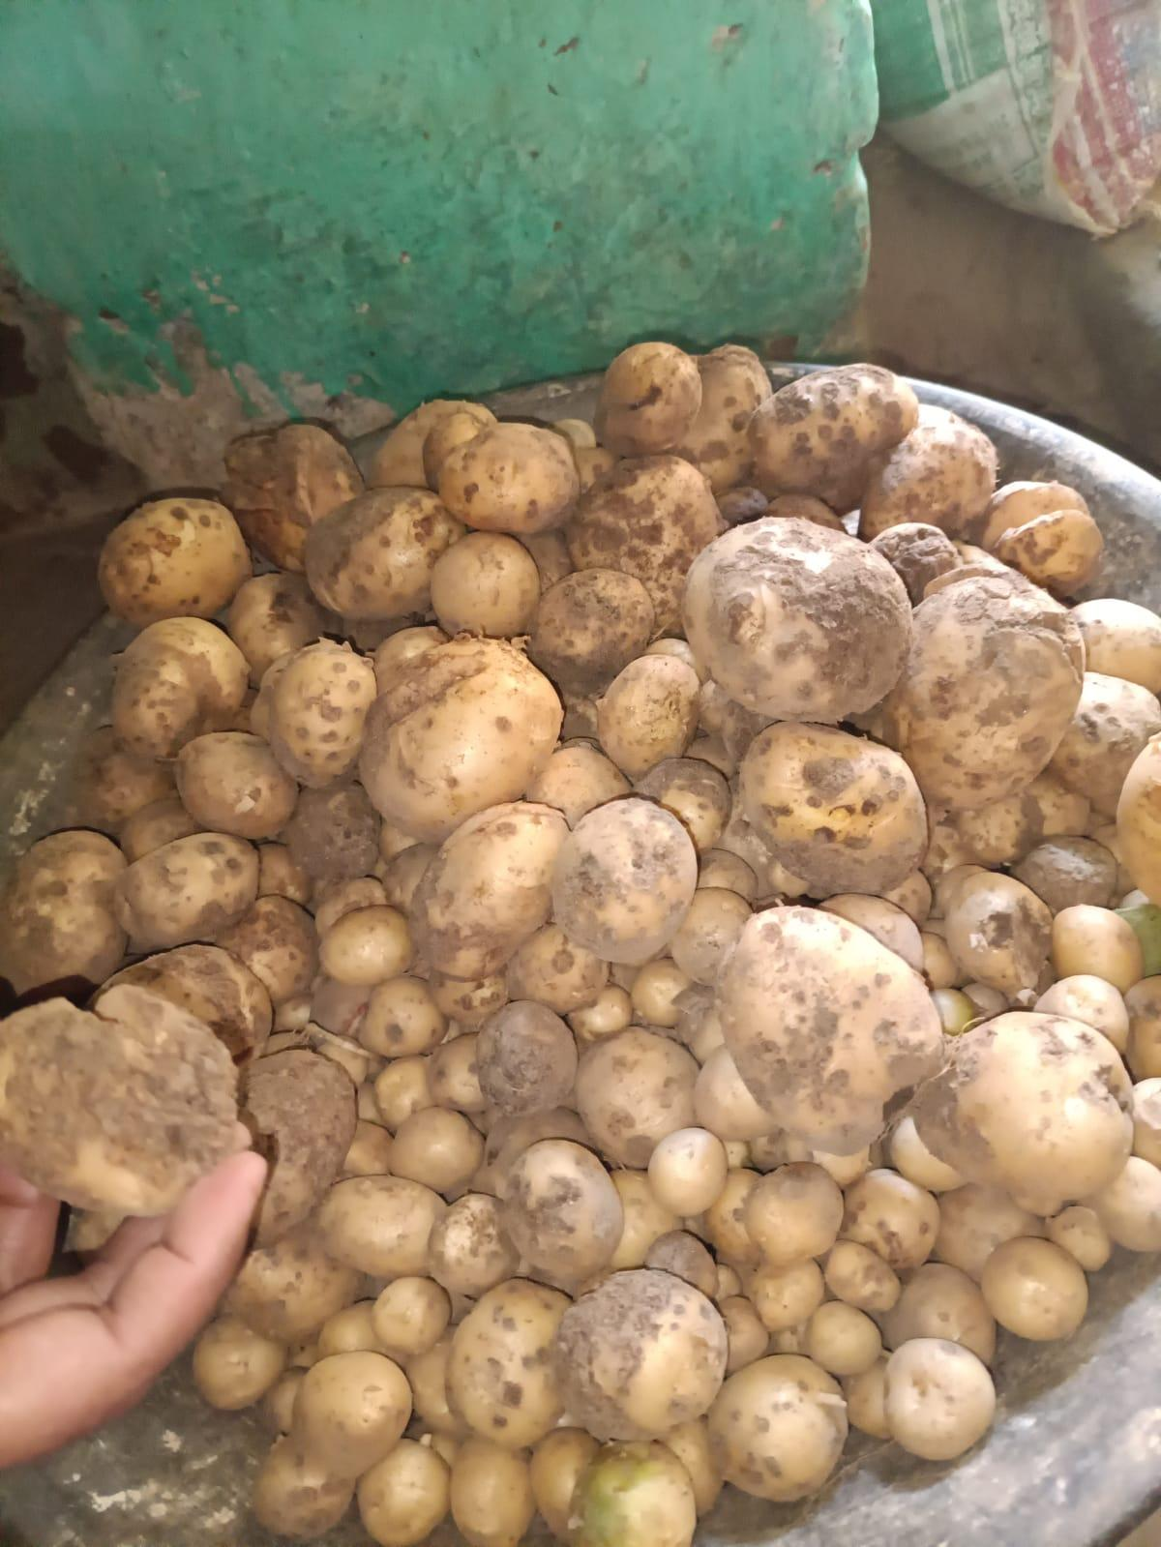

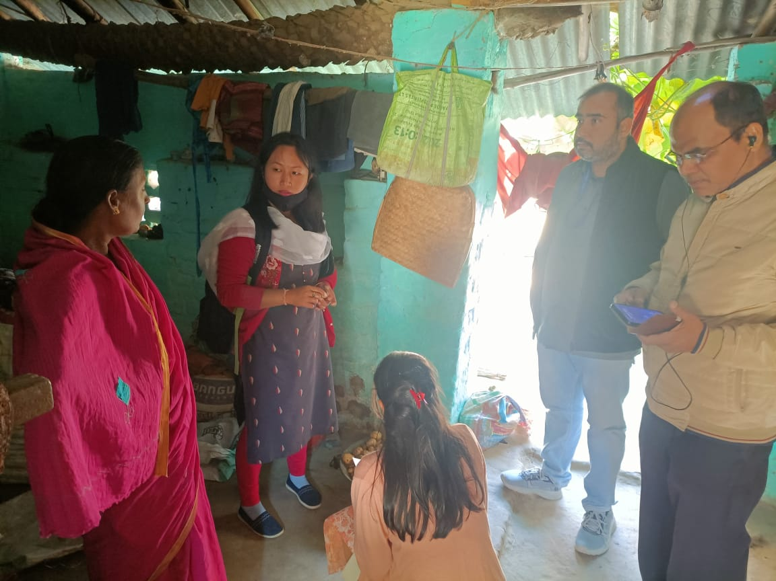

**Recommendation**

**Common Scab of Potato**

**7) AGRICULTURAL ENGINEERING**

**ASSESSMENT OF FARM MECHANIZATION STATUS IN INDIA**

**Farmers Information**

**Name of the surveying Institute/ Agricultural University/Station**

**Table 7.1)**

|  |  |  |  |  |  |  |
| --- | --- | --- | --- | --- | --- | --- |
| **1** | **General Information** | | | | | |
| i) | Name of Village, Block, District | | Ramla Naukhil, Dondhri, Godda | | | |
| ii) | Name of farmer | | Sintu Kumar | | | |
| iii) | Mobile No./E-mail | | 9297803039 | | | |
| iv) | Number of family members (Male + Female) | | 4 | | | |
| v) | Number of agricultural  workers in family | Male | 2 | | | |
| Female | 2 | | | |
| vi) | Land holding, ha | | Owned | 0.107 | Leased |  |
| vii) | Crops grown | | Wheat, Mustard | | | |
| viii  ) | Income, Rs | |  | | | |

**Table 7.2)**

|  |  |  |  |  |  |  |  |
| --- | --- | --- | --- | --- | --- | --- | --- |
| **2** | **Farm tools and equipment in use** | | | | | | |
| **S.N.** | **Operation** | **Name of equipment in use** | **Owned**  **/ leased** | **Power source and size** | **CostRs.** | **Custom hiring rates**  **(Rs/h)** | **Field capacity ha/h or kg/h** |
| **A** |  | **Crop (** | Wheat | **)** |  |  |  |
| **1.** | **Tillage/ seedbed**  **preparation** | i)Tractor | Leased | Diesel, 30hp | Rs. 600 | Rs. 1000 | 0.312 |
| ii) |  |  |  |  |  |
| **2.** | **Sowing/Planting/**  **Transplanting** | i)Manual | - | - | - | - | - |
| ii)manual | - | - | - | - | - |
| **3.** | **Interculture** | i)manual | - | - | - | - | - |
| ii)manual | - | - | - | - | - |
| **4.** | **Plant protection** | i)manual | - | - | - | - | - |
| ii)manual | - | - | - | - | - |
| **5.** | **Harvesting** | i)manual | - | - | - | - | - |
| ii)manual | - | - | - | - | - |
| **6.** | **Threshing** | i)Theresher | Leased | Diesel | Rs. 462 | 15kg/q | 300.4 kg/b |
| ii) |  |  |  |  |  |

**Table no.:- 7.3)**

|  |  |  |  |  |  |  |  |
| --- | --- | --- | --- | --- | --- | --- | --- |
| **B** |  | **Crop (** | Mustard | **)** |  |  |  |
| **1.** | **Tillage/ seedbed**  **preparation** | i)Tractor | Leased | Diesel, 30hp | Rs. 400 | Rs. 1000 | 0.323ha/hr |
| ii) |  |  |  |  |  |
| **2.** | **Sowing/Planting/**  **Transplanting** | i) |  |  |  |  |  |
| ii)- | - | - | - | - | - |
| **3.** | **Interculture** | i)- | - | - | - | - | - |
| ii)- | - | - | - | - | - |
| **4.** | **Plant protection** | i)- | - | - | - | - | - |
| ii)- | - | - | - | - | - |
| **5.** | **Harvesting** | i)- | - | - | - | - | - |
| ii)- | - | - | - | - | - |
| **6.** | **Threshing** | i)manually | - | - | - | - | - |
| ii)- | - | - | - | - | - |

------------------ ------------- ------------------------------------------------------------------------------------

Name date (name, designation, mobile no., sign of surveyor)

**8. Animal Husbandry Intervention**

1. **INTRODUCTION**

Livestock plays an important role in the village economy. Livestock contributed 16% to the income of small farm households. Livestock provides not only food for their producers,but also a range of other products which could be sold or consumed by the livestock owner to provide income, nutrition and fuel. The major products of livestock include meat , milk ,egg, manure which is used as fertilizer or fuel ,fiber .In addition to these products livestock serve as an asset and may provide a reserve that can be converted to cash in times of need.

1. **Objective:-**

* Information on available LIVESTOCK & POULTRY resources ,their role in AGRICULTURE(IFS) economic importance including women empowerment.
* To be acquainted with the available animal feed resources (conventional & unconventional), fodder production ,availability of grass and grassland ,existing farmers’ practices of feeding to animals & poultry.

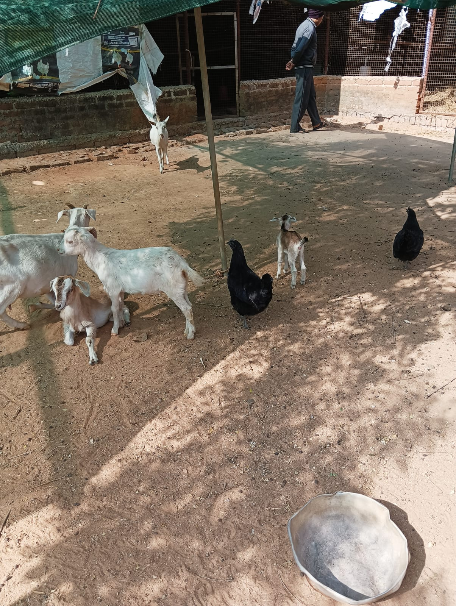

**Schedule for collection of Basic Data on Livestock**

**General Information**

**To be collected from knowledgeable person i.e. village/ward head man/local school teachers, Veterinary Doctors, AI workers etc. (secondary data)**

Name of Student :- Anamika Pandey. Date of Survey :-

i) Block Name:- Godda. ii) District :- Godda

iii) Name of respondent :-

iv) Village :- Ramla Nokhil

**Particulars of the selected village**

i) Total number of households as per the latest Population Census:- 500

ii) Total human population:- 1800

iii) Net geographical area of the village (hectares):- 220 hectare

iv) Total cultivated area (hectares):- 82 hectare

**Table no. :- 8.1**

|  |  |  |  |
| --- | --- | --- | --- |
|  | **Cultivated area** | **Current year** | **Last year** |
| (a) | Irrigated | **26** | **26** |
| (b) | Unirrigated | **56** |  |

v) Area under fodder crops (hectares):- 0.75 hectare

vi) Average production of Fodder per Hectare (In Tons):- 37.5 tonn/hectare

vii) Area under permanent pasture and other grazing land (hectares):- 4 hectare

viii) Location and distance to the nearest veterinary services facilities:- 1 km from Ramla Nokhil

**Table no. -8.2**

|  |  |  |  |  |
| --- | --- | --- | --- | --- |
|  | **Veterinary/Animal Husbandry Services** | | **Location** | **Distance from**  **Village/Town (km)** |
| (a) | A.I. Centre /Semen Collection centre | | **NIL** | **NIL** |
| (b) | Veterinary Hospital /Dispensary | | **Ramla** | **1km** |
| (c) | Markets for | |  |  |
|  | (i) | Purchase of Cattle feed / Poultry feed | **Godda** |  |
|  | (ii) | Sale and purchase of livestock products | **Godda** |  |

ix) Is the village/Urban ward covered under any of the following development programme:

**Table no. - 8.3**

|  |  |  |
| --- | --- | --- |
| **Sl. No.** | **Name of the Development Programme** | **Yes/No** |
| (a) | National Project for Bovine Breeding and Dairy Development (NPBBDD) | **No** |
| (b) | Poultry Development Project | **No** |
| (c) | Piggery Development | **No** |
| (d) | Sheep and Wool Extension Centre | **No** |
| (e) | Milk Collection Centre | **No** |
| (f) | Feed and Fodder Development | **No** |
| (g) | Special Livestock Breeding Project | **No** |
| (h) | Any Other Development Program (specify) | **No** |

x) Any outbreak of disease of Livestock / Poultry during the last five years

**Table no.:- 8.4**

|  |  |  |  |  |  |  |  |
| --- | --- | --- | --- | --- | --- | --- | --- |
| **Name of the disease** | **Particulars** | **Cattle**  FMD | **Buffalo**  Anthrax | **Sheep** | **Goat**  Pox | **Pig** | **Poultry**  Ranikhet |
| **1** | **2** | **3** | **4** | **5** | **6** | **7** | **8** |
|  | a. Number of animals affected | 20 | 12 | 0 | 15 | 0 | 250 |
|  | b. Number of animals died | 8 | 2 | 0 | 5 | 0 | 50 |
|  | Number of prophylactic  vaccinations made* | 1 | 0 | 0 | 0 | 0 |  |

**Table no. - 8.5 Livestock and Poultry population**

|  |  |  |  |  |  |  |  |
| --- | --- | --- | --- | --- | --- | --- | --- |
| **Classification** | | **As per**  **Census/**  **Breed**  **Survey** | **As per**  **Survey**  **present** | **Classification** | | **As per**  **Census**  **/Breed**  **Survey** | **As per**  **Survey**  **present** |
| **1** | | **2** | **3** | **1** | | **2** | **3** |
| **CATTLE** | |  |  | **BUFFALOES** | |  |  |
| **A. Exotic Cattle\*** | | 5 |  | **A. Indigenous Buffaloes** | | 80 |  |
| **B. Crossbred Cattle** | | 10 |  | **B. Non-Descript Buffaloes** | | _ |  |
| **C. Indigenous Cattle** | | 40 |  | **Total Buffaloes** | | 80 |  |
| SHEEP | |  |  | **A. Exotic/ Crossbred Sheep** | |  |  |
|  | |  |  | **B. Indigenous/Non-Descript Sheep** | |  |  |
| **D. Non-Descript Cattle** | |  |  | **Total Sheep** | |  |  |
| **GOAT** | | 50 |  | **Total Goat** | | 50 |  |
| **Total Cattles** | | 55 |  | **PIGS** | |  |  |
| **HORSES/ PONIES** | |  |  | **Total Pigs** | |  |  |
| **BACKYARD POULTRY** | |  |  | **OTHER LIVESTOCK (Specify)** | |  |  |
| **A. Fowls** | |  |  |  | |  |  |
| i) | Desi |  |  |  |  |  |  |
| ii) | improved |  |  |  |  |  |  |
| **iii)** | **Total Fowls** |  |  |  |  |  |  |
| **B. Ducks** | |  |  |  |  |  |  |
| i) | Desi |  |  |  |  |  |  |
| ii) | improved |  |  |  |  |  |  |
| **iii)** | **Total Fowls** | 200 |  |  |  |  |  |
| **Total Poultry** | |  |  |  |  |  |  |

1. **Economic Benefits Of Livestock**

* Income generation-Livestock rearing not only provide nutritional household security to rural families but extra family income also.
* Cattle dung which is widely used as organic manure which is environmentally safe for cultivation.
* Can be used as draught animal in carrying out farm operations such as ploughing and harrowing.

1. **Constraints Faced By Farmers**

* Lack of improved livestock population.
* Poor care and management
* Improper and unbalanced feeding
* Poor marketing facilities.
* Less facility of training.
* It was observed that in most part of the study area ,veterinary doctors were not available when needed by the farmers

1. **Suggestion**

* Farmers are suggested to:
* Proper live stock management
* Keep animals healthy.
* Follow proper vaccination
* Provide pasture for grazing
* Feed quality food not quantity.

**9. Agricultural Economics Intervention**

**Agricultural/Rural Economics**

|  |  |  |  |
| --- | --- | --- | --- |
| **A.** | **Transport, Education & Health Services** |  | |
| (i) | Bus Stand : 10 km |  |  |
| (ii)  (iii) | Railway Station : 8 km  Post Office : 4 km |  |  |

1. Condition of Road: Good
2. School : 0.5 km (Primary/Middle/Higher secondary)
3. College : 13 km
4. Primary Health Centre : 3 km
5. Private Dispensary : 1.5 km
6. Aaganbadis/Baalbadis : 0.5 km
7. **Population (Village Demography)**

**Table 9.1 Classification of families**

|  |  |  |
| --- | --- | --- |
| **Sl. No.** | **Occupation** | **No. of Families** |
| 1 | Agriculturists | 179 |
| 2 | Landless farmers/Agri.Labourers | 27 |
| 3 | Village Artisans | 31 |
| 4 | Industry/Factory Workers | nil |
| 5 | Self Employed (Business) | 18 |
| 6 | Teachers | 8 |
| 7 | Private Sector Employee | 23 |
| 8 | Other Govt.Sector | 9 |
|  | Total | 295 |

**Table 9.2 Population**

|  |  |  |  |  |  |
| --- | --- | --- | --- | --- | --- |
| **Sex** | **Category** | **Literate** | **Illiterate** | **Total No.** | **Total Population**  **(in Percentage)** |
| Male | (i)Adults (above  35 yrs) | 139 | 40 | 179 | 9.94% |
|  | (ii) Youth ( 18-35  yrs) | 342 | 17 | 359 | 19.94% |
|  | (iii) Children  (Below 18 yrs) | 365 | 9 | 374 | 20.78% |
| Female | (i)Adults (above  35 yrs) | 103 | 75 | 178 | 9.89% |
|  | (ii) Youth (18 -35  yrs) | 331 | 26 | 357 | 19.83% |
|  | (iii) Children  (Below 18 yrs) | 340 | 13 | 353 | 19.61% |
|  | Total (Male +  Female) | 1620 | 180 | 1800 | 100% |

**Table 9.3 Level of literacy**

|  |  |  |  |  |
| --- | --- | --- | --- | --- |
| **Sl. No.** | **Types of Literary** | **Number** | | **Total** |
| **Male** | **Female** |
| 1 | Illiterate | 66 | 114 | 1 |
| 2 | Studied up to V | 78 | 62 | 2 |
| 3 | Studied up to VIII Class | 92 | 143 | 3 |
| 4 | Studied Up to Xth Class | 137 | 217 | 4 |
| 5 | Studied up to XIth Class | 178 | 173 | 5 |
| 6 | Above XIIth | 361 | 179 | 6 |

**Table 9.4 Drinking Water Facilities:**

|  |  |  |
| --- | --- | --- |
| **Sl. No.** | **Source** | **sources** |
| 1 | Well | yes |
| 2 | Tube wells | yes |
| 3 | Pond | no |
| 4 | Hand pump | yes |
| 5 | Tap water | yes |

**Table 9.5 Marketing Facilities**

|  |  |  |  |  |
| --- | --- | --- | --- | --- |
| **Sl. No.** | **Type** | **Available within village** | **Nearest Place to the village** | **Distance in Km** |
| 1 | Weekly Haat | Yes | yes | 1km |
| 2 | Regulated Market | No | yes | 9km |
| 3 | Daily need/Kirana | Yes | yes | 0.5km |
| 4 | Veg & Fruit stall | Yes | yes | 1km |
| 5 | Fair price (Ration) shop | Yes | no | 0.5km |
| 6 | Any other |  |  |  |

**Table 9.6 Livestock Population (As per the Gram Panchayat Records)**

|  |  |  |
| --- | --- | --- |
| **Class** | **Type of livestock** | **Number** |
| A | Draft animal | 70 |
|  | Bullocks | 38 |
|  | He buffaloes | 80 |
|  | Total | 188 |
| B | Milch animals | 72 |
|  | Local/Desi breed cows | 56 |
|  | Crossbred cows | 16 |
|  | Buffaloes | 28 |
|  | Total | 100 |
| C | Calves (below 3 years) | 28 |
|  | Local breed cows | 13 |
|  | Crossbreed cows | 7 |
|  | Buffaloes | 8 |
|  | Total |  |
| D | Goats/Sheep | 50 |
|  | Poultry | 160 |
| E | Others |  |

**Table 9.7 Veterinary Aid available for Livestock**

|  |  |  |  |  |
| --- | --- | --- | --- | --- |
| **Sl. No.** | **Particular** | **Available in village/town** | | |
| **Village** | **At nearby** | **Distance (in Km)** |
| 1 | Veterinary Dispensary | No | 1 | Veterinary Dispensary |
| 2 | Artificial Insemination Centre | No | 2 | Artificial Insemination Centre |
| 3 | Dairy Cooperative Society | No | 3 | Dairy Cooperative Society |
| **Sl. No.** | **Particular** | **Available in village/town** | **Sl. No.** | **Particular** |

**Table 9.8 Land utilization pattern**

|  |  |  |
| --- | --- | --- |
| **Sl. No.** | **Particulars** | **Area (in ha)** |
| 1 | Total geographical area | 220 |
| 2 | Forest area | 2 |
| 3 | Grazing and pasture land | 0.5 |
| 4 | Land put to non-agril use | 42 |
| 5 | Total cultivable area | 82 |
| 6 | Area under rainfed agri. | 56 |
| 7 | Area under irrigation | 26 |
| 8 | Net sown area | 82 |
| 9 | Area sown more than once | 26 |

**Table 9.9 Structural distribution of land holdings**

|  |  |  |  |  |  |
| --- | --- | --- | --- | --- | --- |
| **Sr. No.** | **Farm size (ha)** | **No. of Holdings** | **Total (in Percentage)** | **Area (ha)** | **Total**  **(in Percentage)** |
| 1 | Upto 1.00 | 208 | 87.39% | 43 | 52.43% |
| 2 | 1.01-2.00 | 24 | 10.08% | 26 | 31.70% |
| 3 | 2.01-4.00 | 6 | 2.52% | 13 | 15.85% |
| 4 | 4.01-6.00 |  |  |  |  |
| 5 | 6.01-above |  |  |  |  |

**Table 9.10 Source of irrigation**

| **Sl. No.** | **Source** | **Number** | **Area Covered (ha.)** | | |
| --- | --- | --- | --- | --- | --- |
| **4monthly** | **8monthly** | **Perennial** |
| 1 | Canal | 0 |  | 1 | Canal |
| 2 | Tube wells | 18 | 8 | 2 | Tube wells |
| 3 | Tanks | 0 |  | 3 | Tanks |
| 4 | Private Lifts | 0 |  | 4 | Private Lifts |
| 5 | Other(Co operative lifts) | 0 |  | 5 | Other(Co operative lifts) |
|  | Total | 18 |  |  | Total |

**Table 9.11 Availability of agricultural labourers**

|  |  |  |  |
| --- | --- | --- | --- |
| **Sl. No.** | **Type of Labour** | **Adequate/Inadequate** | **Wages paid (Rs/day)** |
| 1 | Male | Adequate | 300 |
| 2 | Female | Adequate | 300 |
| 3 | Bullock pairs | inadequate |  |

**Table 9.12 Agro-Based Industries in the village or nearby area**

|  |  |  |  |  |
| --- | --- | --- | --- | --- |
| **Sl. No.** | **Agro-based industry** | **No. of families engaged** | **Number** | |
| **In the Village** | **Nearby area** |
| 1 | Rice mill | 1 | 3 | 1 |
| 2 | Daal/Oil mill | 2 | 7 | 2 |
| 3 | Floor mill | 2 | 7 | 3 |
| 4 | Jaggery making | 0 |  | 4 |
| 5 | Others | 0 |  | 5 |

**Table 9.13 Subsidiary Enterprises**

|  |  |  |
| --- | --- | --- |
| **Sl. No.** | **Enterprise** | **No. of families**  **engaged** |
| 1 | Dairy | 30 |
| 2 | Poultry | 20 |
| 3 | Goat/sheet rearing | 20 |
| 4 | Piggery | 2 |
| 5 | Huller | 0 |

**Table 9.14 Other village institutions**

|  |  |  |
| --- | --- | --- |
| **Sl. No.** | **Institute** | **Yes/No** |
| 1 | Gram Panchyat | yes |
| 2 | Mandi | yes |
| 3 | Cooperative Society | yes |
| 4 | Kisan Club | no |
| 5 | Youth Club | no |
| 6 | Mahila Club | no |
| 7 | BhajanMandali | yes |
| 8 | Sports Club | no |
| 9 | Others |  |

**Table 9.15 Transportation means available in the village**

|  |  |  |
| --- | --- | --- |
| **Sl. No.** | **Type** | **Number** |
| 1 | Cycles | 450 |
| 2 | Cartload | 3 |
| 3 | Motor Cycles | 100 |
| 4 | Car/Jeeps | 10 |
| 5 | Others(Bus) | 2 |

**Total number of houses:**

* 1. Electrified - 500
  2. Pucca - 450
  3. Kachha - 50

**Recreational facilities available in the village:**

**Items Number**

1. Television (B/W)
2. Television (Colour) 100
3. Radio 3
4. Cinema 0
5. Nachha Party 0
6. Bhajan Mandali 1

**Table 9.16 Farm Machinery and Equipments available in the village**

|  |  |  |
| --- | --- | --- |
| **Sl. No.** | **Machinery/Equipment** | **Number** |
| 1 | Tractor | 7 |
| 2 | Power Tiller | 2 |
| 3 | Combine | 0 |
| 4 | Seed drill | 0 |
| 5 | Thresher | 4 |
| 6 | Sprayer | 30 |
| 8 | Duster | 0 |
| 9 | Ridger and leveler | 0 |
| 10 | Sprinkler irrigation sets | 0 |
| 11 | Drip irrigation sets | 0 |
| 12 | Others |  |

**Table 9.17 Facilities for repair of machinery like Tractor/Electric motor etc.**

|  |  |  |  |  |
| --- | --- | --- | --- | --- |
| **Sl.**  **No.** | **Type of machinery** | **Repairs in Village** | **Facilities available at nearby village** | **Distance from the village** |
| 1 | Tractor | No | yes | 10 |
| 2 | Electric motor | No | yes | 10 |
| 3 | Oil engine | No | yes | 10 |
| 4 | Implements | No | yes | 10 |

**Table 9.18 Availability of agro-inputs**

|  |  |  |  |  |
| --- | --- | --- | --- | --- |
| **Sl. No.** | **Agro-inputs** | **Available** | | **Distance** |
| **In village** | **At nearest**  **village** |
| 1 | Implements | No | yes | 1 |
| 2 | Seed | No | yes | 2 |
| 3 | Fertilizers | No | Yes | 3 |
| 4 | Insecticides/Fungicides | No | Yes | 4 |
| 5 | Herbicides | No | Yes | 5 |

**V. Credit Institutions in the village**

1. Banks : State Bank Of India
2. Cooperative Societies : Available but not functional
3. Others : no

**10) Agricultural Extension Interventions**

**Table 10.1 – Common details of farmer**

|  |  |  |  |  |  |  |
| --- | --- | --- | --- | --- | --- | --- |
| S.no | Name | Age | Area {hectare} | Gender | Educational qualification | Caste |
|  | Sintu Kumar | 27 | 0.107 | male | matriculation | OBC |
|  | Bhawani Devi | 40 | 0.144 | Female | Can read and write only | OBC |
|  | Hardev Mandal | 55 | 0.92 | Male | 8th pass | OBC |
|  | Shrikant Mandal | 58 | 0.28 | Male | 8th Pass | OBC |
|  | Dhananjay Vaidh | 56 | 0.46 | Male | Can read and write only | OBC |
|  | Basant Mandal | 60 | 0.20 | Male | Can read and write only | OBC |
|  | Shri Sitaram Vaidh | 47 | 0.46 | Male | Graduate | OBC |
|  | Chandan Kumar  Vaid | 28 | 0.46 | Male | Intermediate | OBC |
|  | Chakardhar Manjhi | 60 | 0.23 | Male | 5th Pass | OBC |
|  |  |  |  |  |  |  |

**SURVEY OF 9 FARMERS**

**Table 10.2:- Age classification**

|  |  |  |  |
| --- | --- | --- | --- |
| **S.no** | **Age group** | **Frequency(n)** | **%** |
| **1.** | Young (<35) | 2 | 22.22% |
| **2.** | Middle (35-55) | 3 | 33.33% |
| **3.** | Old (>55) | 4 | 44.44% |
| **Total** |  | 9 |  |

**Table 10.3:- Land holding classification**

|  |  |  |  |
| --- | --- | --- | --- |
| **S.no** | Type of farmers | Frequency (n) | % |
|  | Marginal farmers (<1ha) | 9 | 100% |
|  | Small farmers (1-2ha) | - | - |
|  | Semi-medium(2-4ha) | - | - |
|  | Medium (4-10ha) | - | - |
|  | Large (>10ha) | - | - |
|  | TOTAL | 9 |  |

**Table 10.4:- Educational qualification**

|  |  |  |  |
| --- | --- | --- | --- |
| S.no | Educational qualification | Frequency (n) | % |
|  | Can read and write only | 3 | 33.33% |
|  | Primary school | 1 | 11.11% |
|  | Middle school | 2 | 22.22% |
|  | High/Secondary school | 1 | 11.11% |
|  | Senior Secondary | 1 | 11.11% |
|  | Graduate | 1 | 11.11% |
|  | TOTAL | 9 |  |

**Table 10.5:- Gender**

|  |  |  |  |
| --- | --- | --- | --- |
| S.no | Gender | Frequency (n) | % |
| 1 | Male | 8 | 88.88% |
| 2 | Female | 1 | 11.11% |
|  | Total | 9 |  |

**Table 10.6:- caste**

|  |  |  |  |
| --- | --- | --- | --- |
| S.no | Caste | Number | Frequency (%) |
| 1 | General | - | - |
| 2 | OBC | 5 | 55.55% |
| 3 | SC | - | - |
| 4 | ST | 4 | 44.44% |
| TOTAL | | 9 |  |

**SCHOOL SURVEY**

**GENERAL PROFILE OF SCHOOL:**

Ø **Name of school :** Utkramit +2 high school, Ramla

Ø **P.O. :** Ramla

Ø **District :** Godda

Ø **Established on :** 1967

Ø **Area :** 0.025 hectare

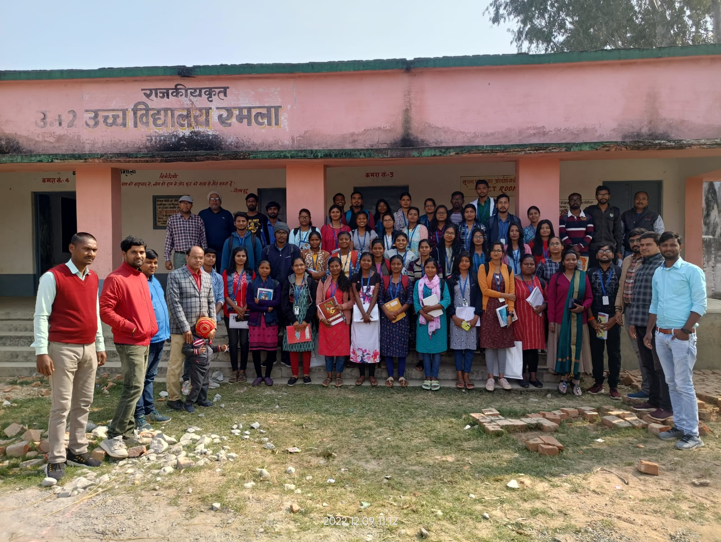

**Table 10.7 No. of students:**

|  |  |  |  |  |  |  |  |
| --- | --- | --- | --- | --- | --- | --- | --- |
| **Class** | **Section** | | **Male** | | **Female** | | **Total** |
| 9th | 3 | | 73 | | 71 | | 144 |
| 10th | 2 | | 62 | | 61 | | 123 |
| **Science** | | | | | | | |
| 11th | 1 | | 20 | | 13 | | 33 |
| 12th | 1 | | 3 | | 6 | | 9 |
| **Arts student** | | | | | | | |
| 11th | 1 | | 21 | | 40 | | 61 |
| 12th | 1 | | 27 | | 31 | | 58 |
| **IT (Vocational)** | | | | | | | |
| **Class** | | **Male** | | **Female** | | **Total** | |
| 9th | | 4 | | 64 | | 68 | |
| 10th | | 0 | | 49 | | 49 | |
| 11th | | 2 | | 44 | | 46 | |
| 12th | | 4 | | 29 | | 33 | |
| **Electronics** | | | | | | | |
| 9th | | 63 | | 0 | | 63 | |
| 10th | | 47 | | 0 | | 47 | |
| 11th | | 46 | | 6 | | 52 | |
| 12th | | 27 | | 5 | | 32 | |
|  |  |  |  |  |  |  |  |

**Table 10.8 Teachers list:**

|  |  |  |
| --- | --- | --- |
| **Name** | **Subject** | **Class** |
| Ram Pratap pandey (principal) (PGT) | Commerce | 10-12 |
| Premlal pandey (PGT) | History | 10-12 |
| Yudhisthir sharma (TGT) | Hindi | 9-10 |
| Sanjay kumar (TGT) | Biology , Chemistry | 9-10 |
| Md. Shail Ahmed (TGT) | Maths | 9-12 |
| Subhash das (TGT) | Geography | 9-12 |
| Shivnandan prasad (TGT) | English | 9-12 |
| Neeraj Kr. Singh |  |  |
| Kr. Yaduvansh mani (TGT) | History | 9-12 |
| Md. Manohar Alam | IT | 9-12 |
| Gopal Mandal |  |  |
| Md. Shahil Iqual | Electronics , hardware | 9-12 |

**Total no. of staff:** 14 (no female)

**PRIMARY AND MIDDLE SCHOOL:**

Ø **Total students :** 275

Ø **Total girls :** 147

Ø **Total boys :** 132

Ø **Total class :** 1 to 8

Ø **Total teachers :** 3 (1 female, 2 male)

Ø **Head teacher :** Dilip Kr. Sah

Ø **Teacher :** Sobha Kumari, Aditya Kumar Anand (1 to 5), Dilip kr. Sah (Head Master)

Ø **School established :** 1955

Ø **Washroom :** 2-6

Ø **Handpump**

Ø **Attendance good (75%-80%)**

Ø **Smart class**

Ø **Gyan setu karyakarm (Program)**

Ø **Area 5 kattha (8000 sq. feet)**

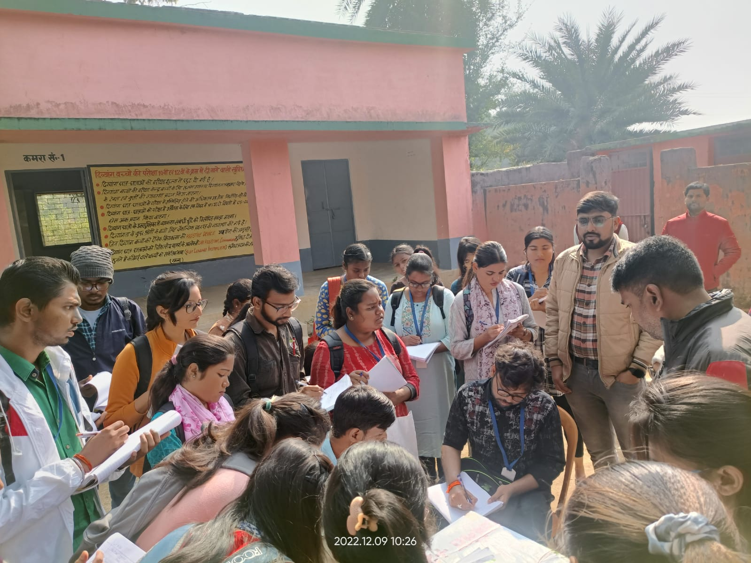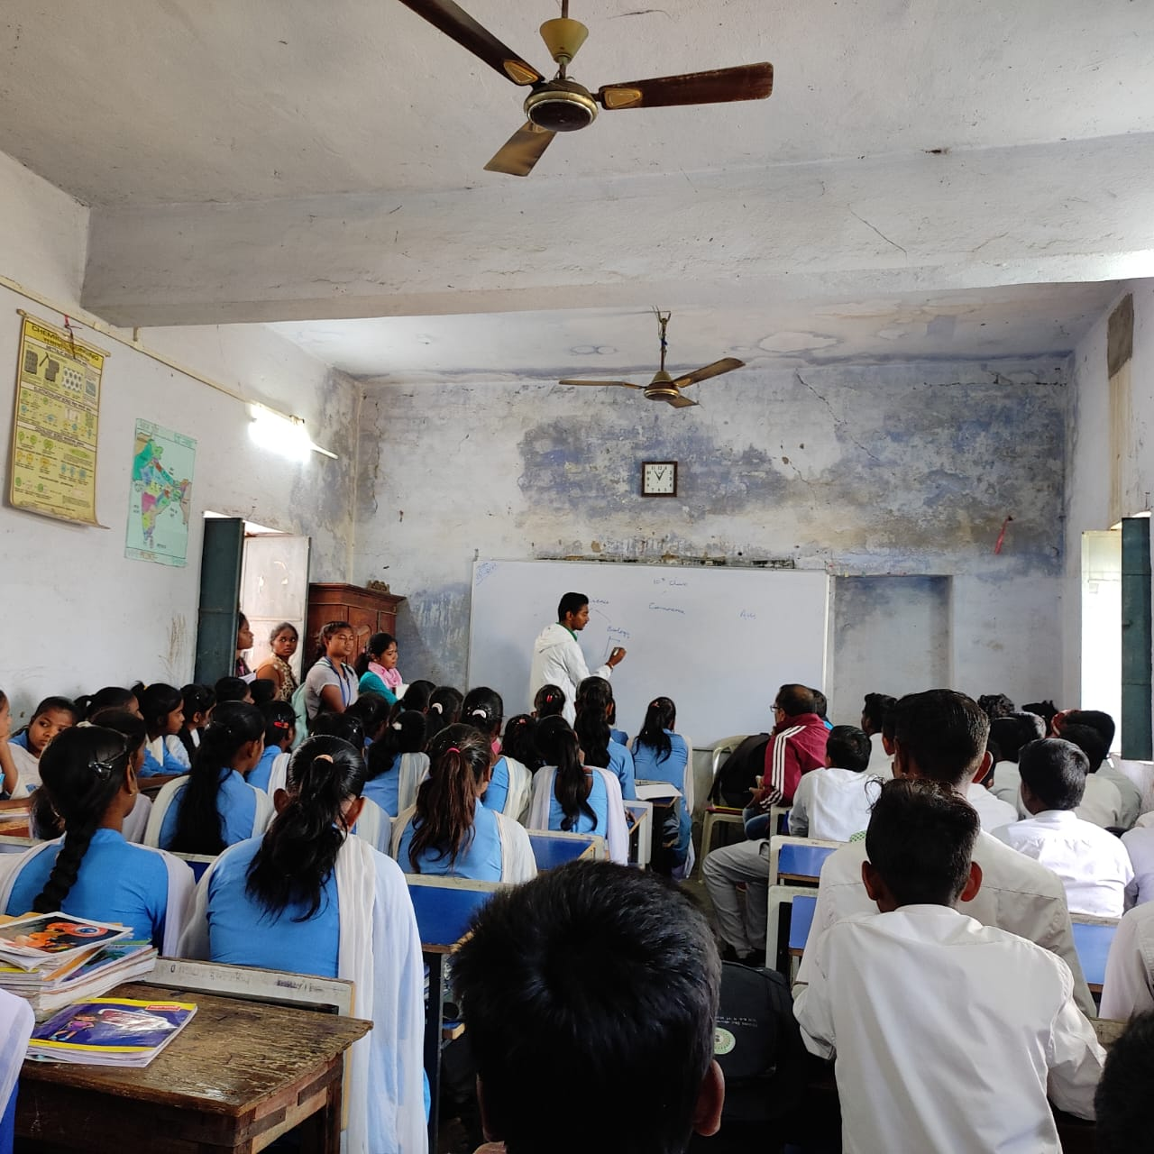

**AANGANBADI SURVEY**

**Established :** 22 Sept. 2009

**Head :** Giriwala Kumari

**Staff :** 2

**Food Source :** Own ( Money from Government)

**Area :** 1 hectare

**Study Material :** Pencil, Slate ( given by Government)

**Office :** Godda Block

**Table 10.9 Students:**

|  |  |
| --- | --- |
| **Age** | **No. of Students** |
| 0-3 yrs | 69 |
| 3-6 yrs | 40 |
| Total | 109 |

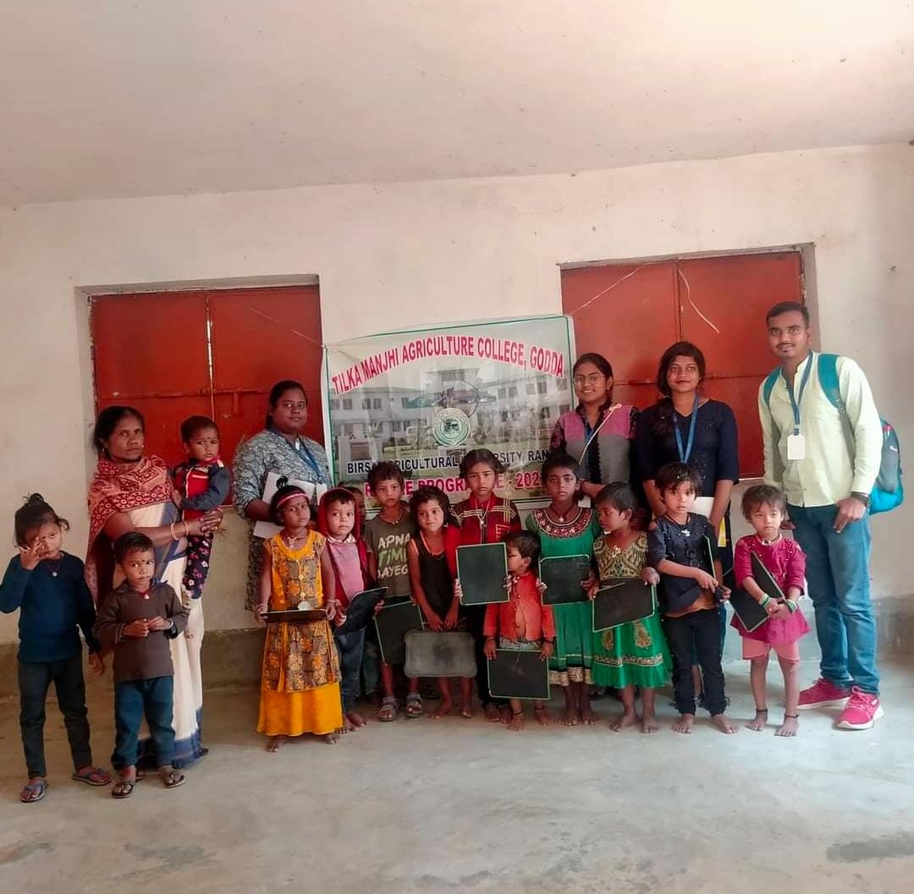

**Camp held by Anganbadi in recent Times:-**

**Sarkar Apke Dawar :-** The government of Jharkhand has announced the launch of the “Aapki Yojana Aapki Sarkar Aapke Dwar Program 2022” on 4th October Tuesday, in the context of the completion of 3 years of the Hemant Soren government. The scheme was launched with the aim to ensure that citizens, especially those living in rural and remote areas, have easy access to government services. The employees are trained to use the equipment and software necessary to provide services, and they are also trained to assist citizens in filling out forms and providing the necessary documents for the services.

**Features and Objectives:-**

* One of the main objectives of the Jharkhand Aapki Yojana Aapki Sarkar Aapke scheme is to reduce the need for citizens to travel long distances to government offices. With the scheme, citizens can access services from the comfort of their homes, without having to go through the hassle and expense of traveling to government offices.
* This is especially beneficial for elderly citizens and those with disabilities, who may find it difficult to travel to government offices.
* The scheme also aims to reduce corruption and improve transparency in the delivery of government services.

**SCHEMES**

* PMMVY (Pradhan Mantri Matritva Vandana Yojana)
* Savitribai Phule Kishori Samriddhi Yojana

**PMMVY ( PRADHAN MANTRI MATRITVA VANDANA YOJANA)**

Previously known as the Indira Gandhi Matritva Sahyog Yojana, is a maternity benefit program run by the government of India. It was originally launched in 2010 and renamed in 2017. The scheme is implemented by the [Ministry of Women and Child Development](https://en.m.wikipedia.org/wiki/Ministry_of_Women_and_Child_Development_(India)). It is a [conditional cash transfer](https://en.m.wikipedia.org/wiki/Conditional_cash_transfer) scheme for pregnant and lactating women of 19 years of age or above for the first live birth. It provides a partial wage compensation to women for wage-loss during childbirth and childcare and to provide conditions for safe delivery and good nutrition and feeding practices.

**Objectives:**

* Promoting appropriate practice, care and institutional service utilization during pregnancy, delivery and lactation
* Encouraging the women to follow (optimal) nutrition and feeding practices, including early and [Exclusive breastfeeding](https://en.m.wikipedia.org/wiki/Breast_feeding#Exclusive_breastfeeding) for the first six months; and
* Providing cash incentives for improved health and nutrition to pregnant and lactating mothers.

**Eligibility conditions and conditionalities:**

Originally, the scheme was brought under the National Food Security Act, 2013 to implement the provision of cash maternity benefit of ₹6,000 stated in the Act. Then, all pregnant women of 19 years of age and above were eligible for conditional cash transfer benefits of ₹5,000 to paid in three installments, except those who receive paid maternity leave. After the implementation of National Food Security Act the amount has been revised to ₹6,000 (US$75) to be paid in two installments of ₹3,000 (US$38) each.

**SAVITRIBAI PHULE KISHORI SAMRIDDHI YOJANA**

The Jharkhand government on Tuesday said it aims at facilitating the education of nine lakh adolescent girls in the state under the Savitribai Phule Kishori Samriddhi Yojana (SPKSY). The welfare programme was launched by Chief Minister Hemant Soren in October 2022 from Giridih.

"The Savitribai Phule Kishori Samriddhi Yojana is an effort of the state government to facilitate the education of adolescent girls and a step towards women empowerment and gender justice...Nine lakh adolescent girls of the state shall be covered by this scheme," a statement issued by the government said.

**Objective:**

* The objective of the scheme is not only providing financial assistance to adolescent girls for education, but also ensuring that the girls don’t drop out from school, and preventing child marriage.
* This scheme will also provide assistance for the health and personal hygiene of girls

**WHAT IS PRA?**

Participatory methods and tools are mainly used for agro eco system analysis. PRA is one of that.

**Participatory** -Means that people are involved in the process - a “bottom-up” approach that requires good communication, skills and attitude of project staff.

**Rural** - The techniques can be used in any situation, urban or rural, with both literate and illiterate people.

**Appraisal** - The finding out of information about problems, needs, and potential in a village. It is the first stage in any project.

PRA is a methodology for interacting with villagers and seeking their participation in putting forward their point of views about problem analysing and equalizing the information to acquire learning.

**Aims of PRA:**

* To build up a permanent “people first” attitudes in the minds of the participants. To show that “people are capable agents to change their own lives” but require limited outside assistance.
* To establish a notion of “respect” to the people’s knowledge in the life of professionals and their institutions.
* To provide simple analytical tools to analyze rural situations.
* To show some of the analytical tools to the community in the field setting and understand their suitability to farmer situation.
* To enhance participant’s ability to plan with the community.

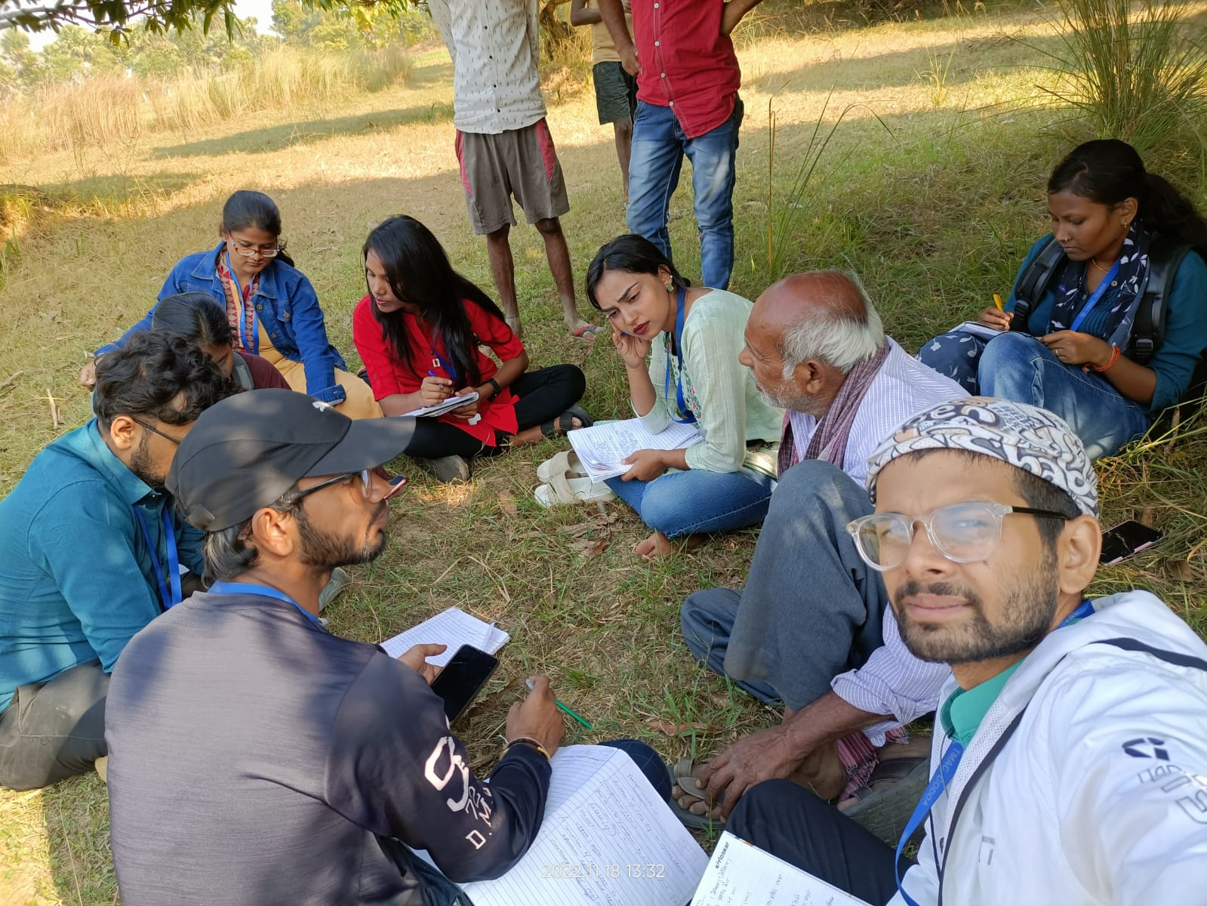 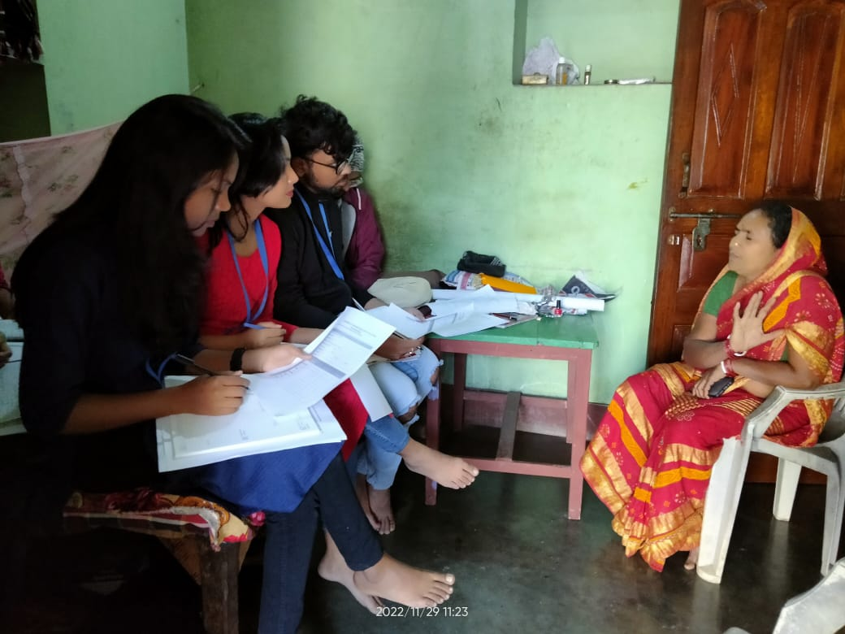

**AREAS OF APPLICATION:-**

* Natural resource management
* Agriculture
* Poverty alleviation/women in development programmes
* Health and nutrition
* Preliminary and primary education
* Village and district-level planning
* Institutional and policy analysis

**DIFFERENT PRINCIPLES THAT FORM THE BASIS OF ANY PRA ACTIVITY:-**

**1) Participation-** It is important for local communities to participate in PRA to make it successful as they are not only a source of information but indispensable partners in the PRA team in gathering and analyzing information.

**2) Listening and learning-** Listening to the local communities not only help us understand their history and culture, but also opens up a whole new world view which generally remains dormant and unrevealed to the outside world.

**3) Offsetting Biases-** While listening and learning, it is important that the preconceived notions of individuals are cast aside. PRA promotes relaxed but active listening and learning, seeking participation from people who are relatively worse off. Thus, letting a group of people find their voice who rarely get a chance to speak.

**4) Seeking Diversity-** PRA entails listening to and learning from a diverse community of people. Rather than looking for representatives of each group, it seeks to understand different perspectives within the same community. This helps in portraying a better view of the “reality”.

**5) Triangulation/Cross checking-** Triangulation is a technique used to improve the reliability of the collected data. It is performed by changing the team composition, the sources of information and the techniques applied to gather the information. After collecting the data with this technique, midway corrections are done to minimize errors.

**6) Optimal Ignorance-** As the term suggests, PRA work attempts to be more focused on the relevant information to make the necessary recommendations and decisions. This means knowing only what is worth the time and effort and ignoring the unnecessary information.

**7) Multi-disciplinary Team-** The scientific team conducting PRA should have fairly broad base, thereby including scientists of all important disciplines relevant to the area of study. Not only that, but the team should also include female scientists so that the rural women can be easily involved in the process. There should be at least 3 representatives chosen from the team, each performing a specific job. First is Team Leader/Facilitator, another is Process Recorder or Content Recorder and third one is Environment Controller .The job of the Environment Controller is to develop rapport with the rural people before jumping on to the objective of the study.

**8) Flexibility-** The size and skills of the PRA team, the available time and other resources and the topic and location of work determines the techniques appropriate in a particular study

**9) Teamwork-** The team of scientists generally works with a local team, speaking the local languages, to successfully conduct the PRA.

**10) Empowerment-** The authority to local people through decentralization and confidence building.

**11) Self-critical awareness**- Mistakes are also an important part of the whole program. They help in making individuals better, but one needs self-critical awareness for that.

**TOOLS OF PRA:-**

**Social Map:**

This map is a graphic representation of the cognitive (perceived) image that depicts the whole picture pertaining to a certain place or location. Therefore, proportions, scales and dimensions tend to distort but with a high level of detailing and accuracy can be obtained

**Learning objectives of social map are :**

* To get an overview of the villagers' perception about all their social resources and micro environment
* To gain insight from the villagers about their practice of resource utilization spatially.

**Components**

Road.

Household.

Village institution.

Occupation.

Religion distribution.

Rural leaders.

Any other important rural features.

**Fig. 3**

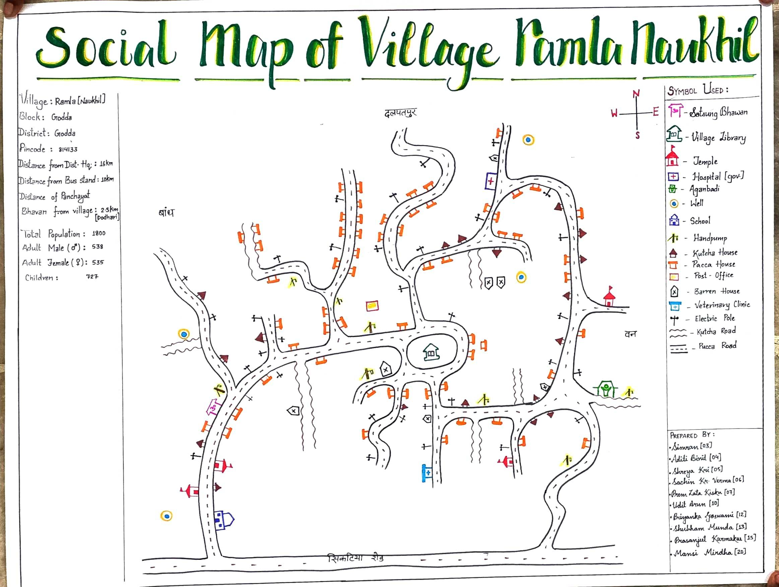

**Resource Map:-**

This map in a graphic representation of the cognitive (perceived) image depicts the whole picture pertaining to a certain place or location with major components like Land type (topography), soil types, enterprises, water resources, cropping sequence, pasture land, problematic area (if any) and other related items.

**Learning objectives:-**

* To have an overview of the villagers' perception about all their natural resources and micro-environment.
* To gain insight from the villager about their practice of resource utilization spatially.

**Method:-** The people who know the area and topic of the natural resource map exercise and are willing to share their knowledge had been chosen for the work.

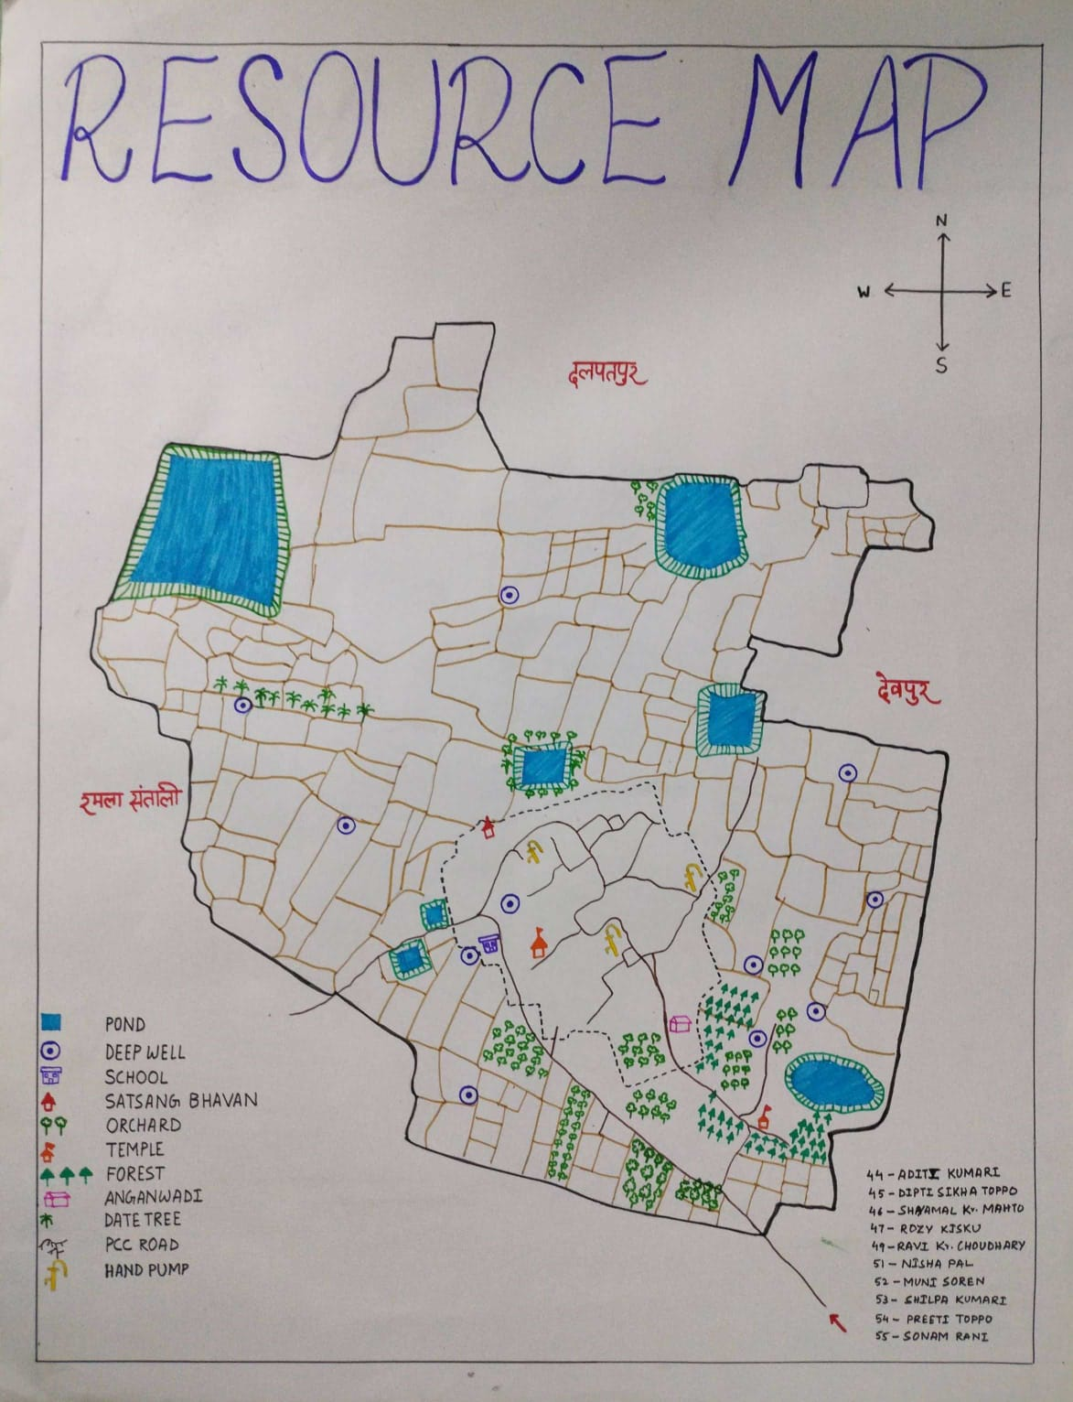

**Fig. 4**

**Timeline Map**

The facilitators meet small groups of villagers and discuss with them the most important events in the community’s past and prepare with the information a historical timeline which serves as the base for further work. It is important to involve different groups of the communities to get their usually different perspectives. The timeline with basic events can be used to focus discussions on problems, social and technological innovations or on communities history of co operations and activities which helped them to solve in past problems successfully.

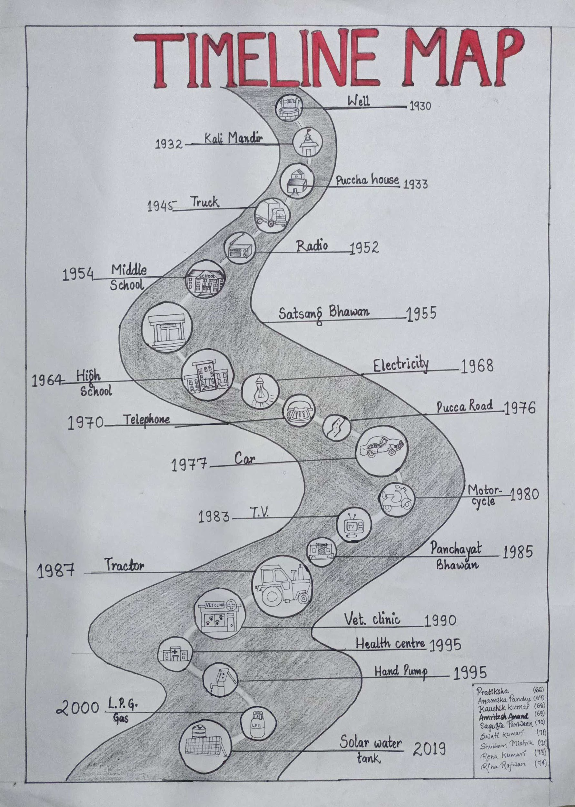

**Fig. 5**

**Trend Analysis**

Time trend designs are a form of longitudinal ecological study and can provide a dynamic view of populations' health status. Like other ecological studies the data are collected at a population level and can be used to generate hypothesis for further research,rather than demonstrating causality

.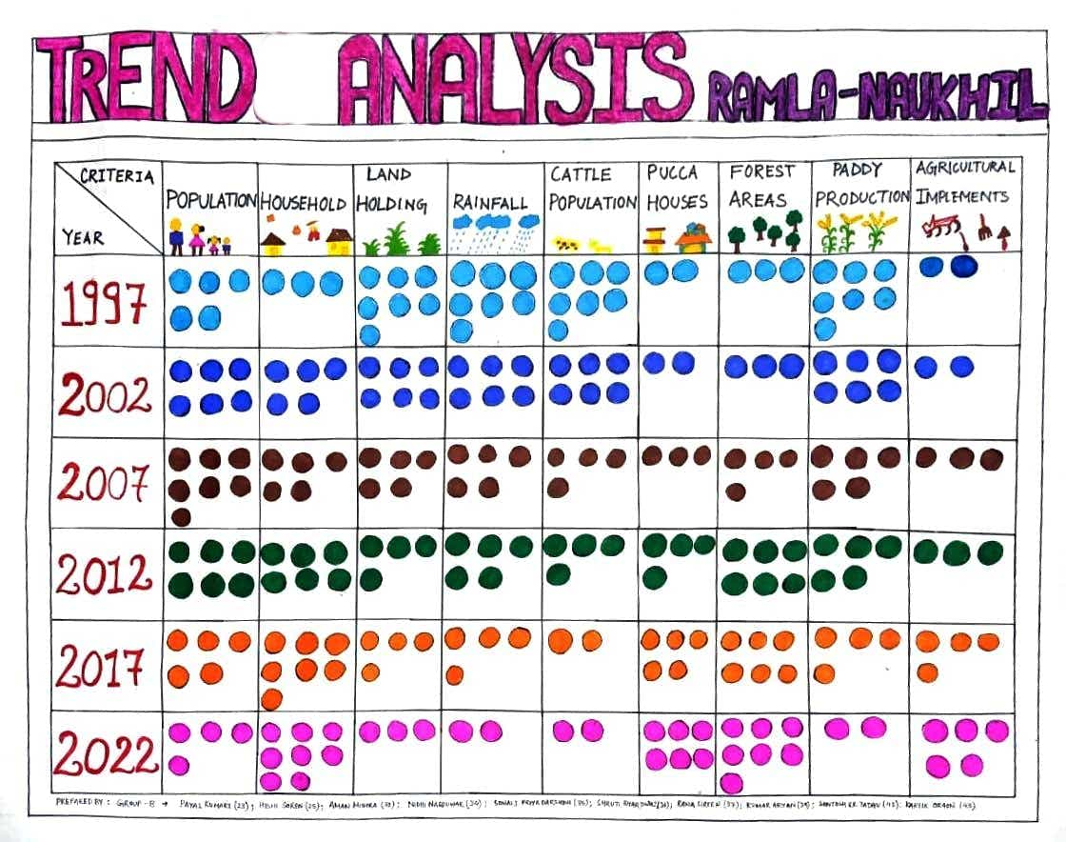

**Fig. 6**

**Venn Diagram**

The Venn Diagram on Institutions shows institutions, organizations, groups and important individuals found in the village, as well as the villagers view of their importance in the community.

Additionally the Diagram explains who participates in these groups in terms of gender and pollution.

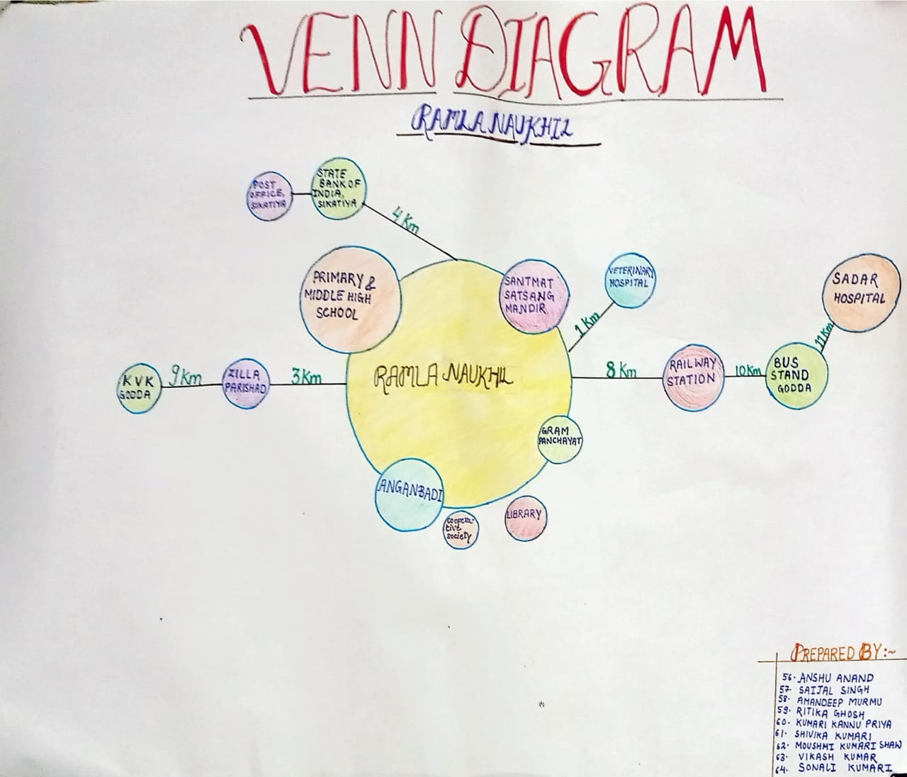

**Fig. 7**

**11. ITK (Indigenous Technical Knowledge)**

1. **PARBOILING**

Parboiling is a hydrothermal treatment followed by drying before milling for the production of milled parboiled grain. Parboiling of paddy has been known in the orient for centuries. Nearly 50 per cent of the paddy produced in India at present is parboiled.

In general, the three major steps in parboiling, i.e. soaking, steaming and drying and have a great influence on the final characteristics and quality of parboiled rice

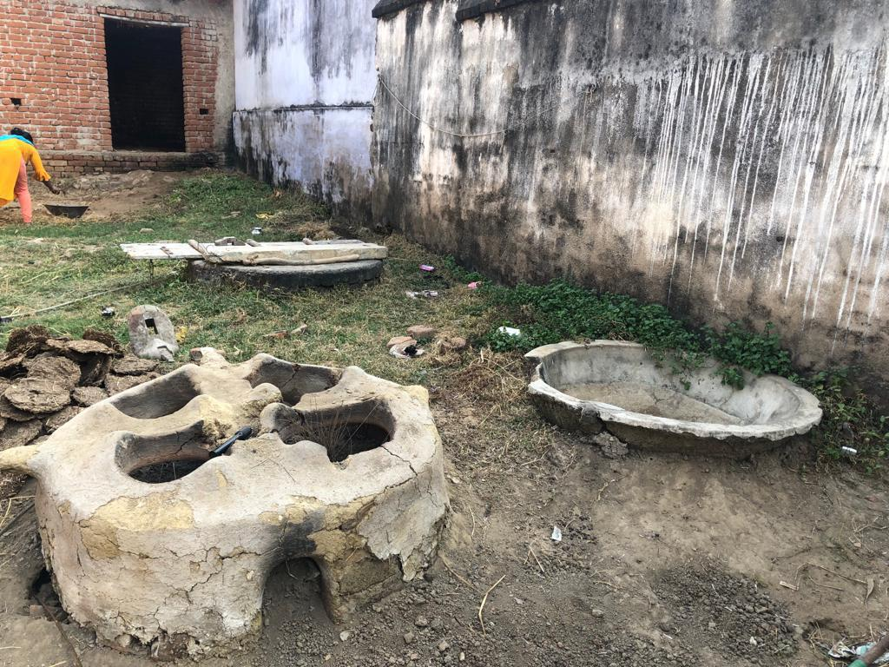

**Earthen stove used for parboiling**

1. **INDIGENOUS PLOUGH / WOODEN PLOUGH**

Indigenous plough is an implement which is made of wood with an iron share point. It consists of body, shaft pole, share and handle. It is drawn with bullocks. It cuts a V shaped furrow and opens the soil but there is no inversion. Ploughing operation is also not perfect because some unploughed strip is always left between furrows. This is reduced by cross ploughing, but even then small squares remain unploughed

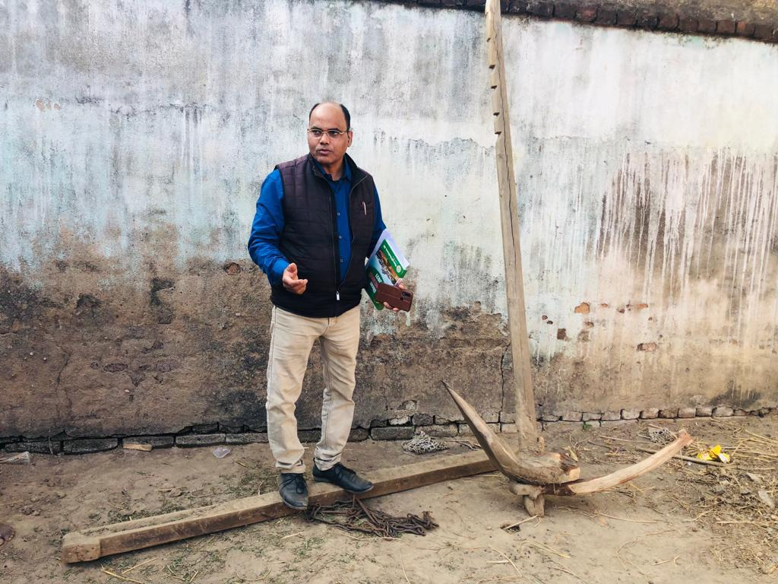

**Wooden Plough**

**12.) ACTION PLAN DEVELOPMENT FOR THE VILLAGE**

**For the unemployed youth :-**

* Government has launched many skill development programs, like Skill India mission, to provide training to inculcate vocational skills in the unemployed youth. E.g. carpentry, electroplating, fashion-designing, marketing for managers, financial statement analysis, etc.
* Unemployed youth can get training from KVKs to get themselves self-employed with bee-keeping, animal husbandry and mushroom cultivation.

**For farm women :-**

* Women can also get training under skill development programs like Skill India mission for skills for fashion designing and entrepreneurship
* Earning income from mushroom cultivation

**In livestock sector :-**

* Proper vaccination of the cattle to save them from dying due to local disease (very common in goats) and increase milk production
* Provide 20 kg of green fodder, 10 kg dry fodder, 4 kg concentrate feed and 30 litres of fresh water everyday

**To mitigate water scarcity :-**

* Rain water harvesting in their house by building small structures and then using the stored water for irrigation
* Growing crop that grows well in rain fed conditions like groundnut, sorghum and millet
* Growing varieties that grow well in minimum water

**Instructions for less cost of cultivation and high output :-**

* Seed treatment before sowing to increase the yield.
* Using the proper amount of fertilizer to minimize soil pollution and water pollution
* Integrated disease and pest management
* Using improved hybrid varieties suitable for the region
* About the loss caused by weed, pathogens and pests and using proper techniques and chemicals to control them

**II. KRISHI VIGYAN KENDRA ATTACHMENT**

**II.1 INTRODUCTION**

Krishi Vigyan Kendra Krishi Vigyan Kendra is a frontline extension programme and innovative institutional model of the Indian Council of Agricultural Research. It is devoted to undertaking the activities of technology assessment, refinement and dissemination through on-farm testing, frontline demonstration, vocational training of farmers, rural youth, farm women and extension functionaries.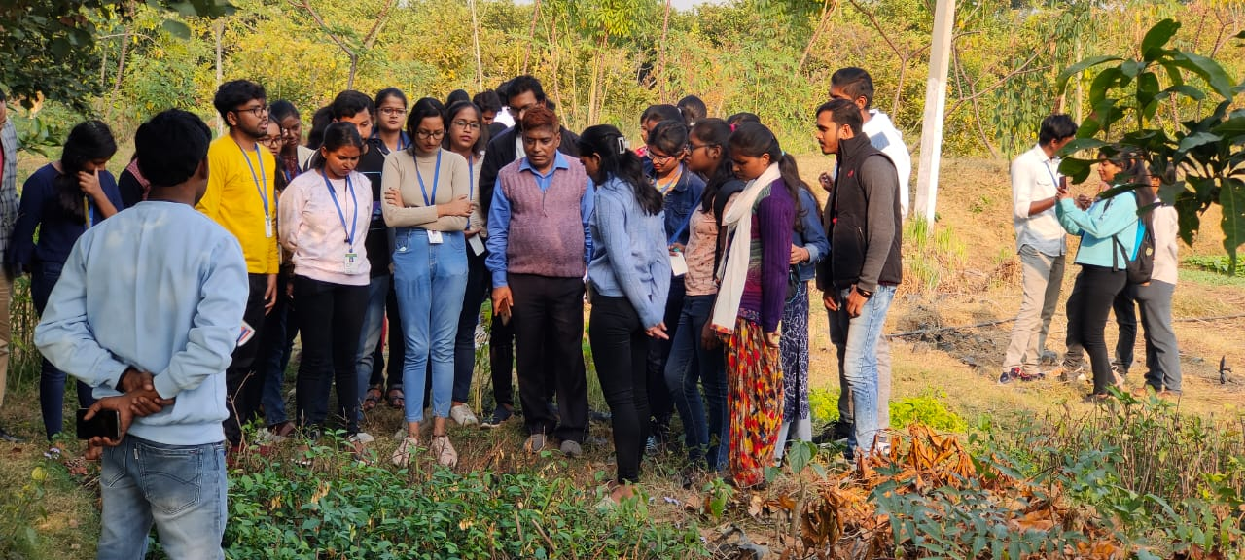

**II.2 OBJECTIVE**

* To test and verify the technology on farmers’ fields through on-farm adaptive research and frontline demonstration to develop location-specific technologies
* To demonstrate the latest agricultural technologies at the instructional farm with a view to reduce the technology dissemination losses
* To impart training to practicing farmers, farm women and rural youth by following the method of “teaching by doing” and “learning by doing”
* To organize vocational training programmes and income generation activities for rural youth and school dropouts by imparting skills.
* To organize skill and production-oriented short and long term training programmes’ both on and off-campus
* To organize training for extension functionaries in the area of frontier technology.
* To organize kisan melas, field days and farmer-scientist interface programmes
* To bring out literature, radio and TV programmes on modern technologies

**II.3 MANDATES**

* Conduct “On-farm testing” for identifying technologies in terms of location-specific sustainable land use systems through technology assessment and refinement.
* Organize frontline demonstrations on various crops to generate production data and feedback information.
* Organize short and long term vocational training courses in agriculture and allied vocations for the farmer and rural youth with emphasis on “learning by doing” for higher production on farms and generation of self employment.
* Organize training to update the extension personnel with emerging advances in. agricultural research on a regular basis.
* Act as a knowledge and resource centre for advancement of agriculture in the district

**KRISHI VIGYAN KENDRA GODDA**

GVT - Krishi Vigyan Kendra (KVK), Godda in Jharkhand was established at the Sub-divisional Agriculture farm near Rautara chowk in the year 2006. GVT - Krishi Vigyan Kendra (KVK), Godda is managed by Gramin Vikas Trust and funded by Indian Council of Agricultural Research, ICAR, New Delhi.

For the farming community KVK has organized various types of training, kisan mela, exposure visits, and exhibition for rural farmers on one hand and on the other hand, it is also facilitated by Govt. for technology assessment, refinement and its dissemination to suit location specific requirements for the practicing farmers.

1. **GENERAL INFORMATION**

**Name of the KVK** : GVT-KVK, Godda

**Name of the Head of KVK** : Dr. Ravishankar

**Geographic location of KVK** :North Latitude Between 240.47

to 250.23’ East Longitude

between 870.08’ to 870.48’

**Nature of Activities**  : Agriculture, Animal

Husbandry, Home science

**Year of Establishment**  : 2006

**Organization owned by** : NGO

1. **Organizational Structure**

Under this the student will know the employee strength, their training needs, organization behavior, employee recruitment policies and methods etc.

**Table II.1**

|  |  |  |
| --- | --- | --- |
| **Sl. No.** | **Subject** | **Scientist(s)** |
| 1. | Horticulture(pomology) | Dr. Ravi Shankar |
| 2. | Animal Husbandry | Dr. Satish Kumar |
| 3. | Plant Protection | Dr.Surya Bhushan |
| 4. | Plant Protection | Dr.Hemant Kumar Chourasiya |
| 5. | Ag. Extension | Dr. Ritesh Dubey |
| 6. | Farm manager | Rakesh Kr. Singh |
| 7. | Home Science | Dr. Pragatika Mishra |
| 8. | Agro meteorology | Rajnish Prasad Rajesh |

1. **Area of operation - KVK Godda**

* Cultivated area of the area of operation (Districts) field and horticultural crops : 167400 ha
* Natural Resources –
* Irrigated area : 7,530 ha
* Forest area : 31,320 ha
* Land under non-agricultural use : 18,080 ha
* Land use classification of the operational area
* Net sown area : 78,200 ha
* Area sown more than once : 6,300 ha
* Gross cropped area : 84,500 ha
* Crops grown including field and horticultural crops

**Field crops**

Rice

Maize

Pigeon pea

Blackgram

Greengram

Groundnut

Wheat

Chickpea

Pea

Lentil

Mustard

**Horticultural crops**

Mango

guava

Litchi

Lemon

Banana

Cauliflower

Cabbage

Tomato

Brinjal

Chilli

Lady Finger

* Area of different Crops in different districts of operation of KVK / Research station;

**Table II. 2 FIELD CROPS**

|  |  |
| --- | --- |
| **crops** | **Area(ha)** |
| Rice | 30.2 |
| Maize | 6.8 |
| Pigeon pea | 3.1 |
| Black gram | 0.6 |
| Green gram | 0.4 |
| Groundnut | 0.1 |
| Wheat | 1.9 |
| Chickpea | 2.8 |
| Pea | 0.6 |
| Lentil | 0.05 |
| Mustard | 1.5 |

|  |  |
| --- | --- |
| **CROPS** | **AREA(ha)** |
| Mango | 0.4 |
| Guava | 0.2 |
| Litchi | 0.2 |
| Lemon | 0.2 |
| Banana | 0.2 |

|  |  |
| --- | --- |
| **CROPS** | **AREA** |
| Cauliflower | 0.8 |
| Cabbage | 0.3 |
| Tomato | 0.6 |
| Brinjal | 0.4 |
| Chilli | 0.3 |
| Okra | 0.4 |

* Crop varieties grown, Average yield of crops

|  |  |
| --- | --- |
| * Rice * Wheat * Linseed * Horse gram * Lentil * Mustard * Mango * Guava * Lemon * Tomato * Brinjal | Sahbagi, Naveen, Sabour Anjali, Lalat, rajendra katarni  Sabour nirjal, Sabour shrestha  Sabour tisi1  Birsa kurthi1,Birsa niger 1  IPL316  Pusa30, Pusa28  Amrapali, Mallika, Malda, Pusa kesar  Allahabadi safeda, Lalit,Lucknow49  Kagzi  Swarna kanchan  Swarna pratibha |

Important activities of the KVK during the past one year

**On campus:**

* 12 on farm trials
* Poultry, goatery, piggery Training
* Plant protection and plant propagation training
* Development of saplings and seedlings of horticultural crops.
* Entrepreneurship development.
* Preservation and value addition of fruits and vegetables
* Soil sample collection and testing
* Fishery training

**Off campus:**

* Frontline demonstration on farmer’s field on 1 acre of land
* Seed production (breeder to certified seeds) e.g.: Paddy, mung, brinjal, tomato, onion
* Formation of FPO and SHGs
* One day training on season and crop based
* Natural resource management
* Integrated nutrient management
* Various sponsored training like ASCH skill training

1. **Resources of the organization:**

* Land -25 acres, 2 Ponds
* Building / Go downs- Administrative staff quarter, Training hostel, Laboratory, seed processing unit
* Equipment: pH meter, EC meter, BOD, Laminar air flow, Autoclave, Juicer, Oven, Microwave, Spectrophotometer, Atomic Absorption Spectroscopy
* Machinery- Land equipments: Tractors (2)
* Transport vehicles: TATA Sumo, Bicycles

1. **Activities of KVK / Research Station:**

**Research:**

* Agriculture - Breeder seed demonstration, Seed production (breeder to certified)
* Including horticulture - Development of seedlings and saplings, nursery development of various vegetable crops (brinjal, tomato, cauliflower, cabbage)
* Seed production of vegetable crops ( brinjal, tomato, onion)
* Sapling development of guava, mango, drumstick
* Veterinary including poultry- Demonstration of feed conversion ratio of Jharsuk

**Demonstrations**

* Agriculture-7 demonstration and 40 awareness programme on Natural Farming
* Including horticulture- Demonstration of nutritional garden
* Veterinary including poultry, fisheries - Demonstration of feed conversion ratio of Jharsuk
* Fisheries: Composite Fish Farming
* Home science- Preservation and value addition of horticultural crops

**Trainings**

* Agriculture Including horticulture - Training on soil sample collection
* Veterinary including poultry-Poultry, goatery, piggery

1. **Achievements of KVK / Research Station:**

* **NICRA** Project in 4 village
* Natural farming – use of Bijamrit, jivamrit
* Annual health worker

**Glimpses of Media Coverage**

